**CS 4513-001 Database Management**

**Fall 2019**

**Dr. Le Gruenwald**

**Treyson Martin**

**112963422**

[**Treyson.M.Martin@ou.edu**](mailto:Treyson.M.Martin@ou.edu)

**Process DB Project**

**1.1) ER Diagram**

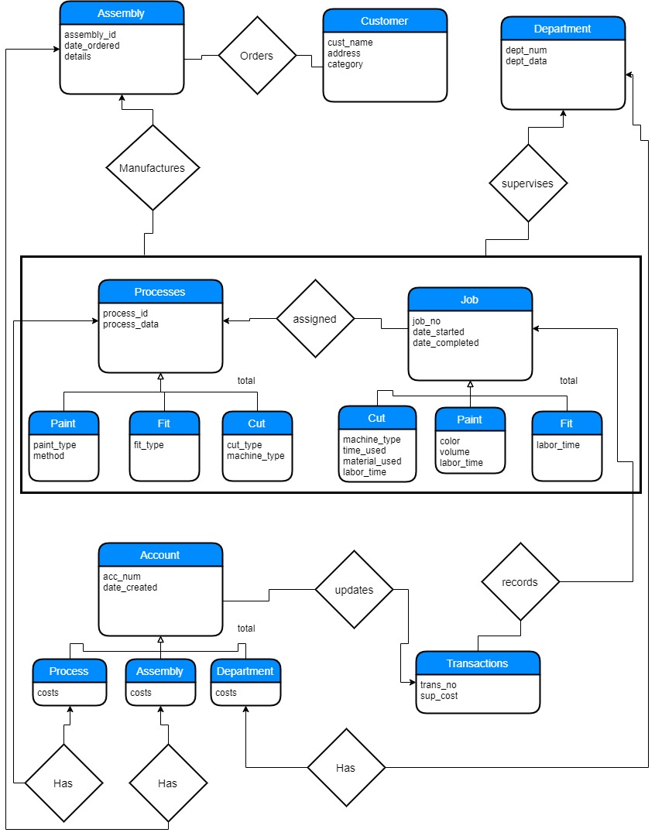

**1.2) Relational Schema**

Assembly(assembly_id, date_ordered, details)

Customer(cust_name, address, category)

Department(dept_num, dept_data)

Processes(process_id, process_data)

Process_Paint(process_id, process_data, paint_type, method)

Process_Fit(process_id, process_data, fit_type)

Process_Cut(process_id, process_data, cut_type, method_type)

Job(job_no, date_started, date_completed)

Job_Cut(job_no, date_started, date_completed, machine_type, times_used, material_used, labor_time)

Job_Paint(job_no, date_started, date_completed, color, volume, labor_time)

Job_Fit(job_no, date_started, date_completed, labor_time)

Transaction(trans_no, sup_cost)

Account(acc_num, date_created)

Account_Assembly(acc_num, date_created, costs)

Account_Process(acc_num, date_created, costs)

Account_Department(acc_num, date_created, costs)

Orders(cust_nume, assembly_id)

Manufactures(assembly_id, process_id, job_no)

Assigned(process_id, job_no)

Supervises(dept_name, process_id, job_no)

Records(job_no, trans_no)

Updates(trans_no, acc_num)

Has1(assembly_id, acc_num)

Has2(process_id, acc_num)

Has3(dept_num, acc_num)

**2) Data Element Dictionary**

|  |  |  |  |  |
| --- | --- | --- | --- | --- |
| **Table** | **Column** | **Type** | **Size(Bytes)** | **Constraints** |
| Assembly | assembly_id | int | 4 | Primary Key |
| Assembly | date_ordered | date | 3 |  |
| Assembly | details | varchar(128) | 130 |  |
| Customer | cust_name | varchar(32) | 34 | Primary key |
| Customer | address | varchar(40) | 42 |  |
| Customer | category | int | 4 | Values 1-10 |
| Department | dept_num | int | 4 | Primary Key |
| Department | dept_data | varchar(128) | 130 |  |
| Processes | process_id | int | 4 | Primary Key |
| Processes | process_data | varchar(128) | 130 |  |
| Process_Paint | process_id | int | 4 | Primary Key |
| Process_Paint | process_data | varchar(128) | 130 |  |
| Process_Paint | paint_type | varchar(32) | 34 |  |
| Process_Paint | method | varchar(32) | 34 |  |
| Process_Fit | process_id | int | 4 | Primary Key |
| Process_Fit | process_data | varchar(128) | 130 |  |
| Process_Fit | fit_type | varchar(32) | 34 |  |
| Process_Cut | process_id | int | 4 | Primary Key |
| Process_Cut | process_data | varchar(128) | 130 |  |
| Process_Cut | cut_type | varchar(32) | 34 |  |
| Process_Cut | machine_type | varchar(32) | 34 |  |
| Job | job_no | int | 4 | Primary Key |
| Job | date_started | date | 3 |  |
| Job | date_completed | date | 3 | Date_completed >= date_started |
| Job_Cut | job_no | int | 4 | Primary Key |
| Job_Cut | date_started | date | 3 |  |
| Job_Cut | date_completed | date | 3 | Date_completed >= date_started |
| Job_Cut | machine_type | varchar(32) | 34 |  |
| Job_Cut | time_used | int | 4 | Positive number |
| Job_Cut | material_used | varchar(32) | 34 |  |
| Job_Cut | labor_time | int | 4 | Positive number |
| Job_Paint | job_no | int | 4 | Primary Key |
| Job_Paint | date_started | date | 3 |  |
| Job_Paint | date_completed | date | 3 | Date_completed >= date_started |
| Job_Paint | color | varchar(32) | 34 |  |
| Job_Paint | volume | int | 4 | Positive number |
| Job_Paint | labor_time | int | 4 | Positive number |
| Job_Fit | job_no | int | 4 | Primary Key |
| Job_Fit | date_started | date | 3 |  |
| Job_Fit | date_completed | date | 3 | Date_completed >= date_started |
| Job_Fit | labor_time | int | 4 | Positive number |
| Transaction | trans_no | int | 4 | Primary Key |
| Transaction | sup_cost | float | 8 | Positive number |
| Account | acc_num | int | 4 | Primary Key |
| Account | date_created | date | 3 |  |
| Account_Assembly | acc_num | int | 4 | Primary Key |
| Account_Assembly | date_created | date | 3 |  |
| Account_Assembly | cost(Details1) | float | 8 | Positive number |
| Account_Department | acc_num | int | 4 | Primary Key |
| Account_Department | date_created | date | 3 |  |
| Account_Department | cost(Details2) | float | 8 | Positive number |
| Account_Process | acc_num | int | 4 | Primary Key |
| Account_Process | date_created | date | 3 |  |
| Account_Process | cost(Details3) | float | 8 | Positive number |
| Orders | cust_name | varchar(32) | 34 | Foreign Key |
| Orders | assembly_id | int | 4 | Primary Key |
| Manufactures | assembly_id | int | 4 |  |
| Manufactures | process_id | int | 4 |  |
| Manufactures | job_no | int | 4 |  |
| Assigned | process_id | int | 4 | Primary Key |
| Assigned | job_no | int | 4 | Foreign Key |
| Supervises | dept_num | int | 4 | Primary Key |
| Supervises | process_id | int | 4 | Foreign Key |
| Supervises | job_no | int | 4 |  |
| Records | job_no | int | 4 | Primary Key |
| Records | trans_no | int | 4 | Foreign Key |
| Updates | trans_no | int | 4 | Primary Key |
| Updates | acc_no | int | 4 | Foreign Key |
| Has1 | assembly_id | int | 4 | Primary Key |
| Has1 | acc_num | int | 4 | Foreign Key |
| Has2 | process_id | int | 4 | Primary Key |
| Has2 | acc_num | int | 4 | Foreign Key |
| Has3 | dept_num | int | 4 | Primary Key |
| Has3 | acc_num | int | 4 | Foreign Key |

**3.1) File Organization**

|  |  |  |  |  |  |
| --- | --- | --- | --- | --- | --- |
| **Table** | **Query # / Type** | **Search Key** | **Query Freq** | **File Organization** | **Justifications** |
| Assembly | #3 Insertion |  | 40/day | Extendible hashing | Tied to customer_name |
| Customer | #1 Insertion  #13 Range Search | category | 30/day  100/day | Heap  Index with search key category | Faster cause of frequency  Fastest range search. |
| Department | #2 Insertion  #4 Insertion |  | Infrequent  Infrequent | Heap  B+ Index tree | Independent on insertion  Because insertion is not often |
| Process_Paint | #4 Insertion |  | Infrequent | B+ index tree | Because insertion is not often |
| Process_Fit | #4 Insertion |  | Infrequent | B+ index tree | Because insertion is not often |
| Process_Cut | #4 Insertion |  | Infrequent | B+ index tree | Because insertion is not often |
| Job_Cut | #6 Insertion  #7 Update  #10 Range Search  #14 Delete  #12 Random Search | Job_no  Date_completed  Job_no  date_completed | 50/day  50/day  20/day  1/month  20/day | Extendible hashing  Heap  Index with date_completed  Index with job_no  Hashing with date_completed | Tied to assembly and process  Fast Process.  Fastest results.  Fastest way to delete records.  Fastest Results |
| Job_Paint | #6 Insertion  #7 Update  #10Range Search  #15 Update  #12 Random Search | Job_no  Date_completed  Job_no  date_completed | 50/day  50/day  20/day  1/week  20/day | Extendible hashing  Heap  Index with date_completed  Heap  Hashing with key date_completed | Tied to assembly and process  Fast Process.  Fastest Results.  Fastest Process  Fastest Results. |
| Job_Fit | #6 Insertion  #7 Update  #10 Range Search  #12 Random Search | Job_no  Date_completed  date_completed | 50/day  50/day  20/day  20/day | Extendible hashing  Heap  Index with date_completed  Hashing with key date_completed | Tied to assembly and process  Fast Process.  Fastest Results.  Fastest Results. |
| Transaction | #8 Insertion |  | 50/day | Heap | Needs to go fast and process FIFO |
| Account_Assembly | #5 Insertion  #9 Random Search  #8 Update | acc_num | 10/day  200/day  50/day | Extendible hashing  With hash key assembly_id  Heap | Tied to assembly.  Fastest search results.  See Updates |
| Account_Department | #5 Insertion  #8 Update | acc_num | 10/day  50/day | Extendible Hashing  Heap | Tied to department  See Updates |
| Account_Process | #5 Insertion  #Update | acc_num | 10/day  50-day | Extendible Hashing  Heap | Tied to Process  See Updates |
| Orders | #3 Insertion |  | 40/day | Extendible hashing | Tied to customer_name |
| Manufactures | #6 Insertion  #12 Random Search | job_no | 50/day  20/day | Extendible hashing  Hashing with job_no | Tied to assembly and process.  Fastest results. |
| Assigned | #6 Insertion |  | 50/day | Extendible hashing | Tied to assembly and process |
| Supervises | #4 Insertion  #10 Range Search  #12 Random  Search | Date_completed  dept_num | Infrequent  20/day  20/day | B+ index tree  Index with date_completed  Hashing with key dept_num | Because insertion is not often  Fastest results.  Fastest results. |
| Records | #8 Insertion |  | 50/day | Heap | Needs to go fast and process FIFO |
| Updates | #8 Insertion |  | 50/day | Heap | Needs to go fast and process FIFO |
| Has1 | #5 Insertion  #9 Random Search | assembly_id | 10/day  200/day | Extendible hashing  Hashing with key assembly_id | Tied to assembly.  Fastest search results. |
| Has2 | #5 Insertion |  | 10/day | Extendible Hashing | Tied to process |
| Has3 | #5 Insertion |  | 10/day | Extendible Hashing | Tied to department |

**3.2) File Organization.**

This is a bit tricky. For the most part it looks like storage implementation will be within the relational table. The biggest issue is the relations ie(Manufactures) and making sure these get populated. Normally I would just implement foreign keys within the other tables like Customer and etc. Since then you don’t have that middle table that can sometimes muddy stuff up. Some tables changed to match the 3.1 from the pictures in the create tables this is to allow proper insertion / updates because of the relationships between tables.

**4) SQL Statements**

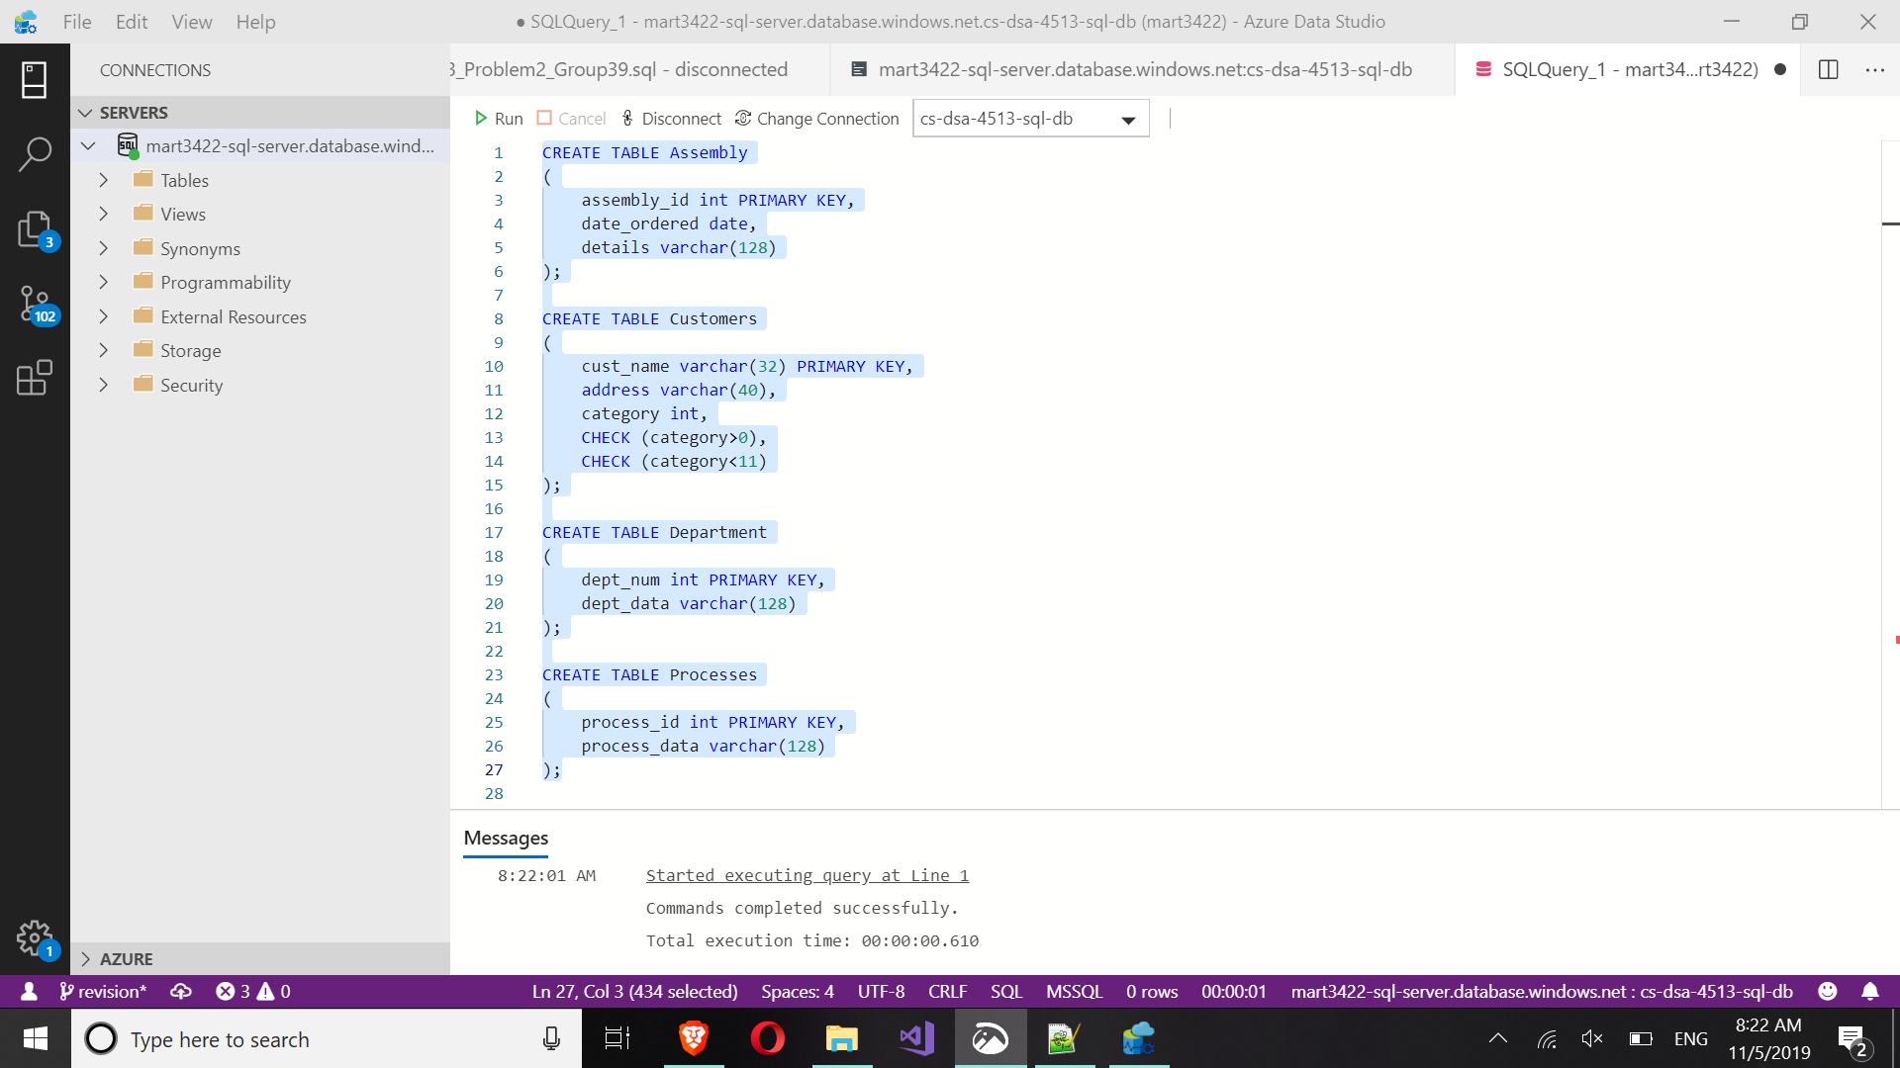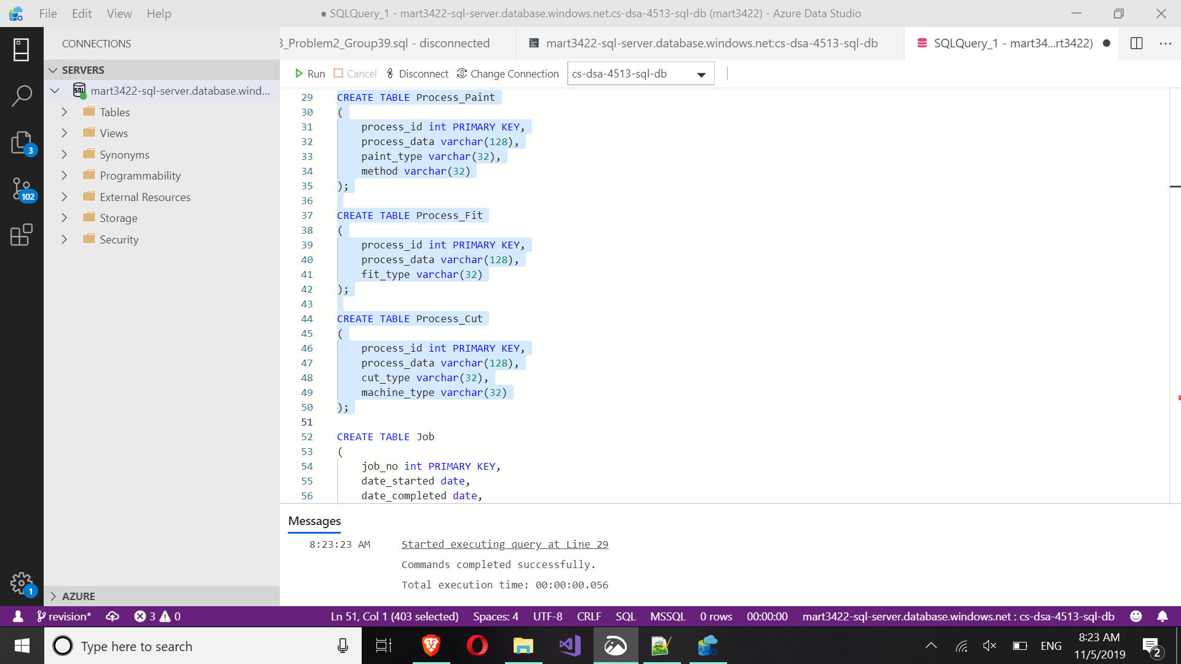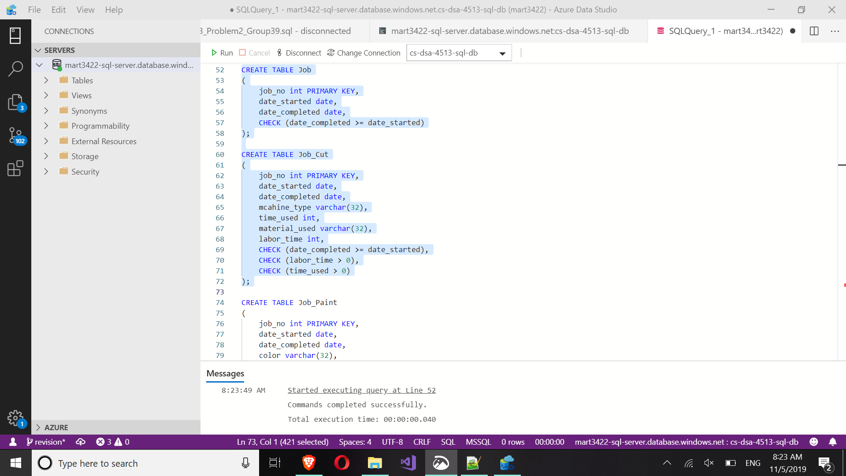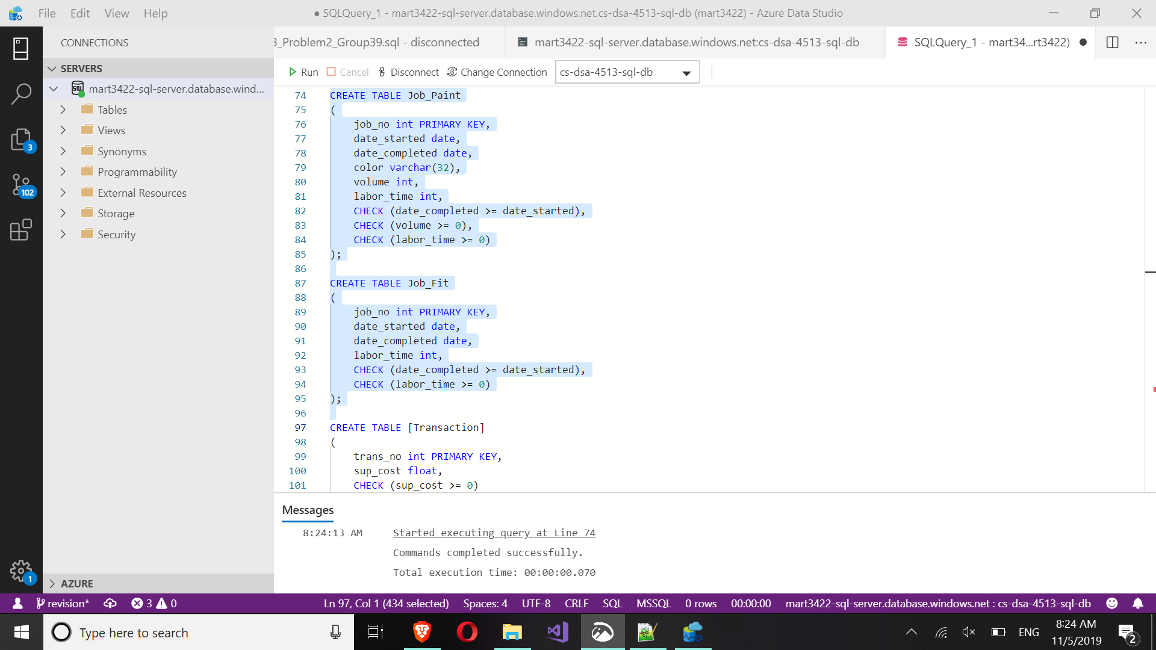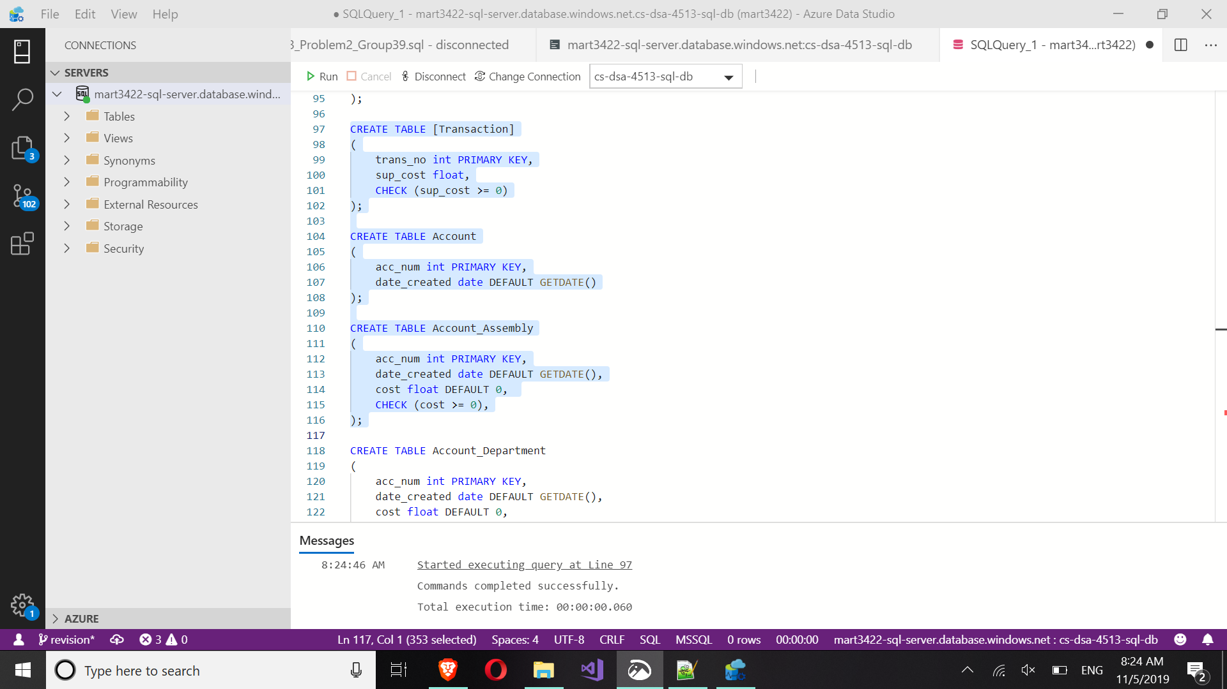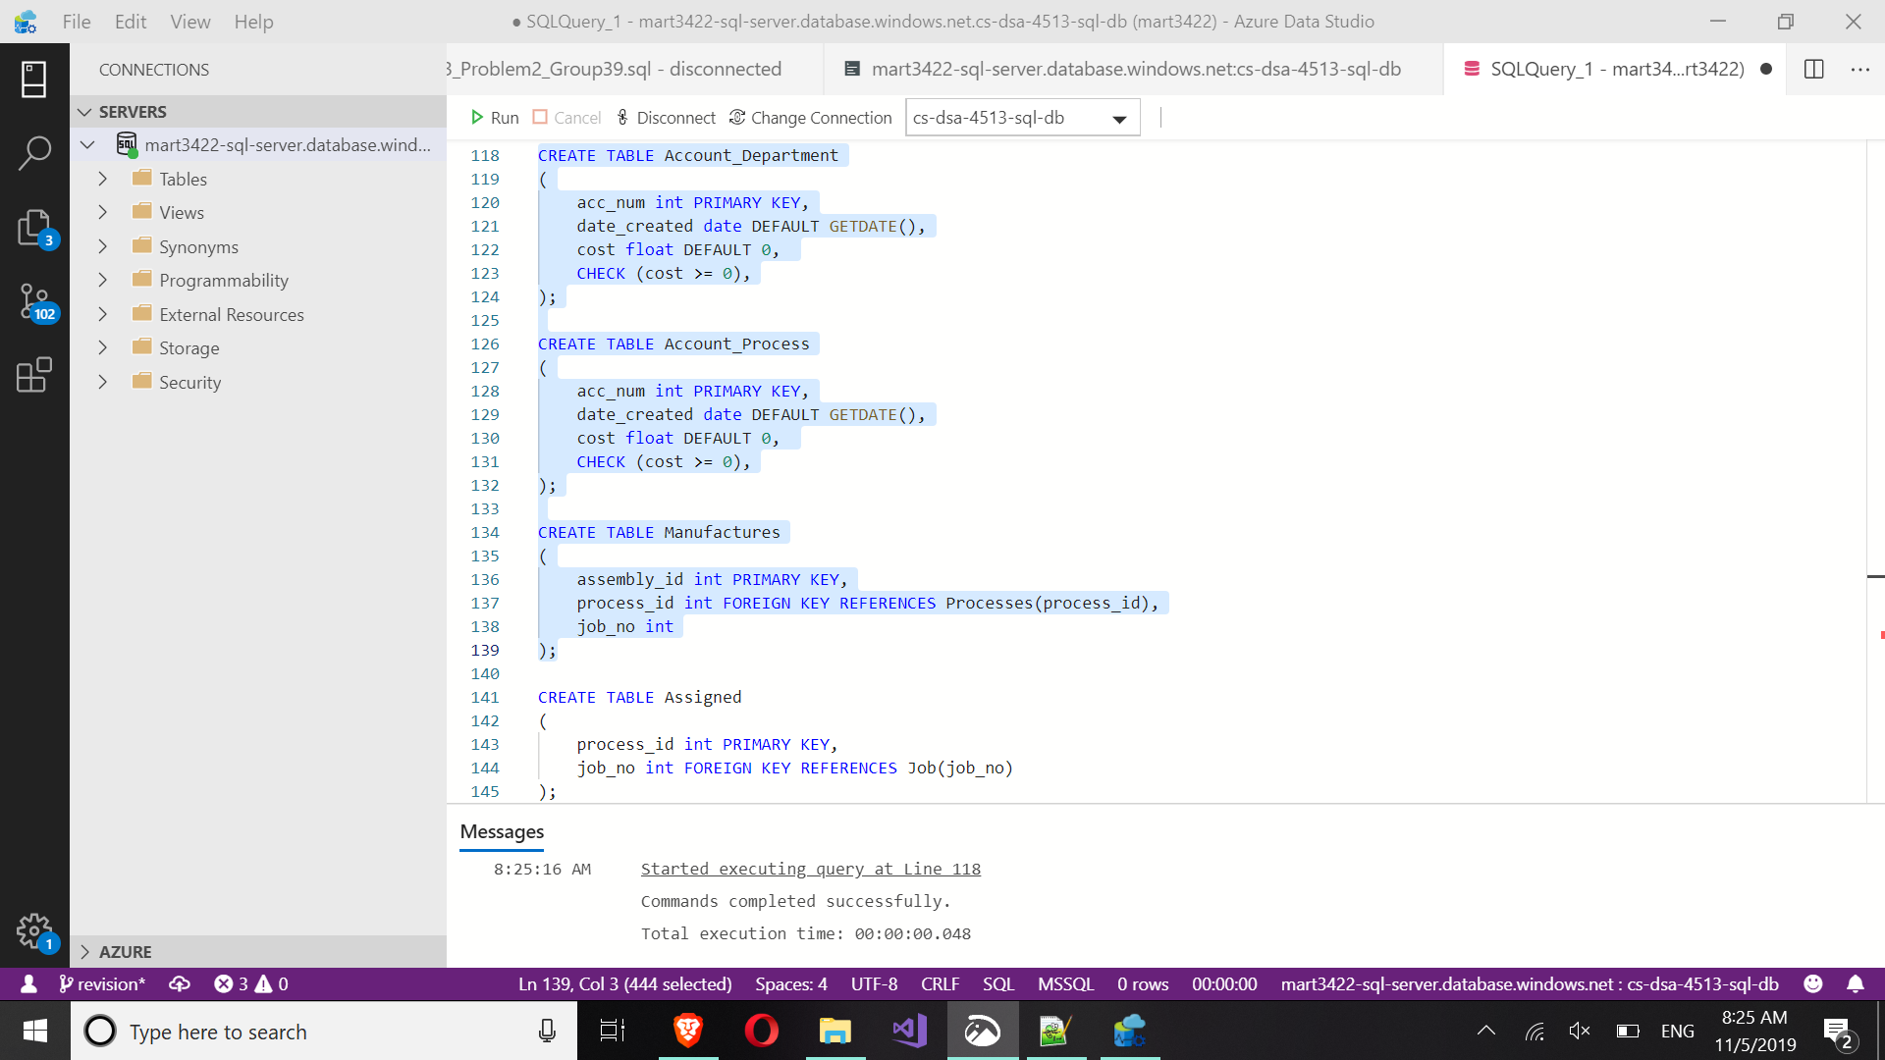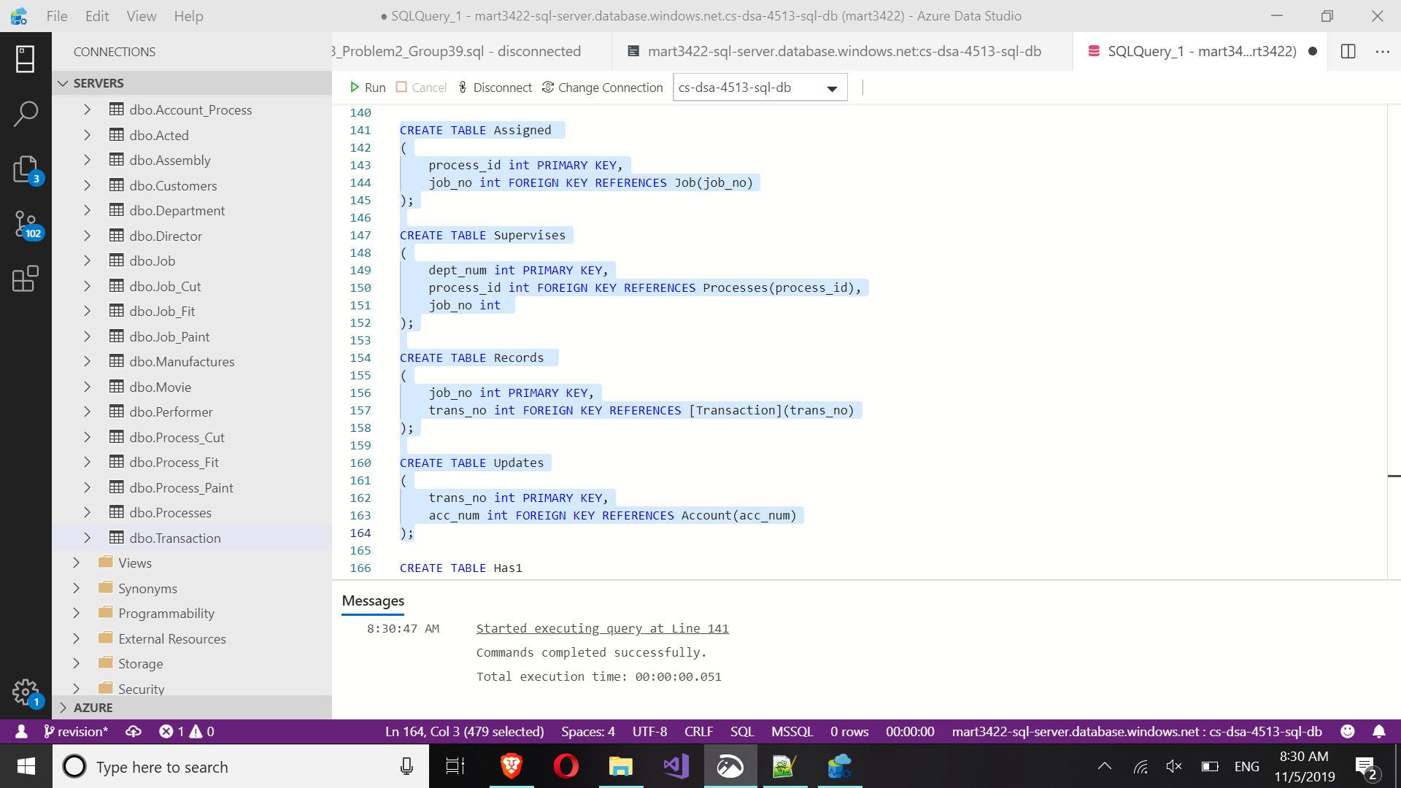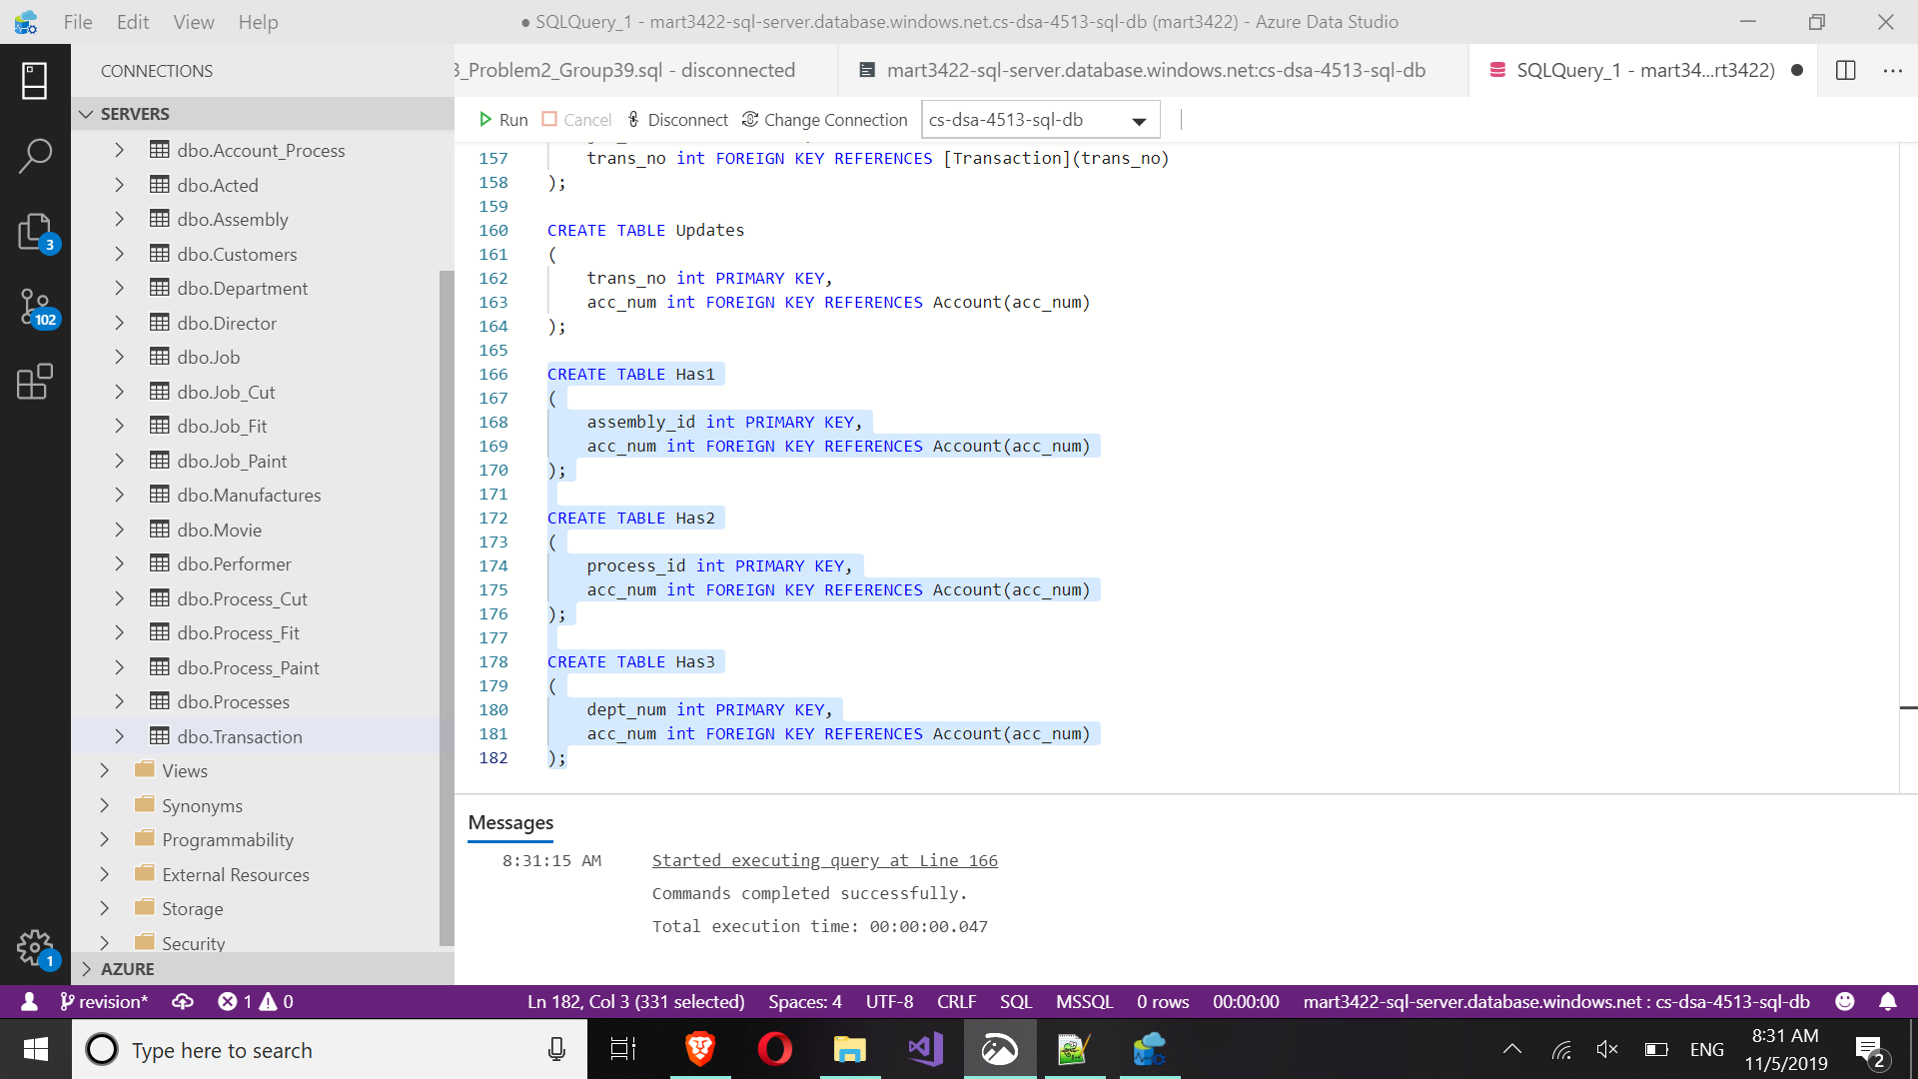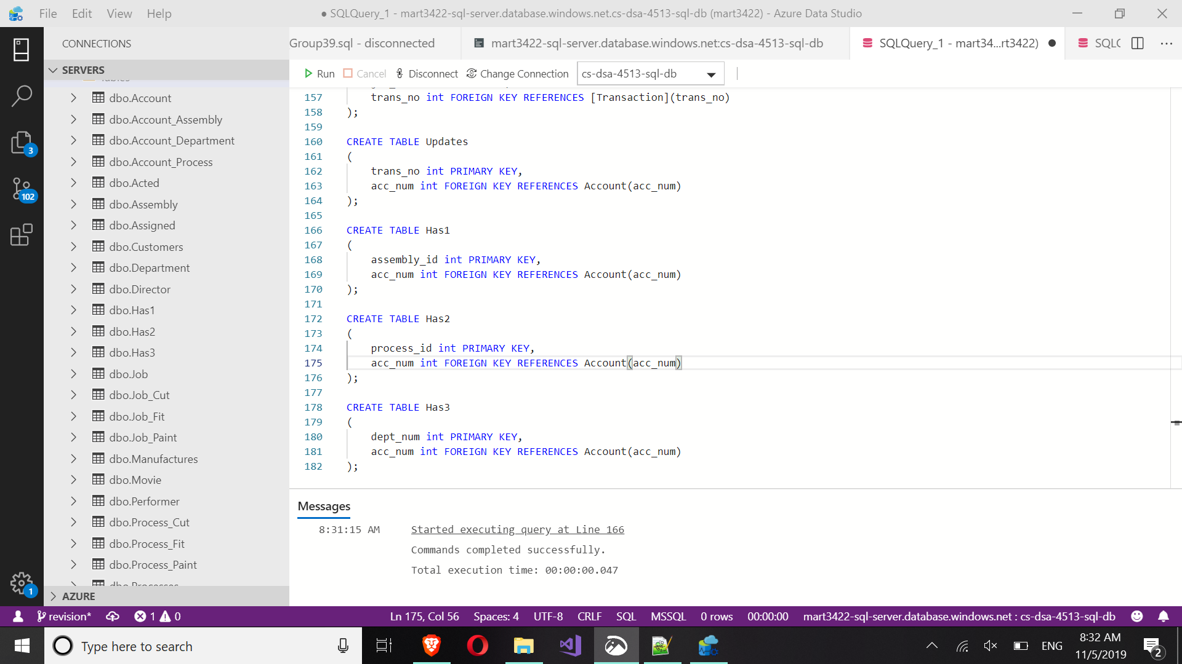

**5) Java Application**

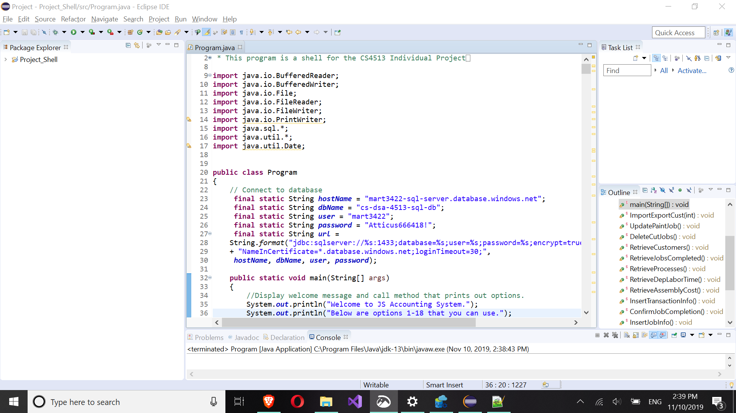

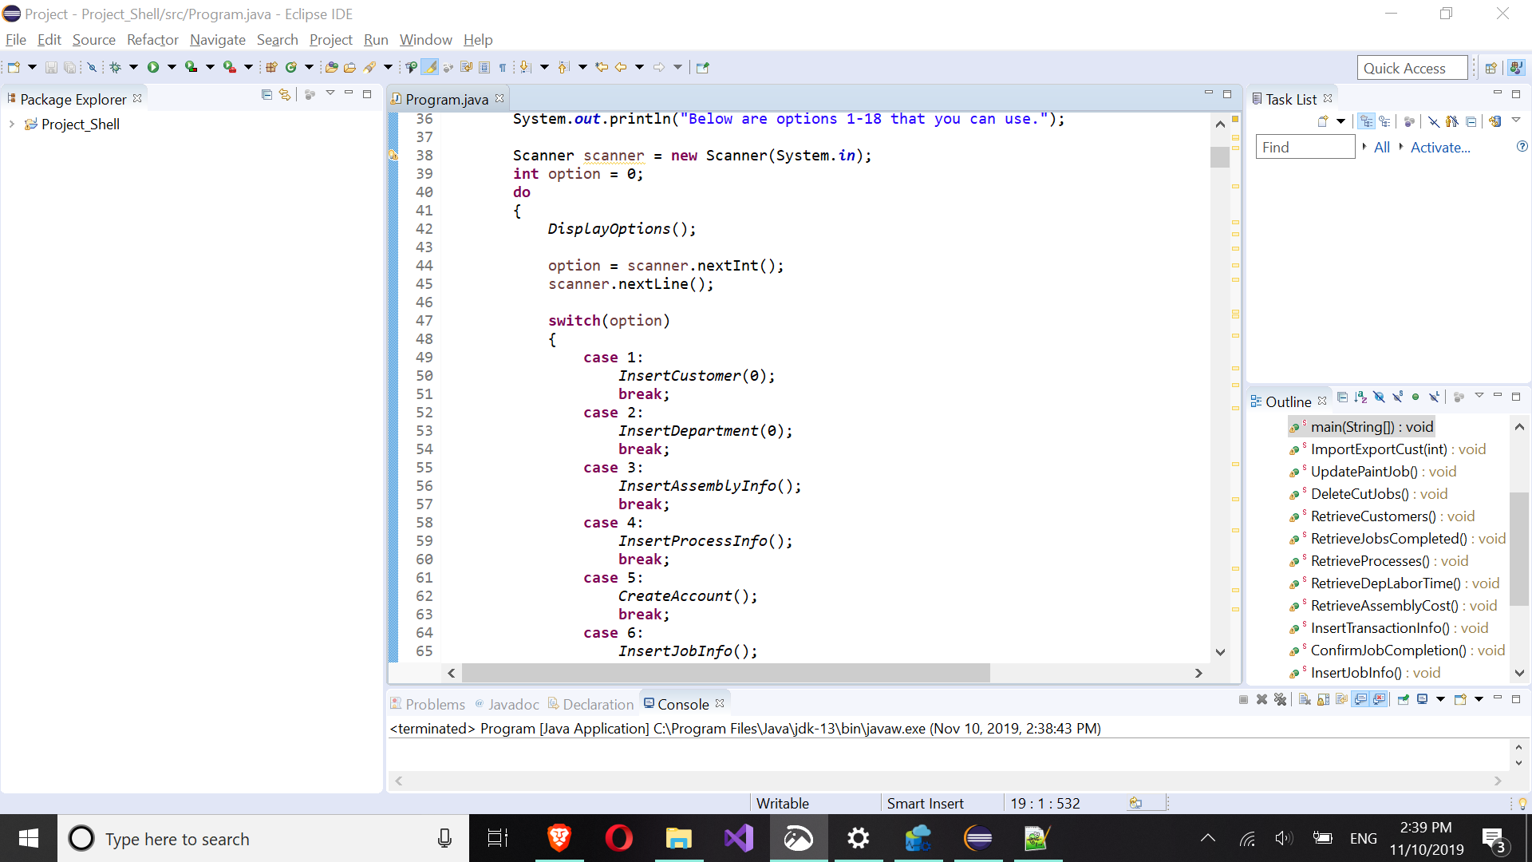

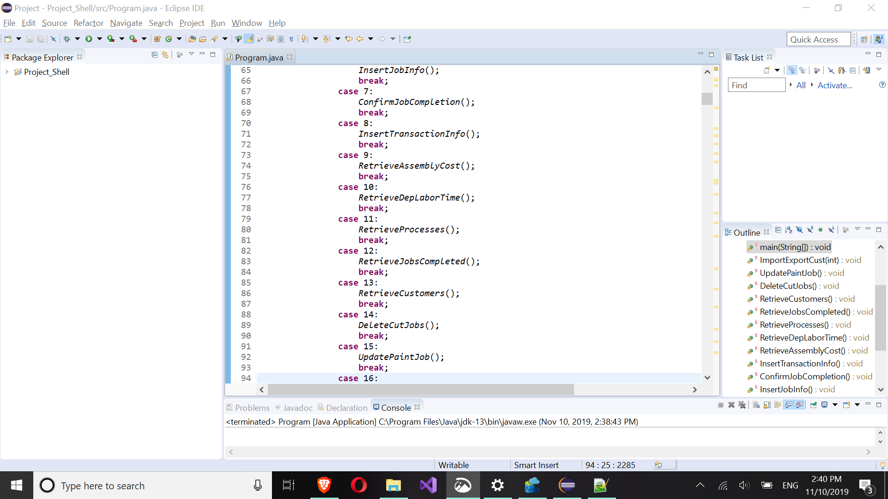

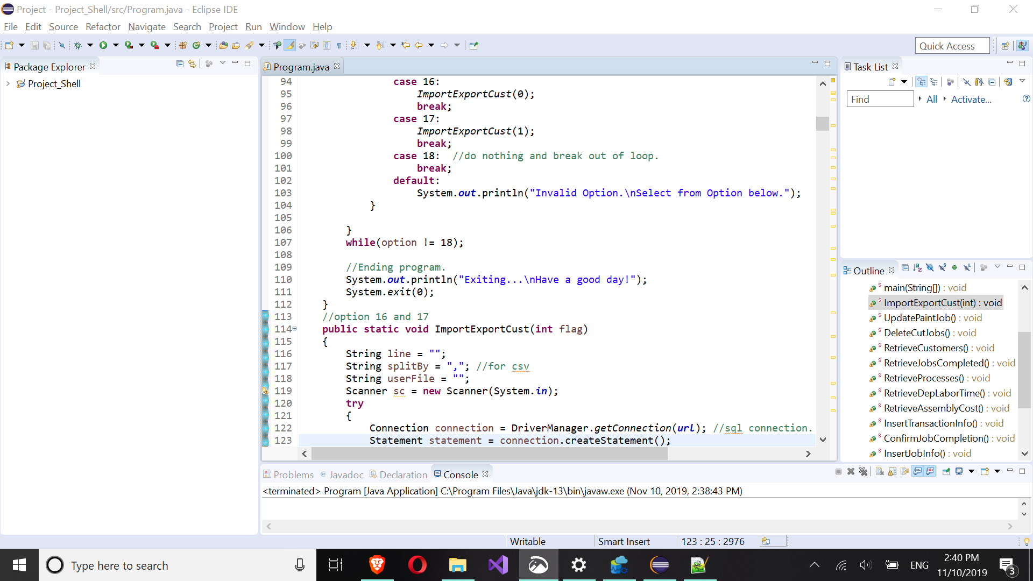

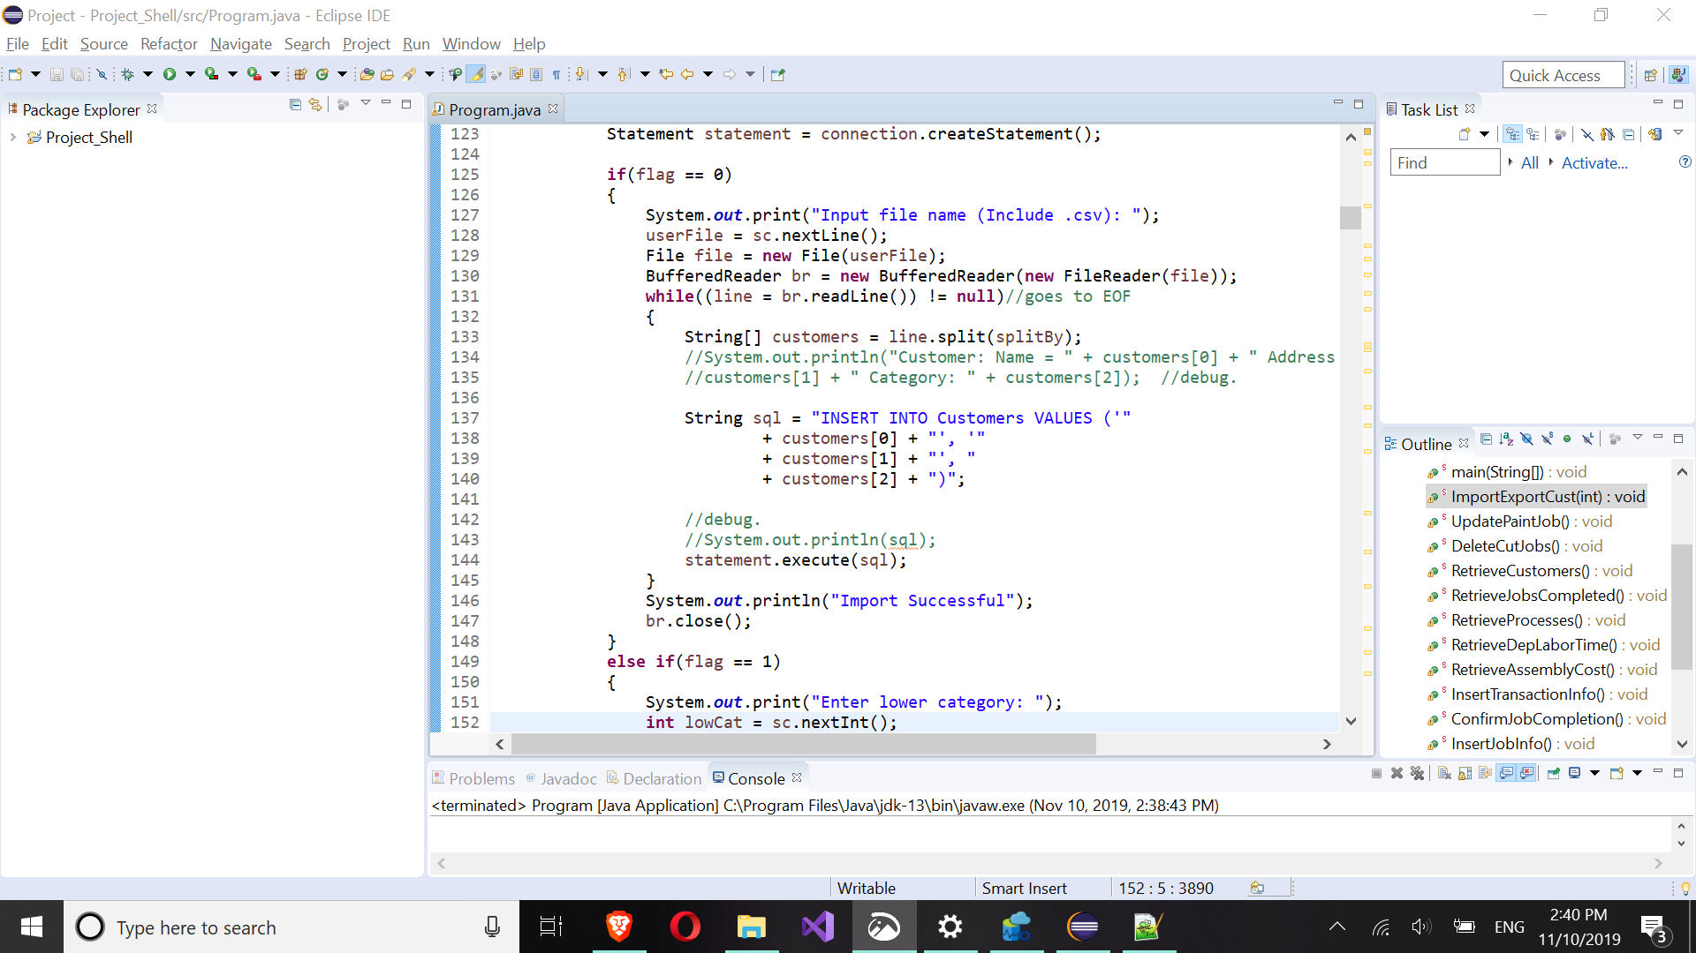

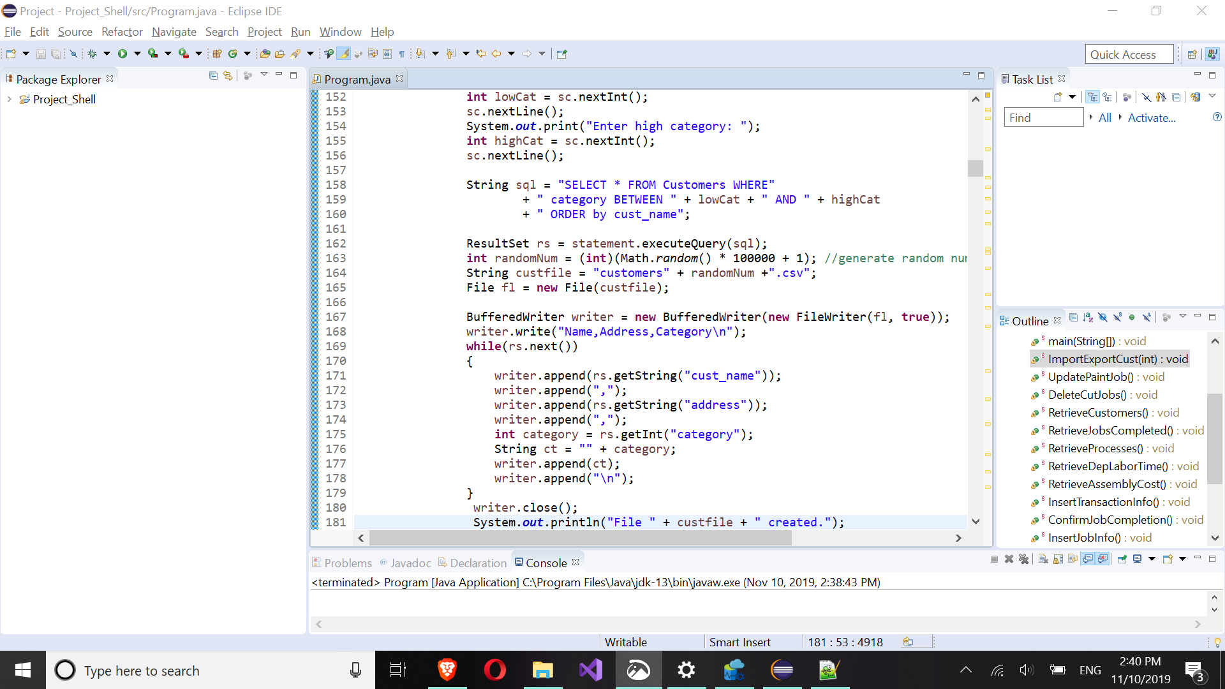

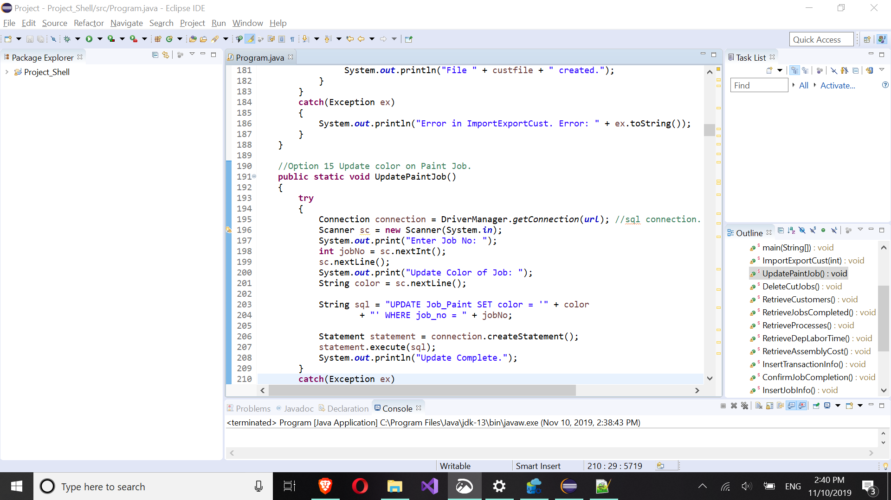

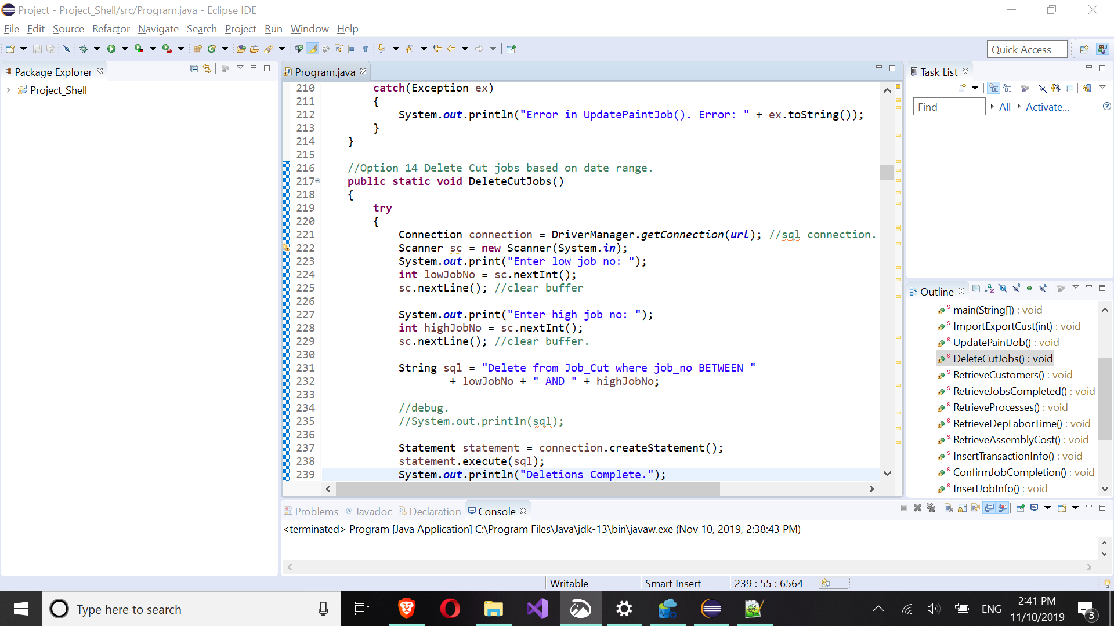

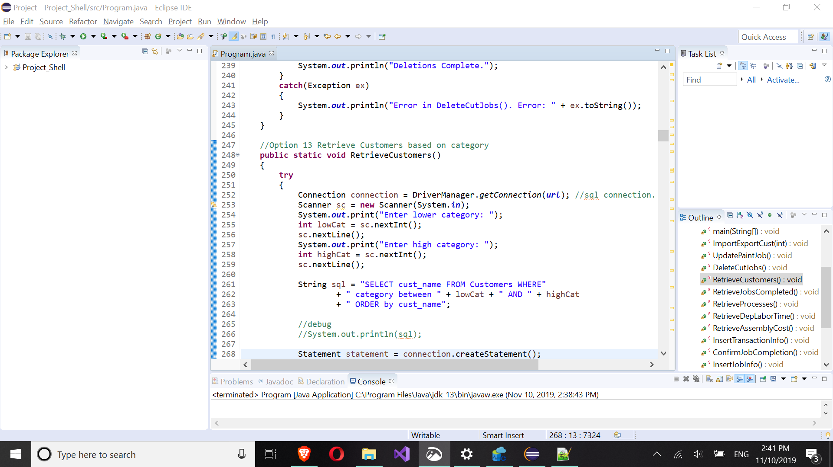

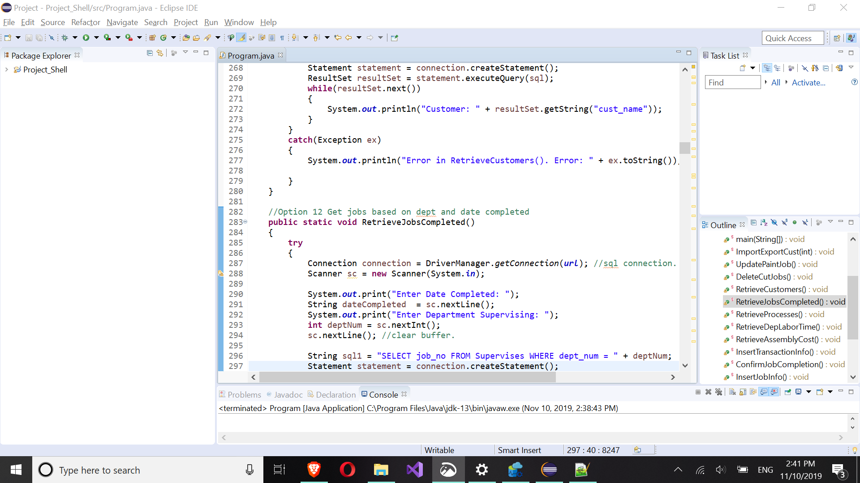

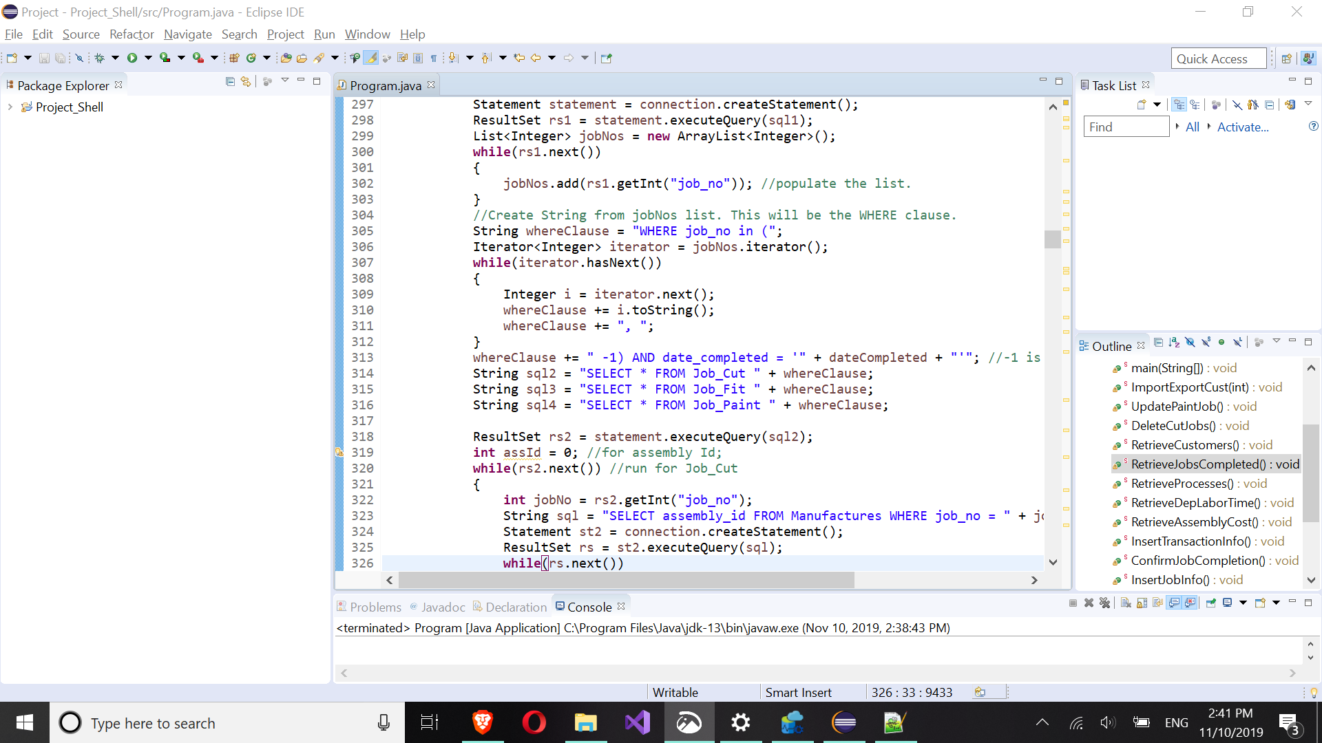

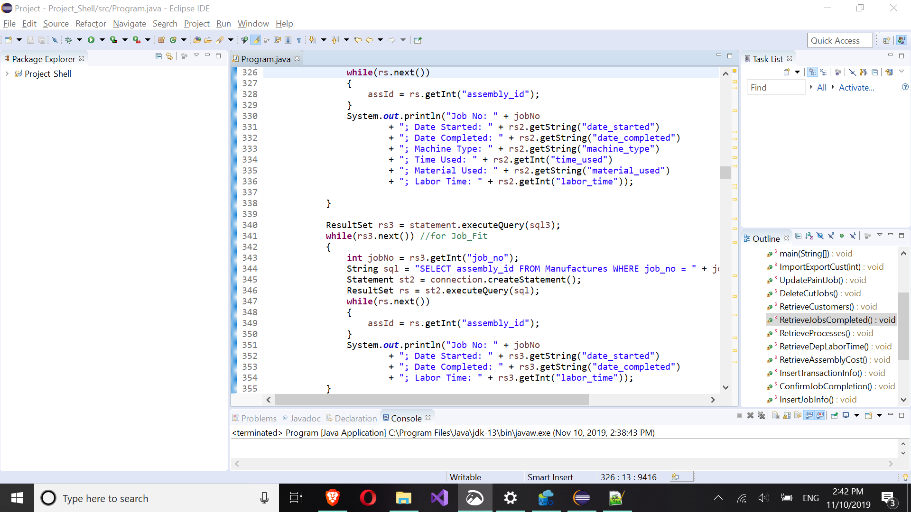

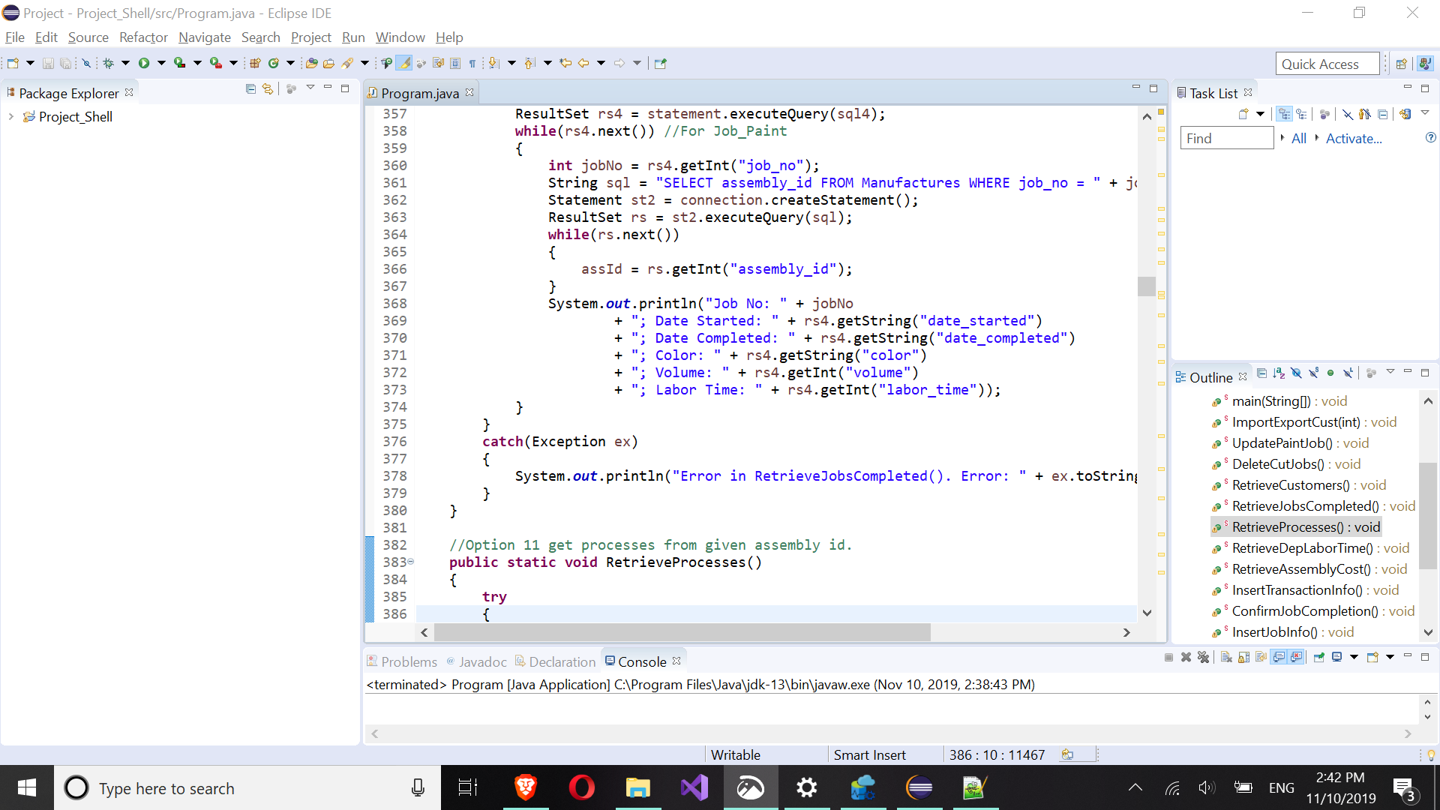

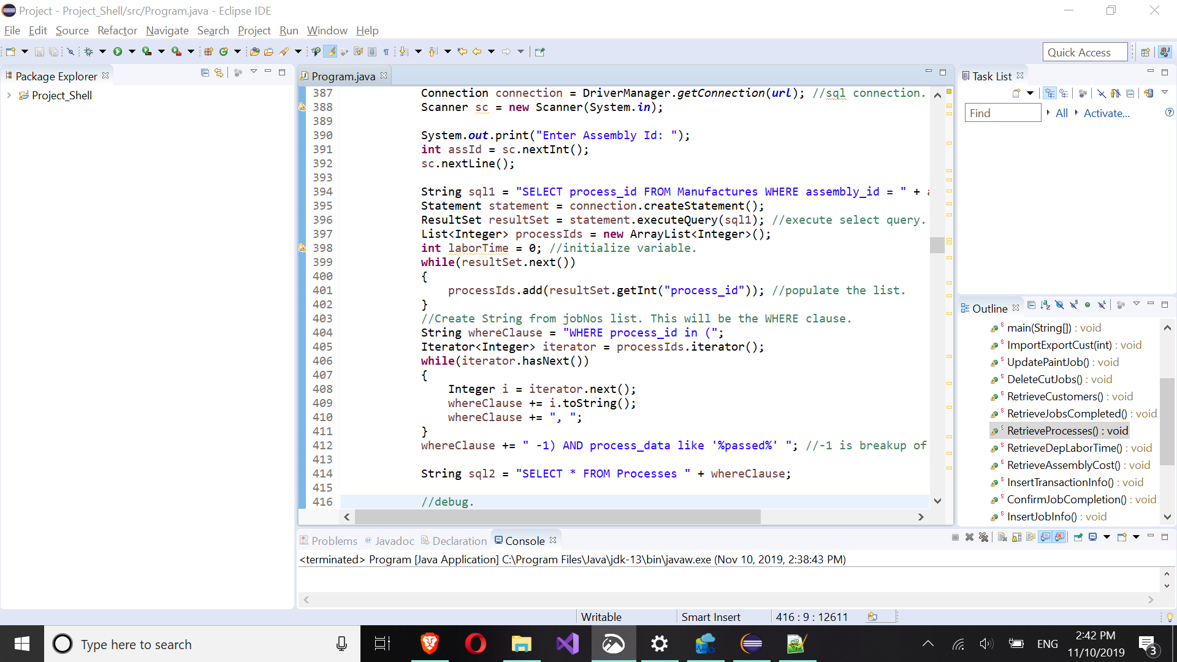

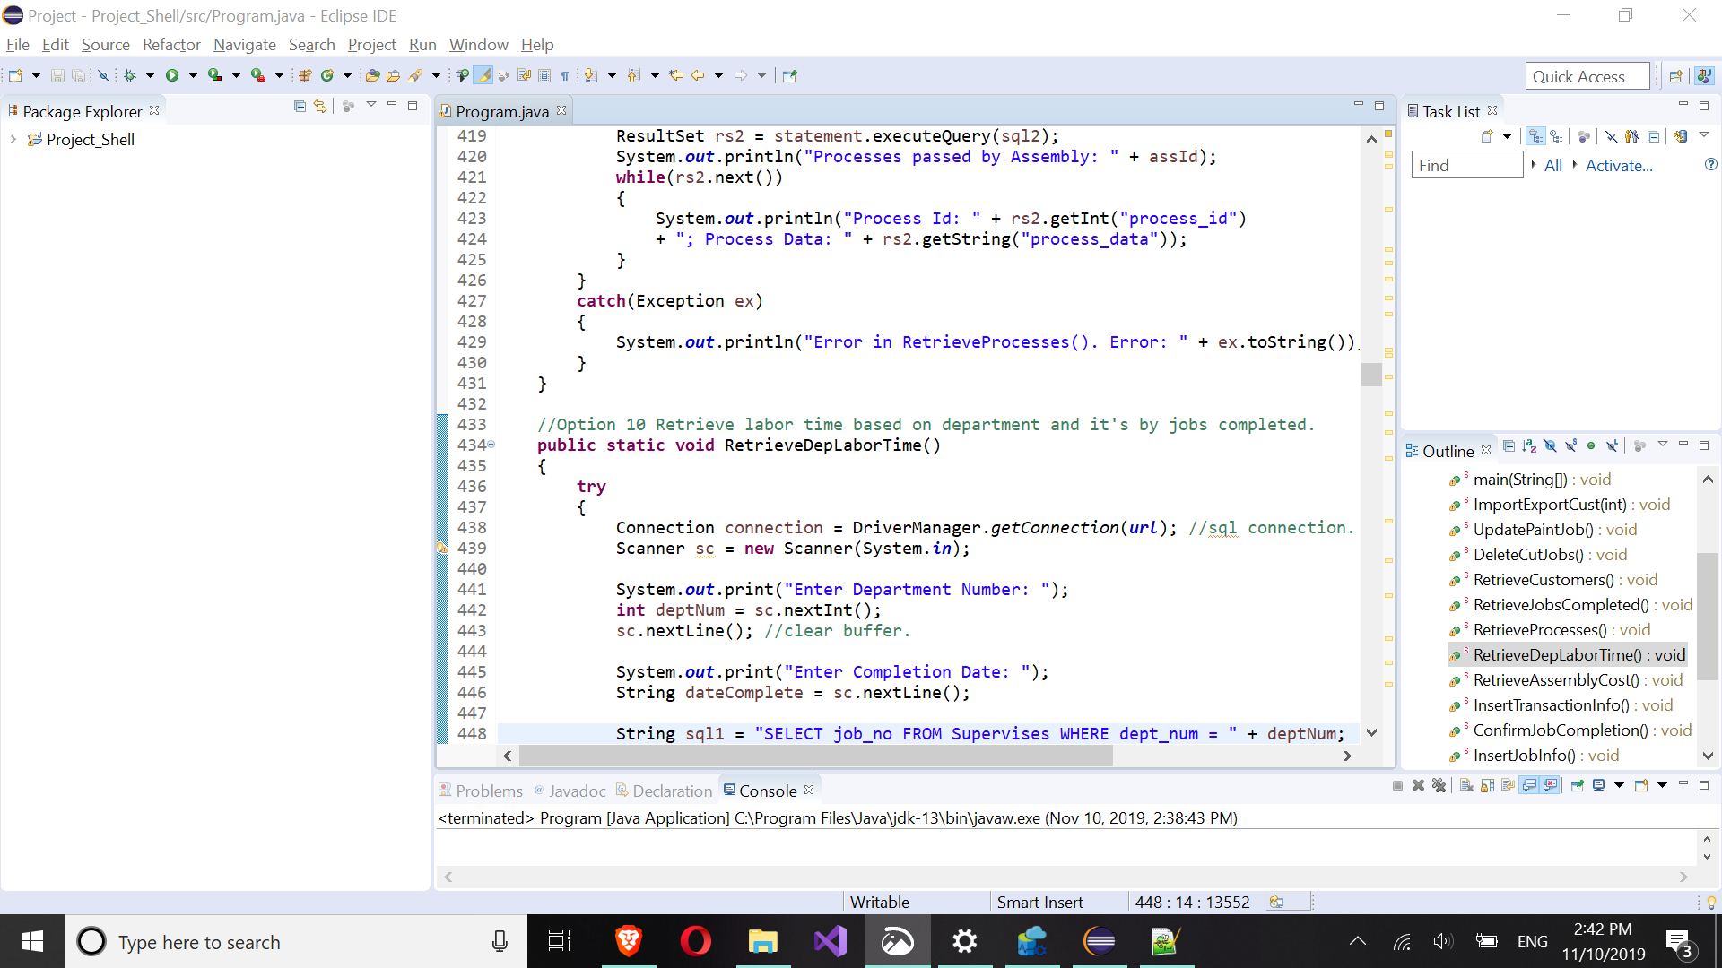

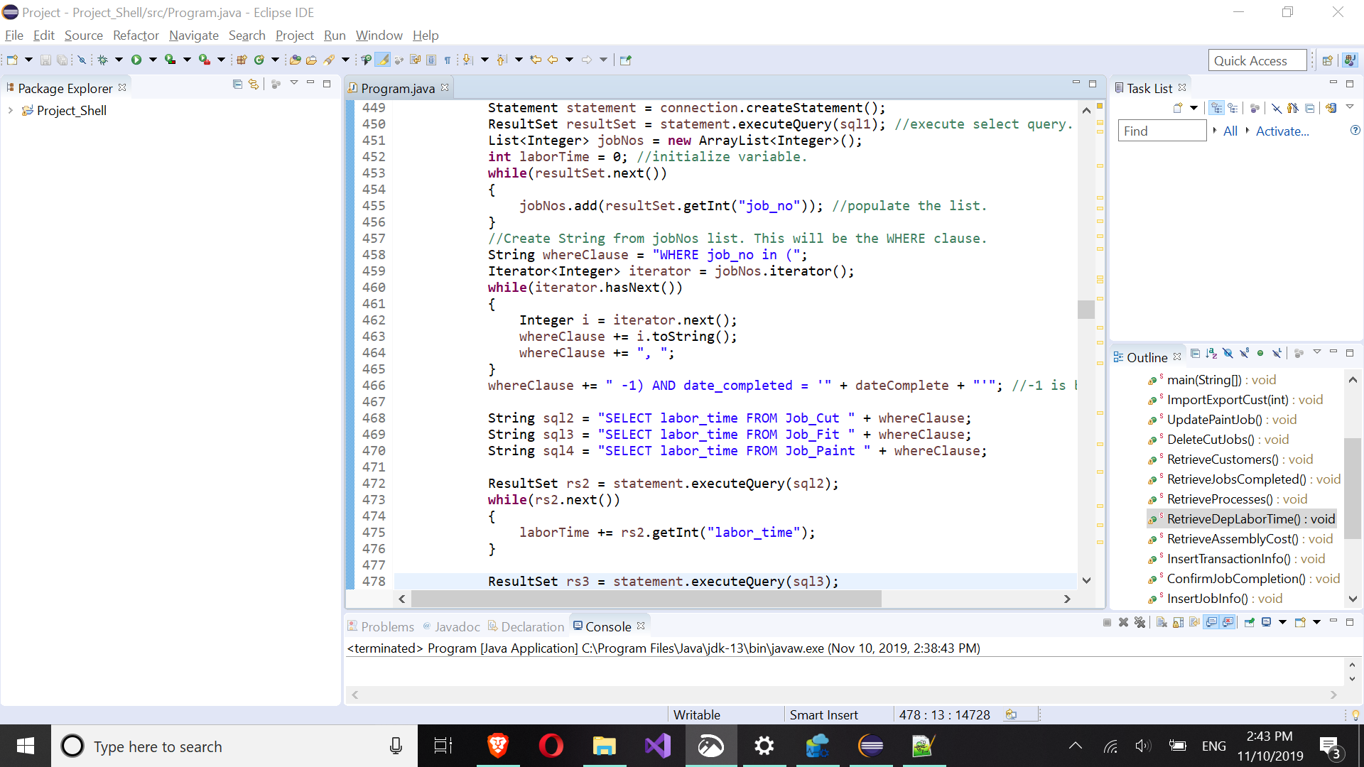

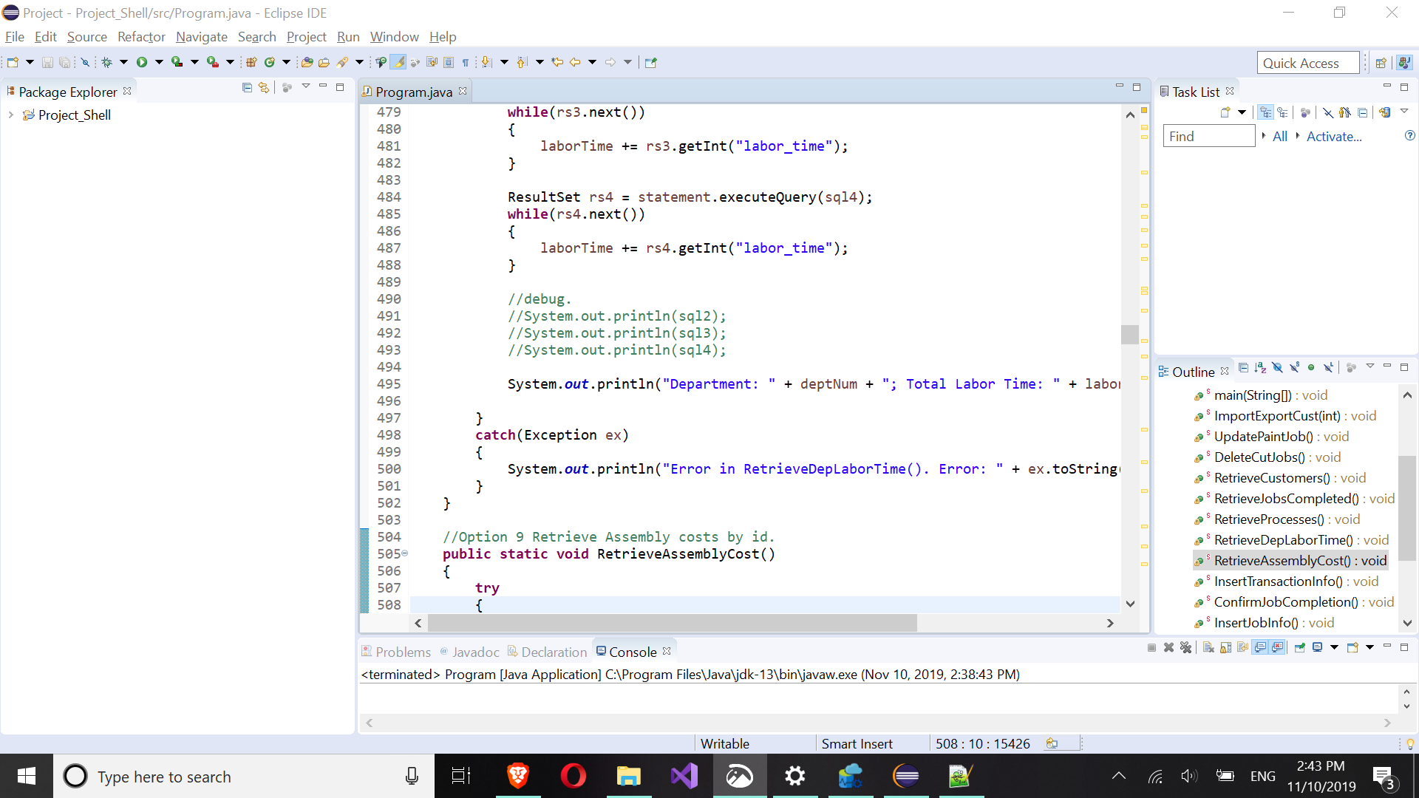

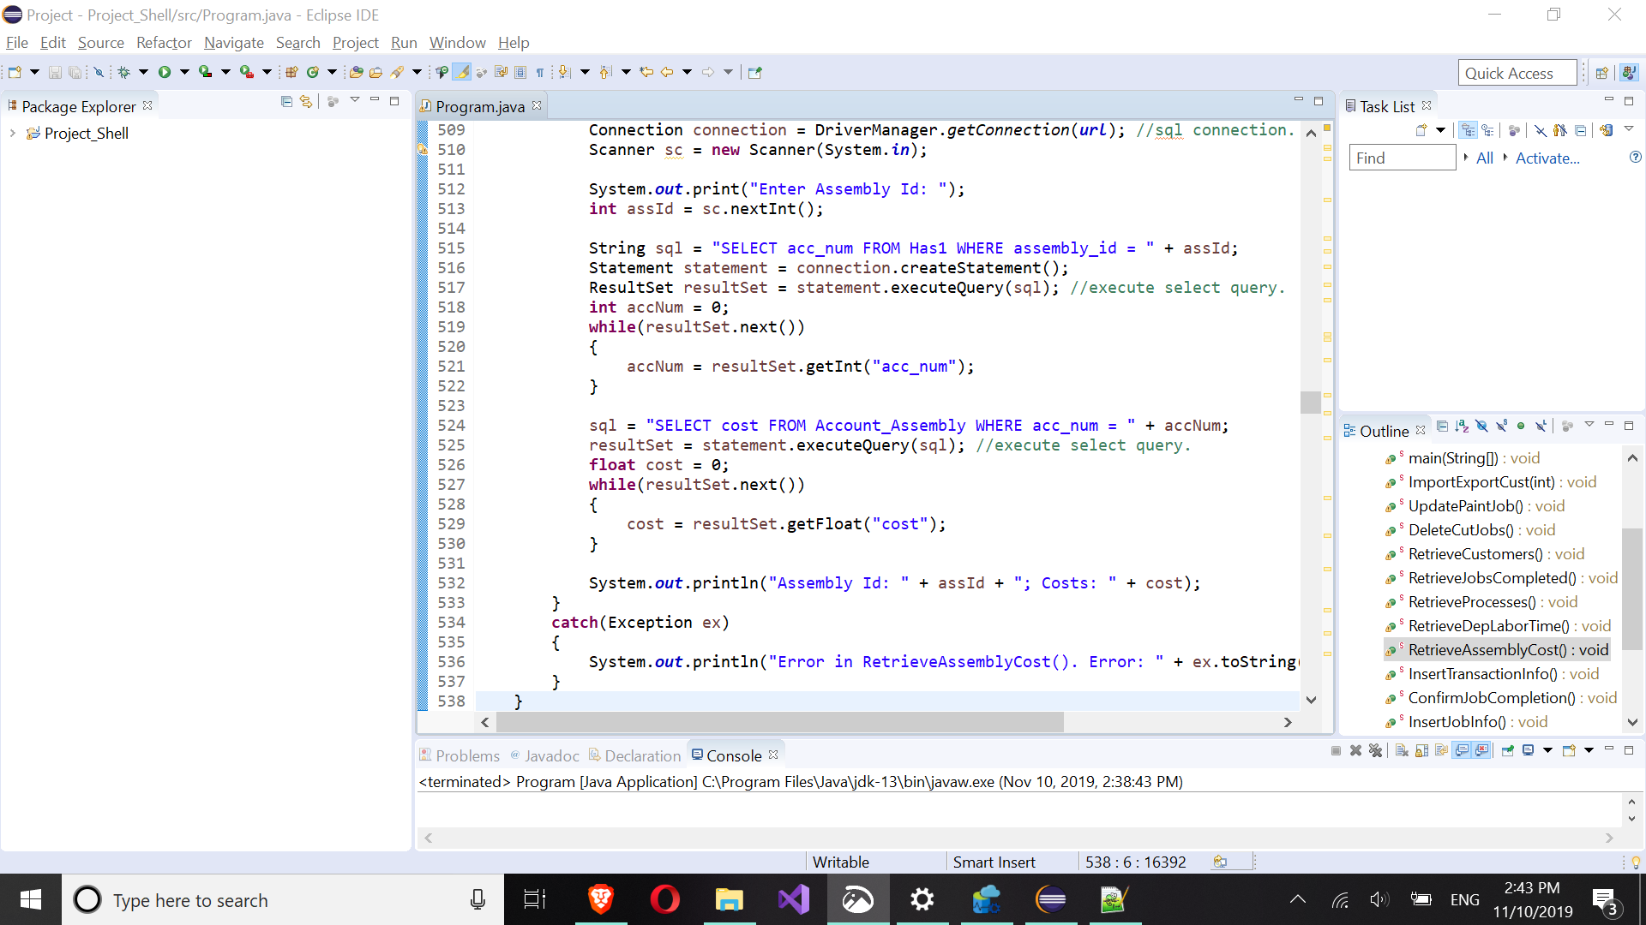

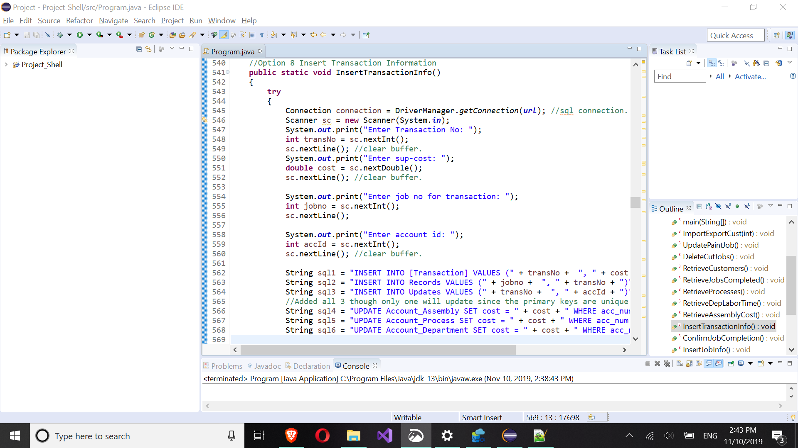

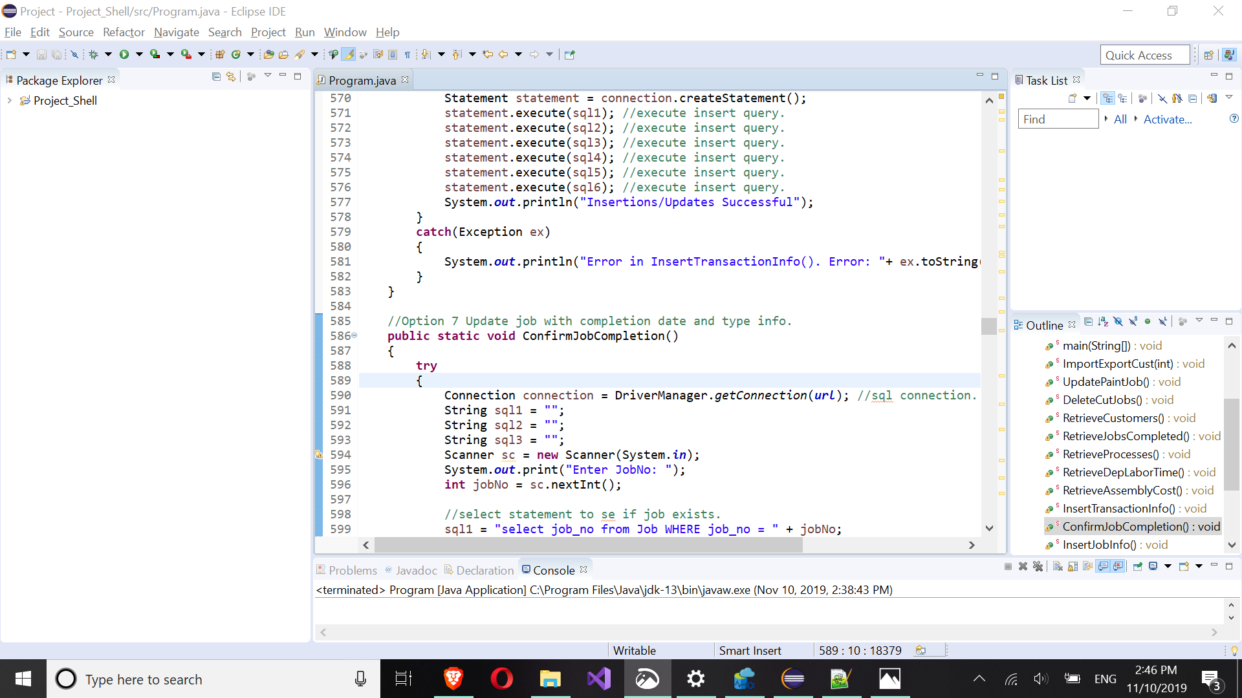

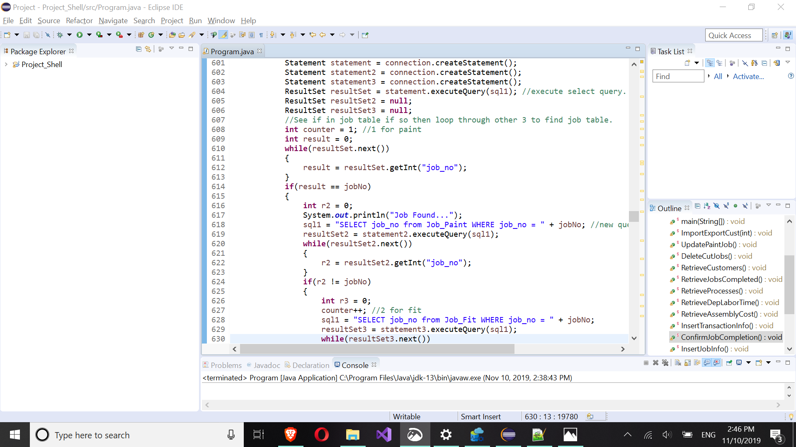

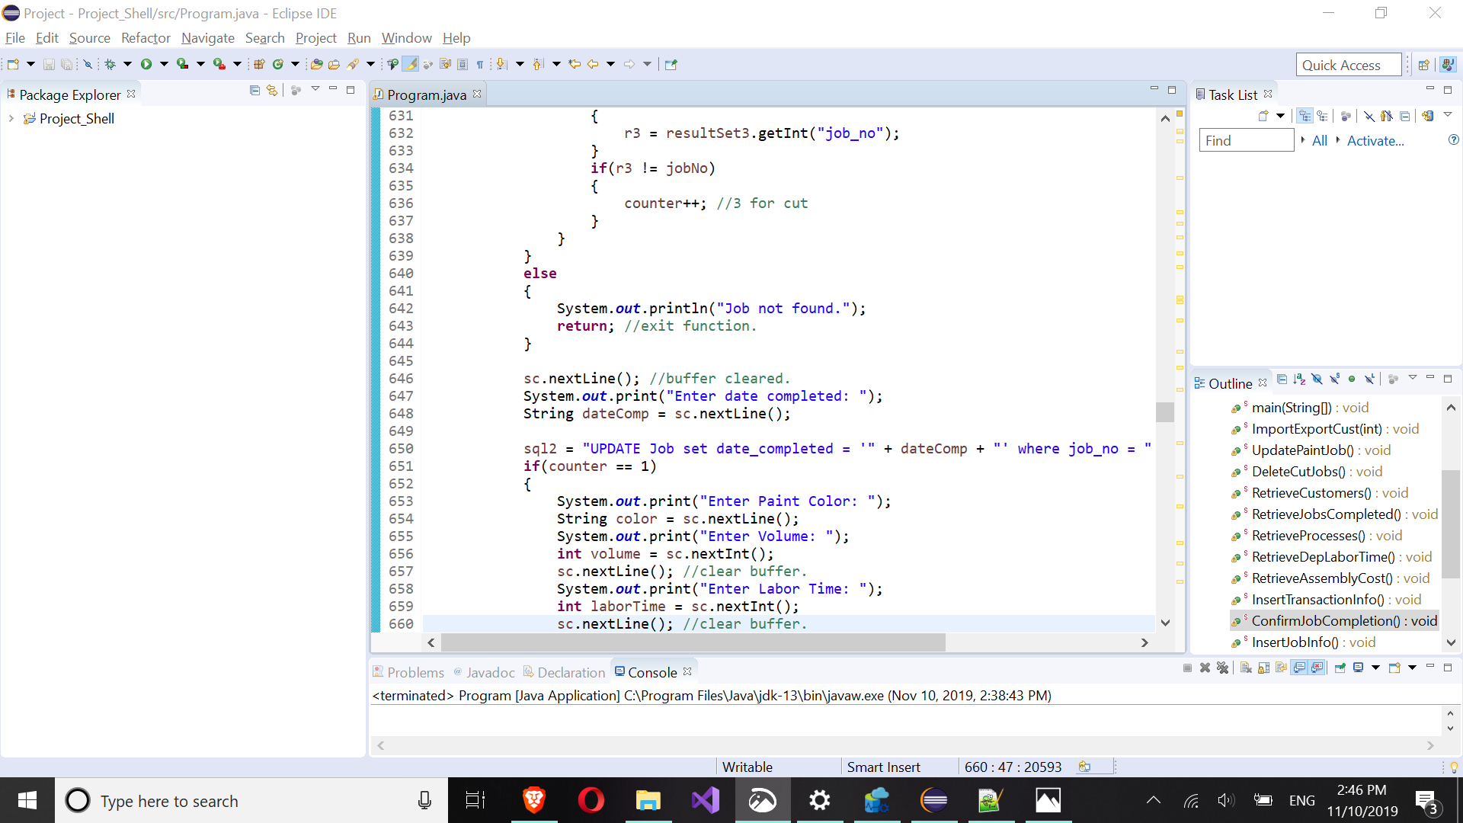

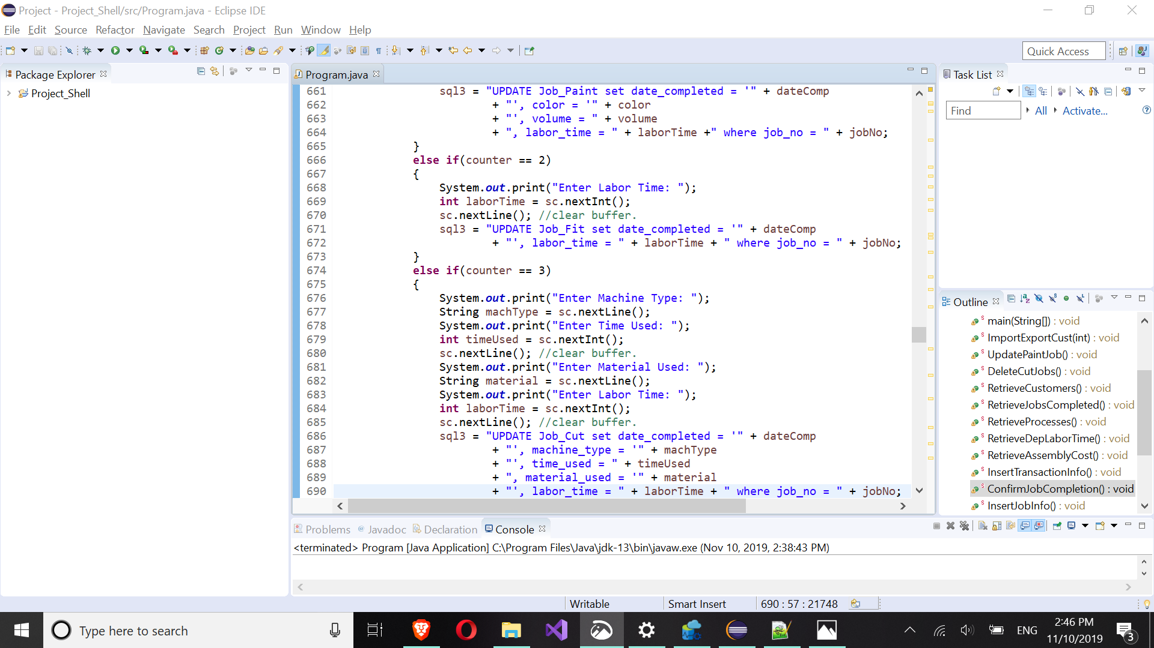

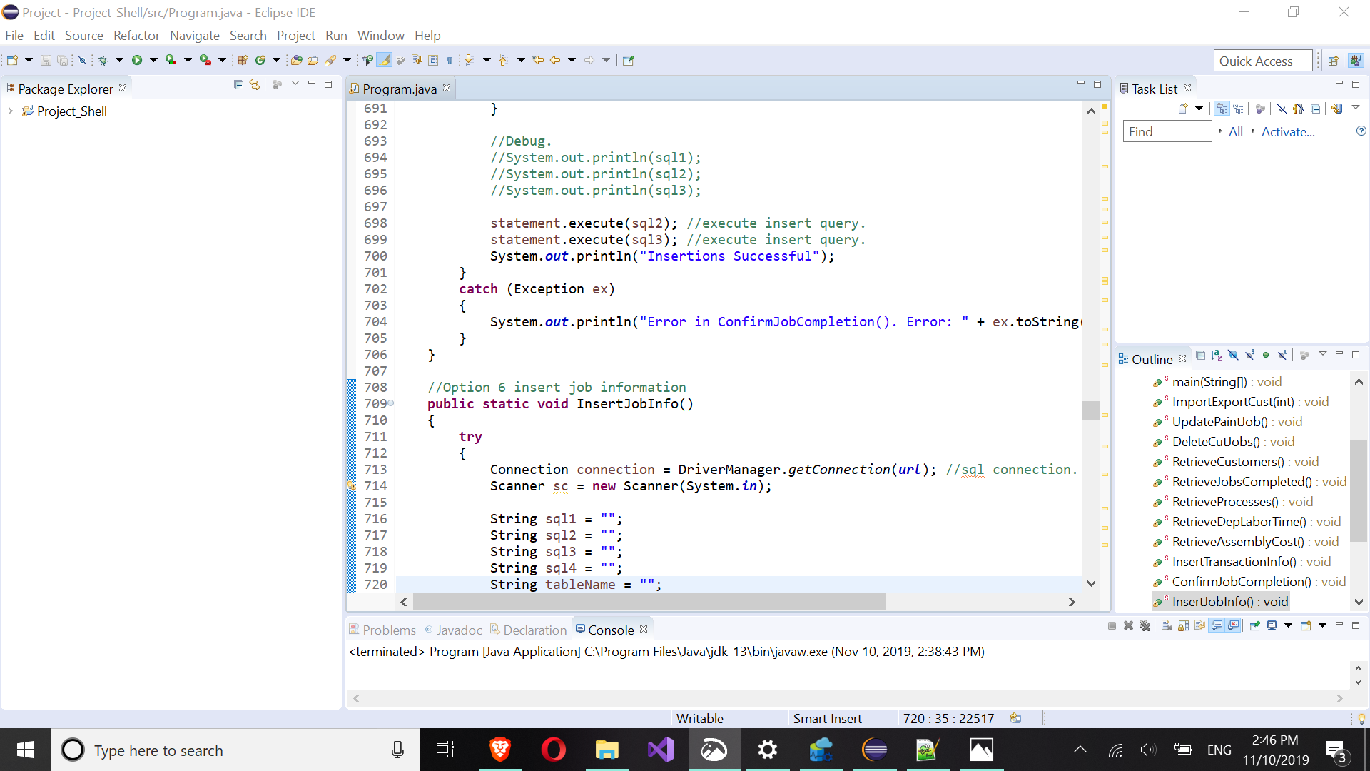

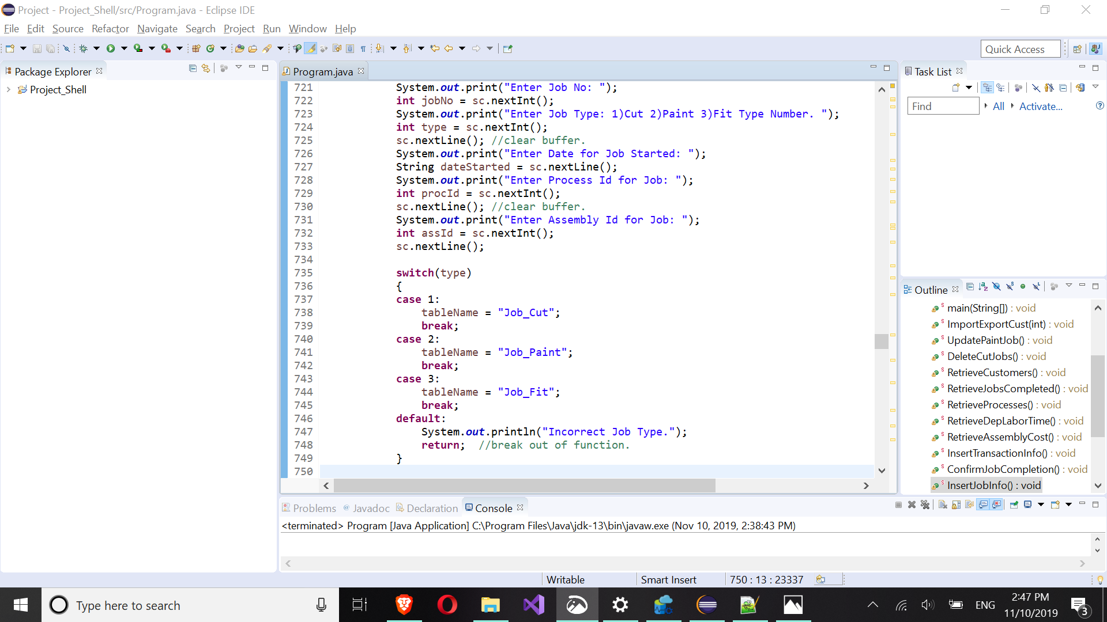

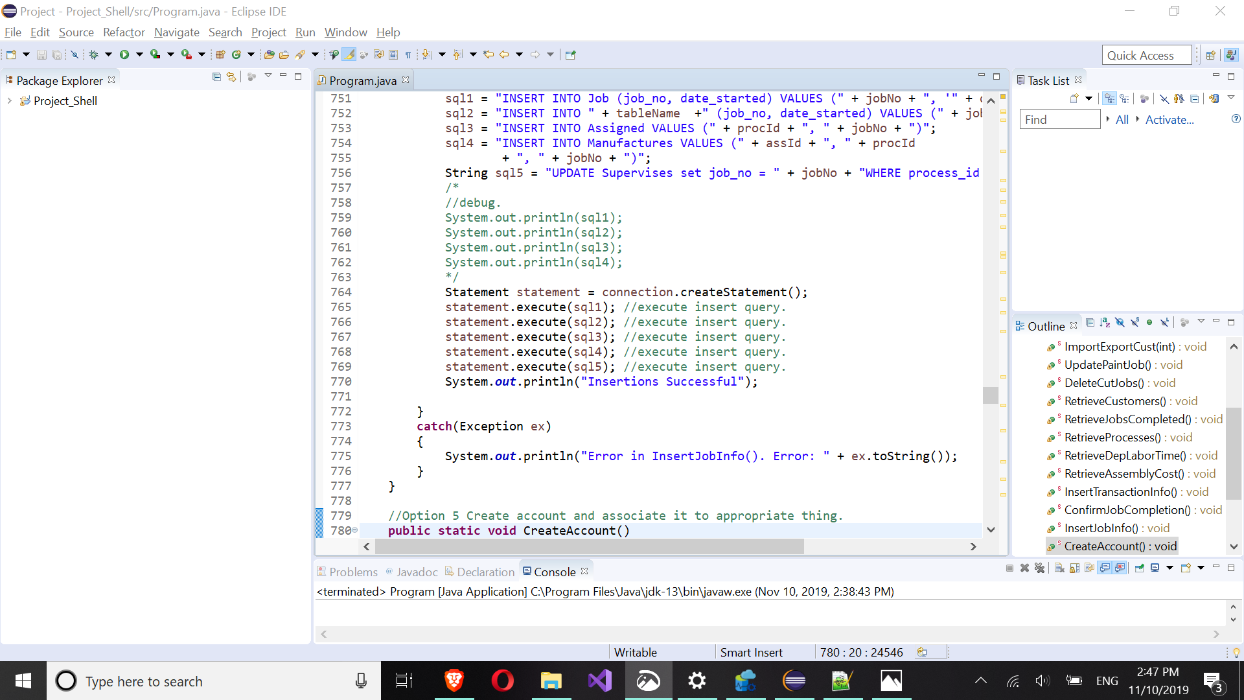

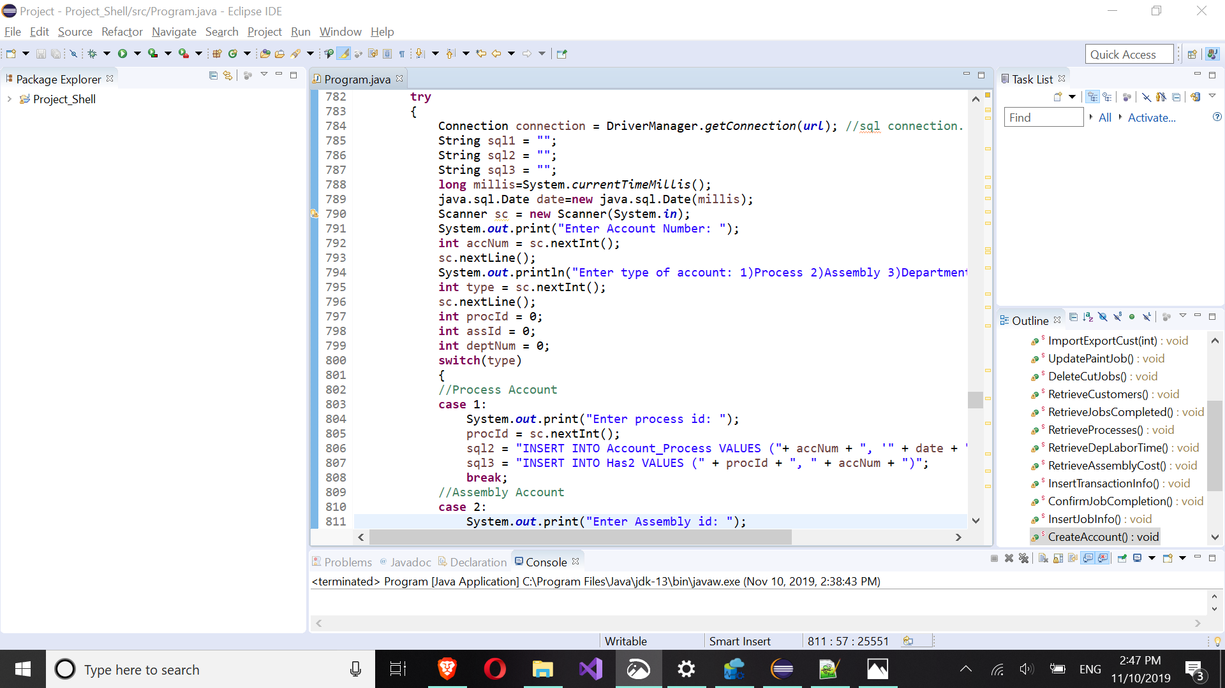

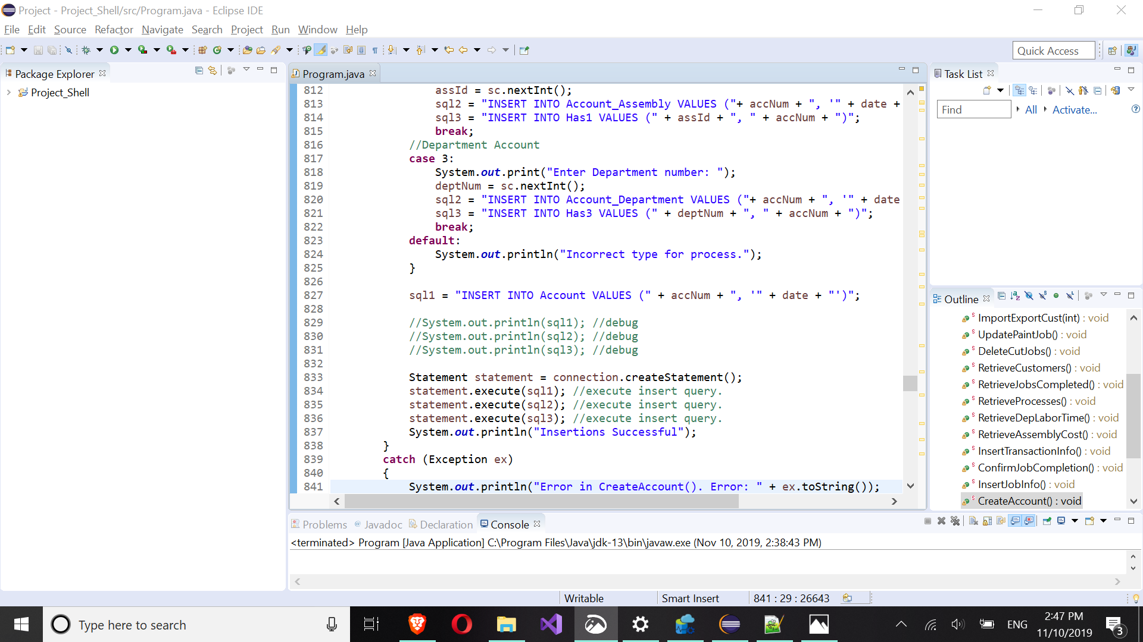

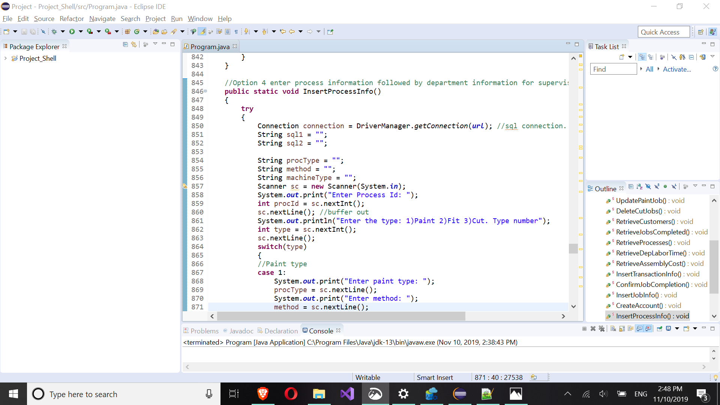

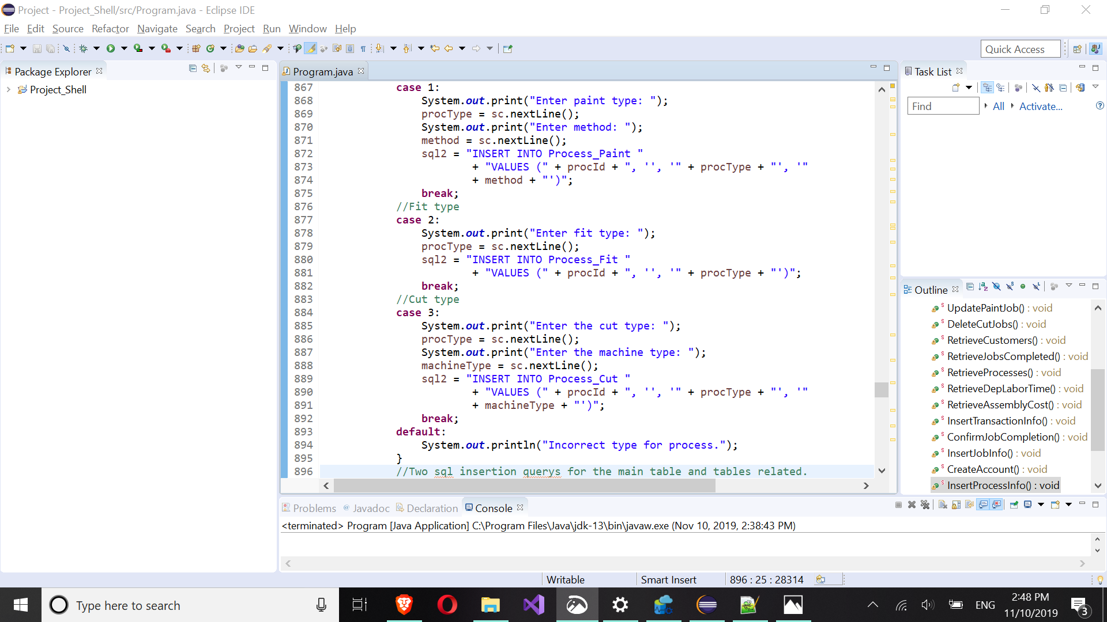

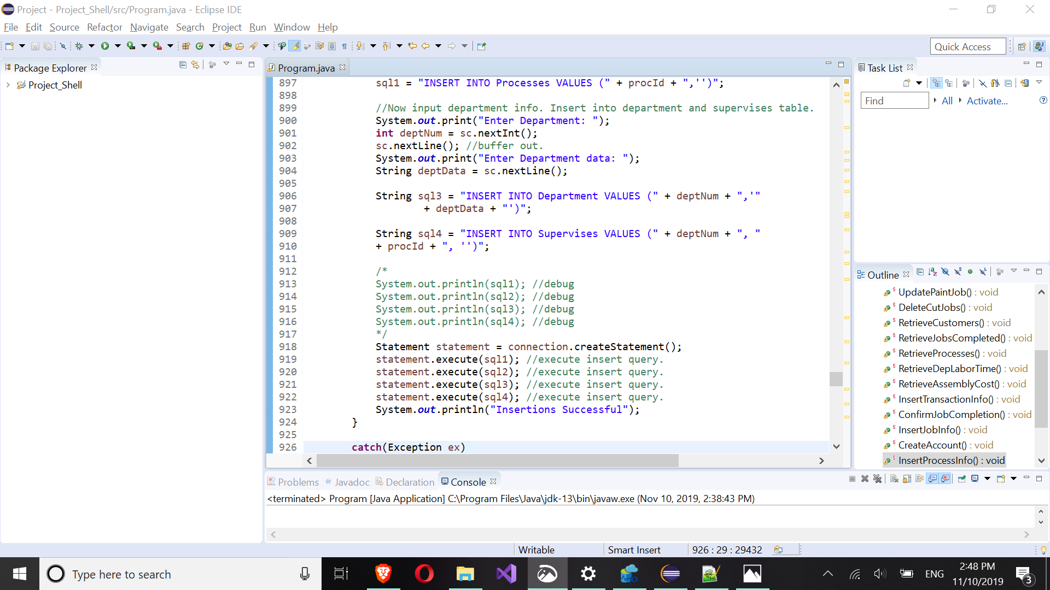

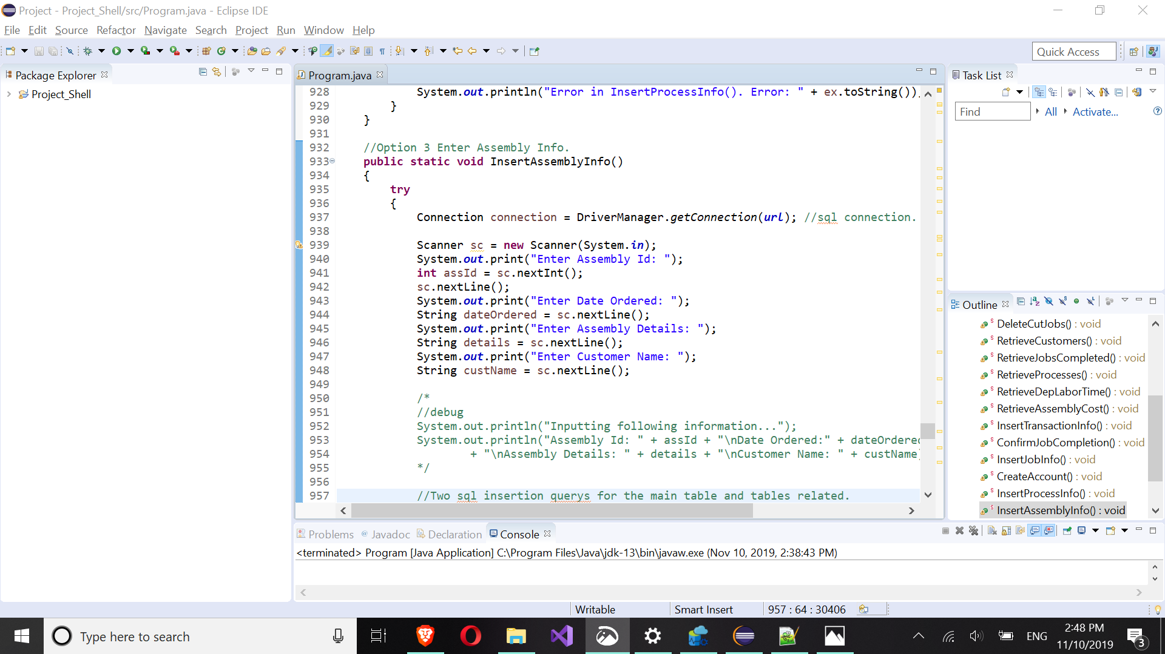

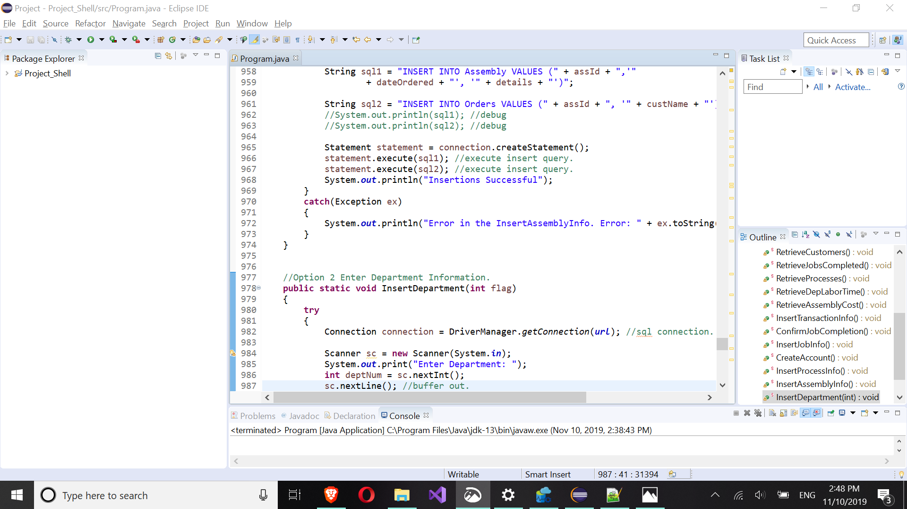

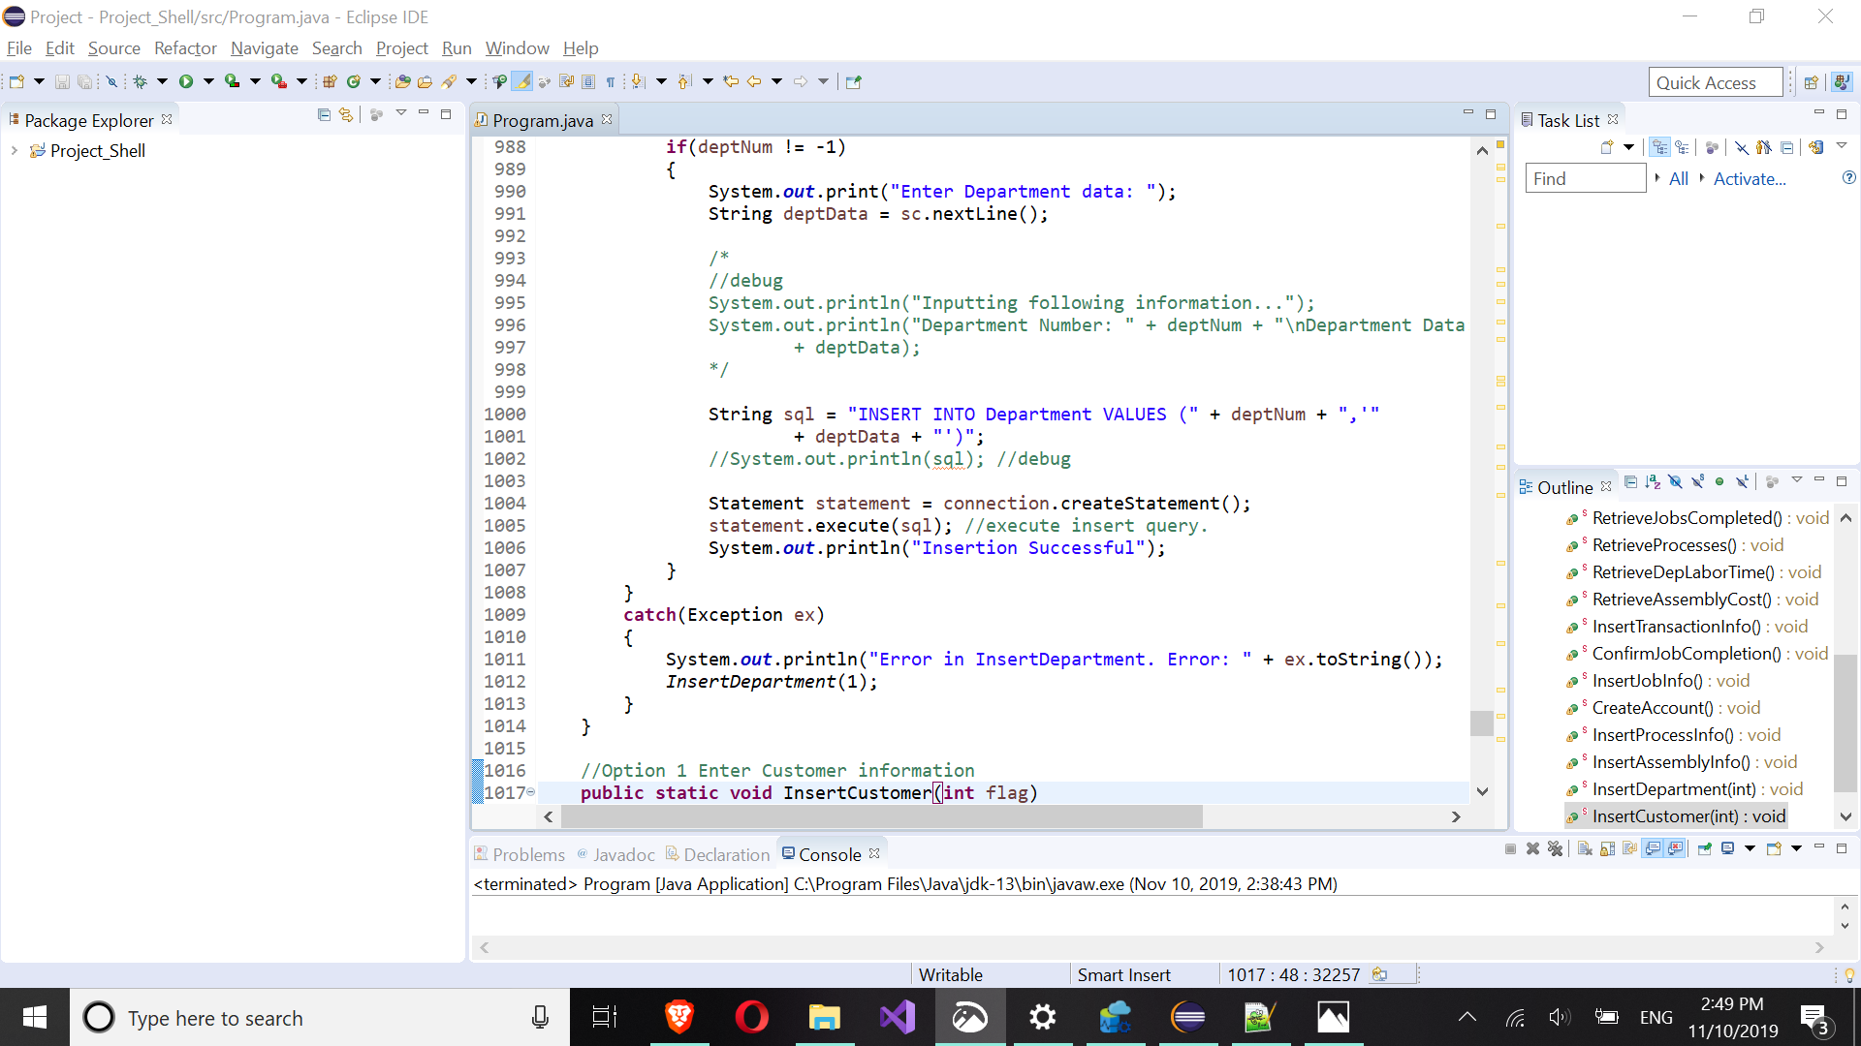

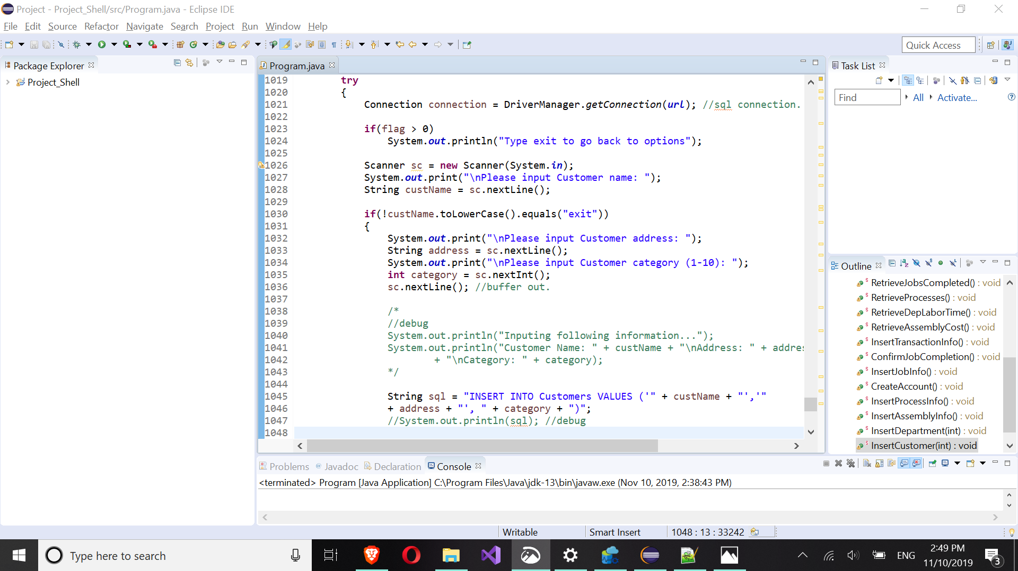

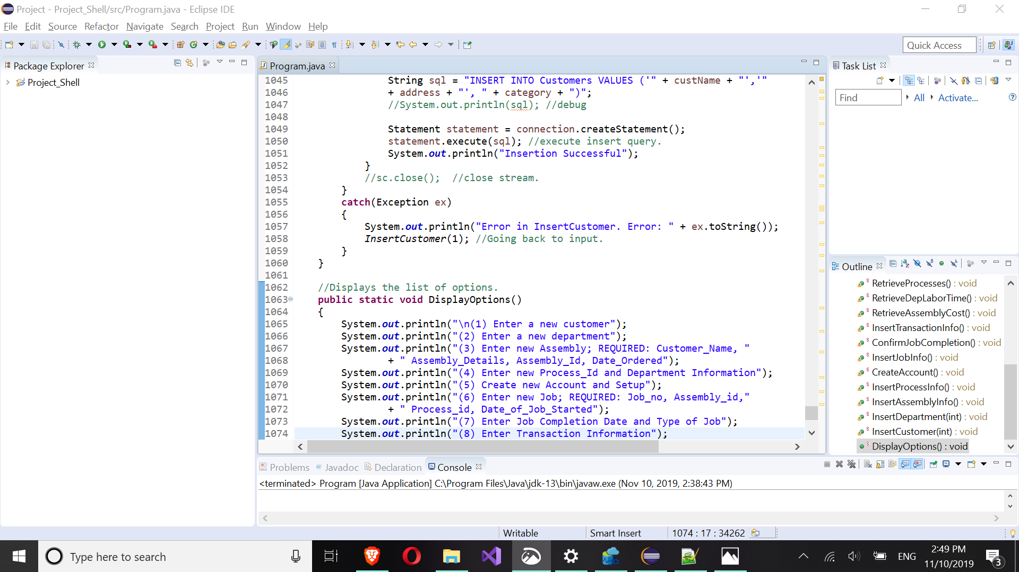

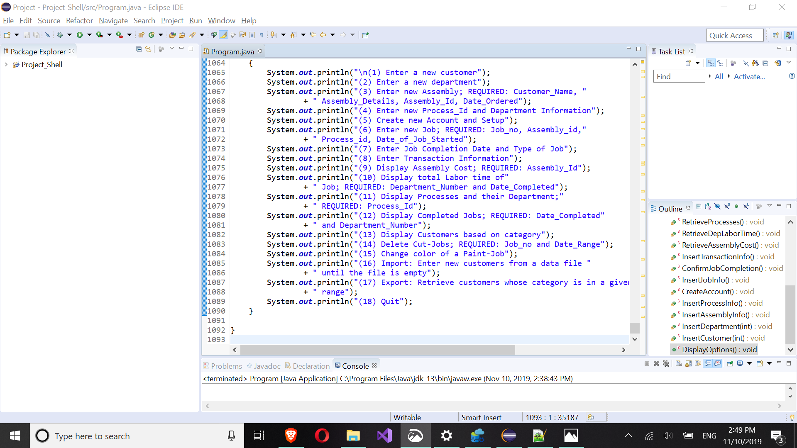

**6) Java Execution**

Note: Use shows only on insert by the app though all are. Some results have more than the 5 or 10 requested. These are there from debugging.

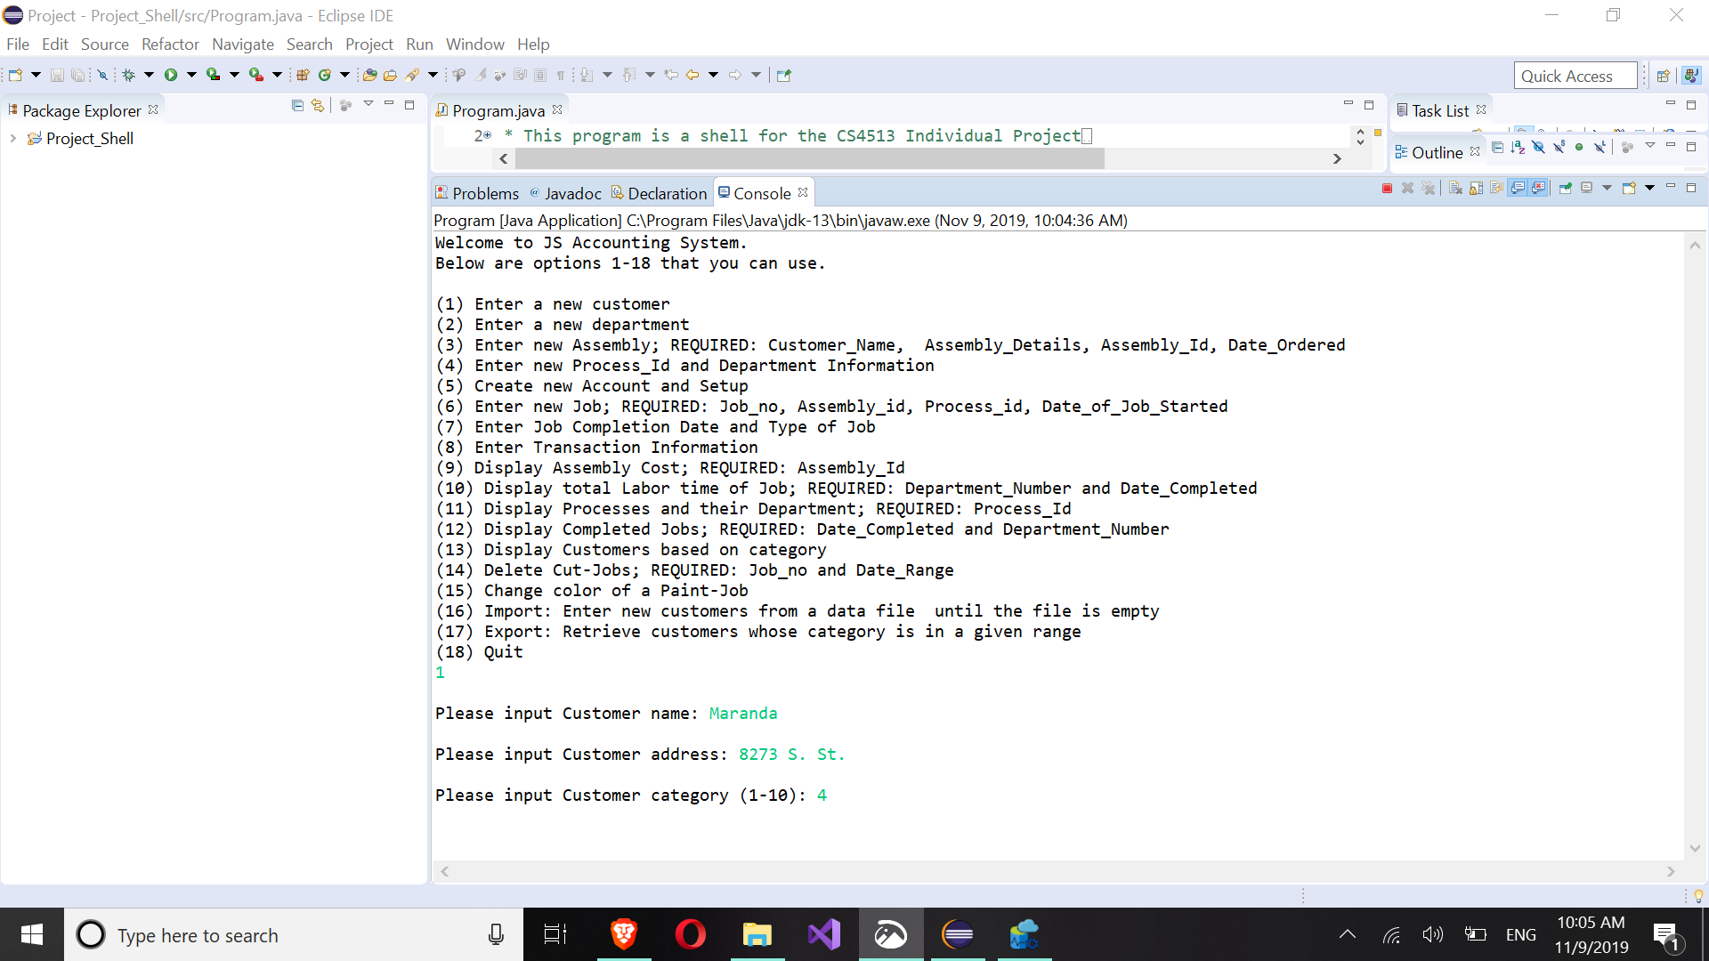

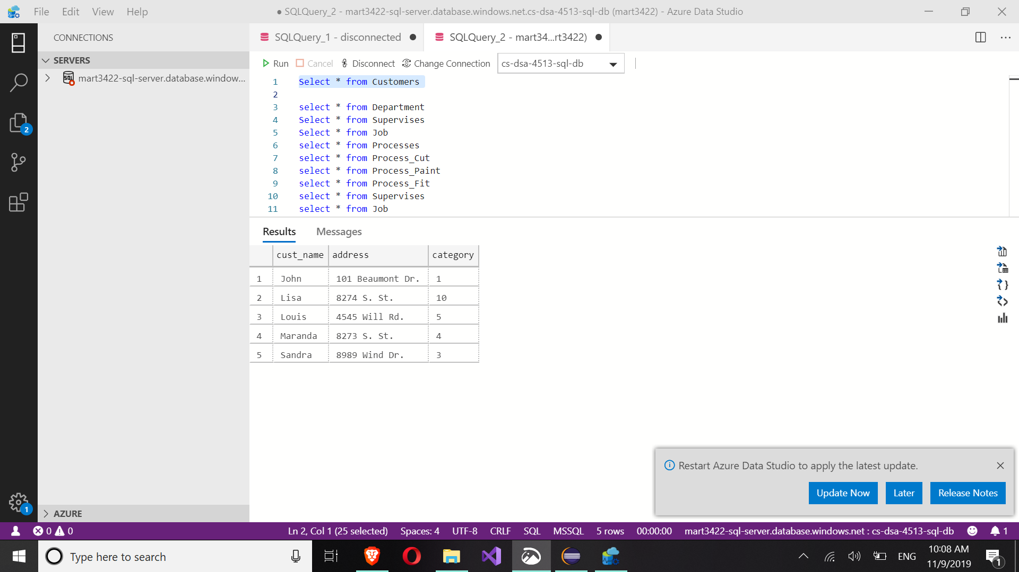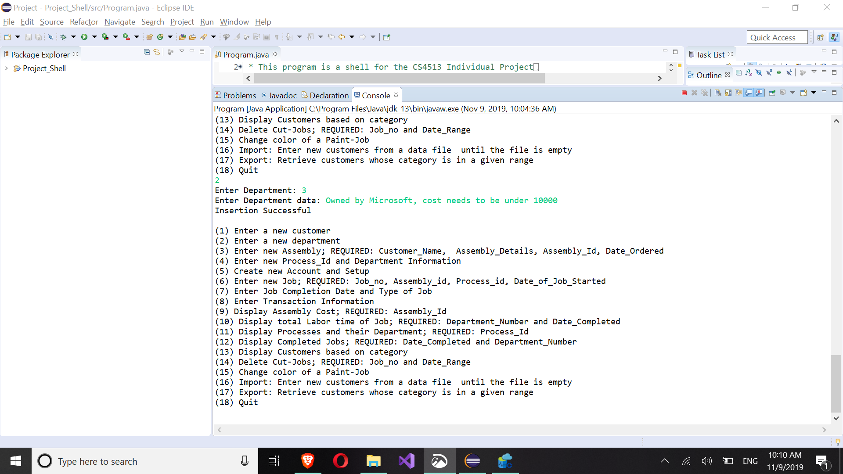

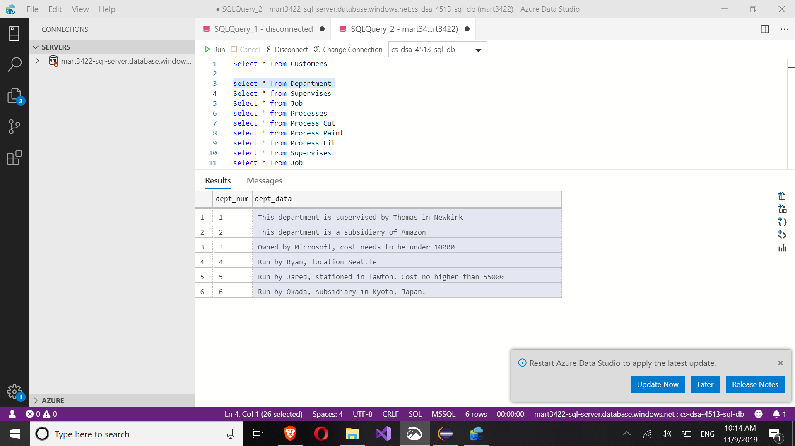

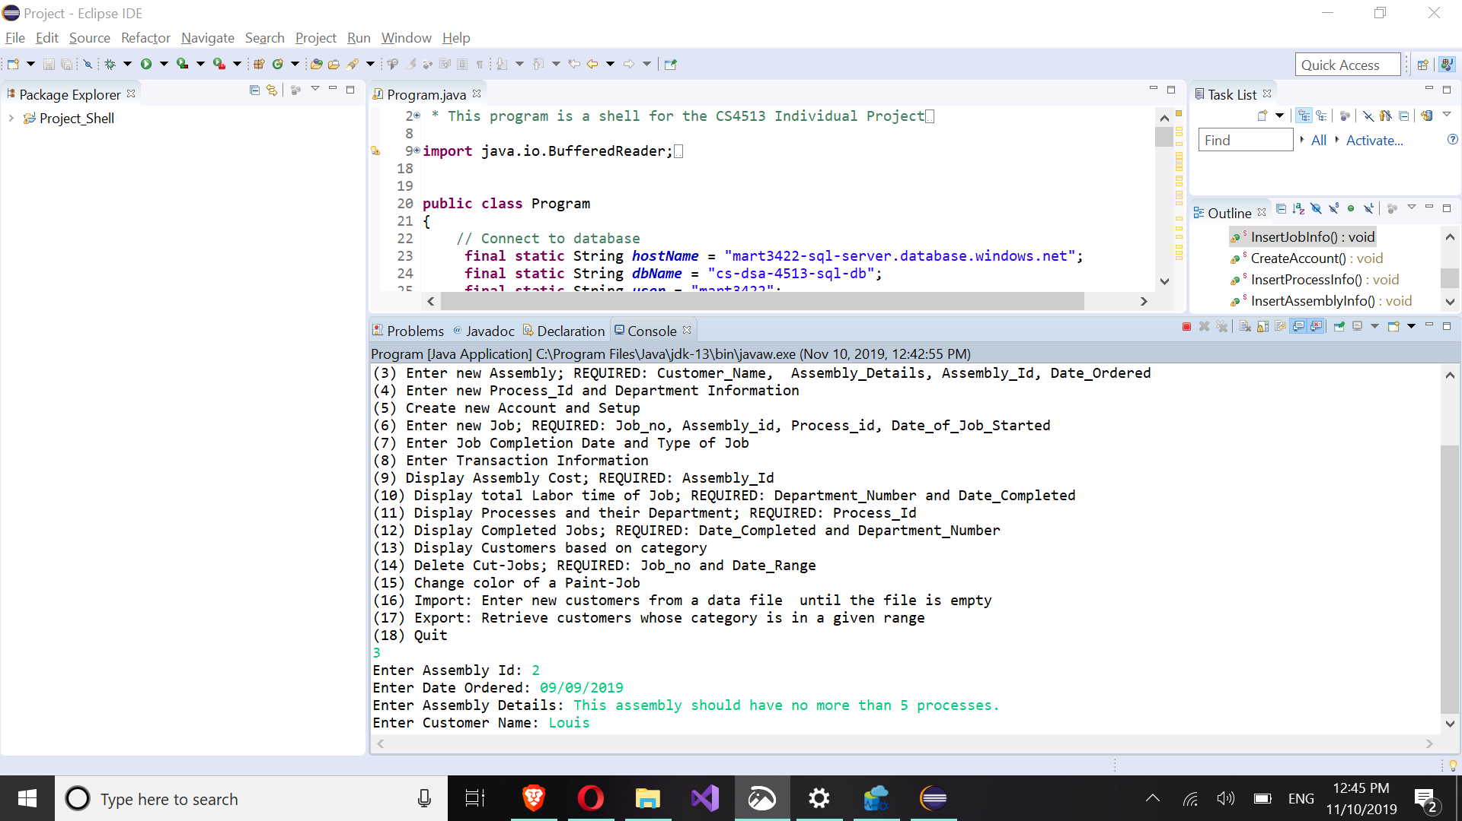

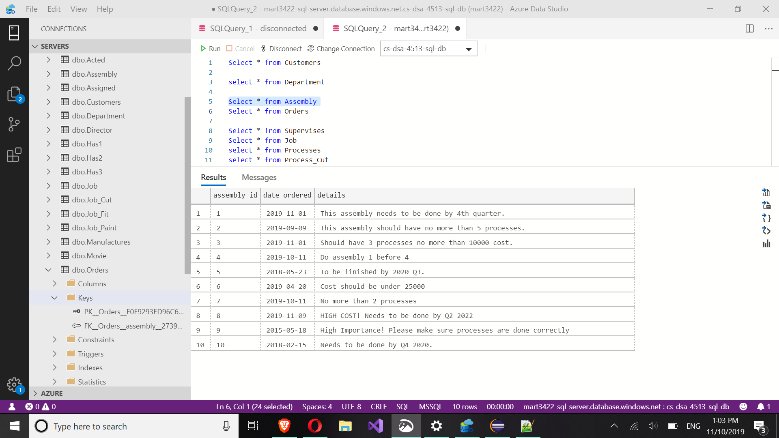

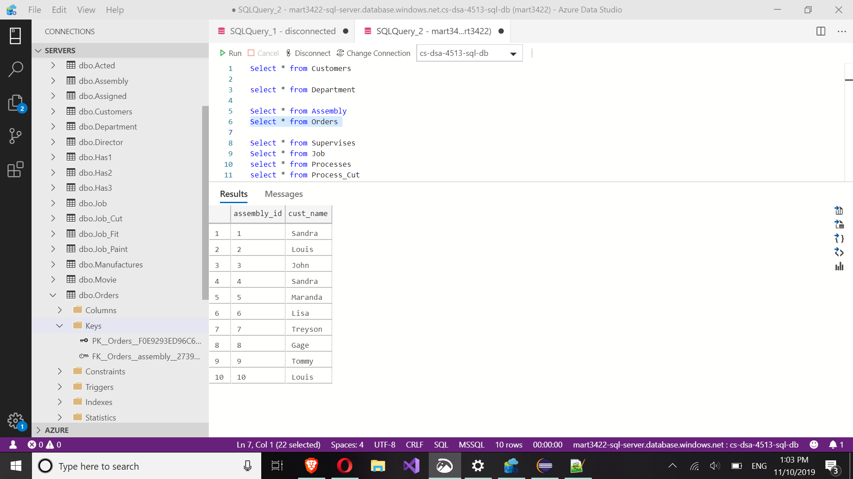

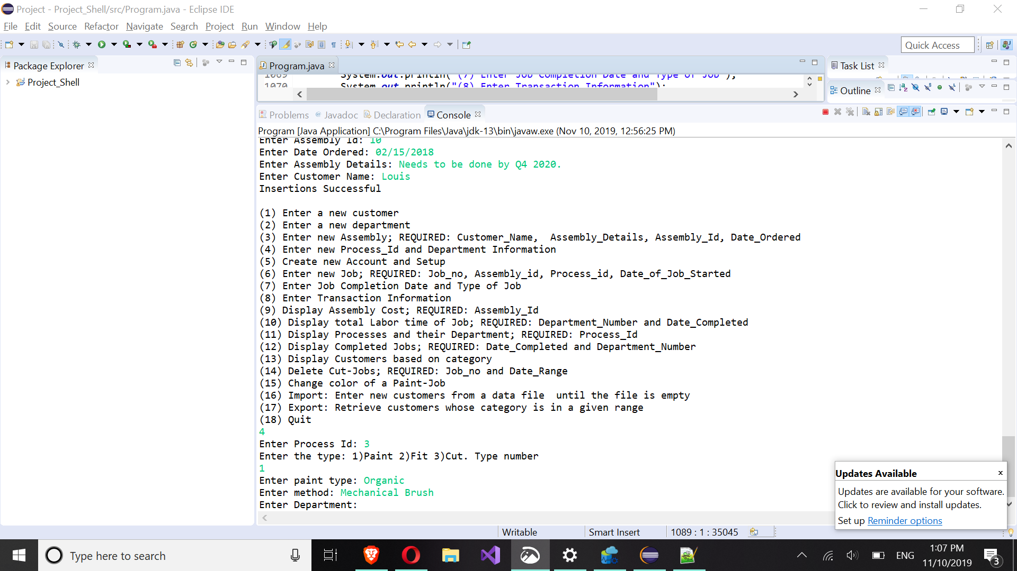

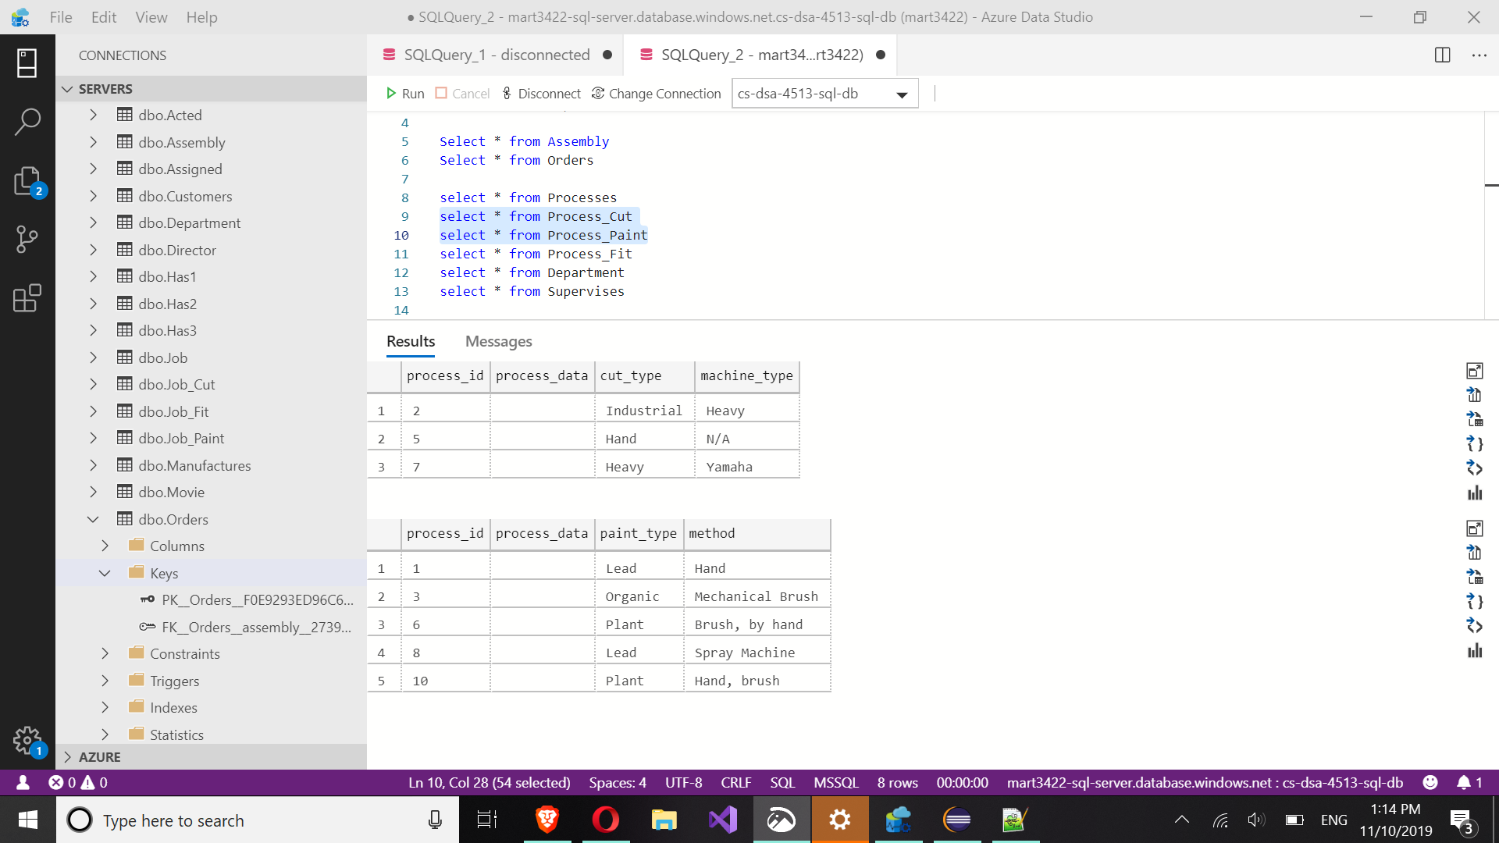

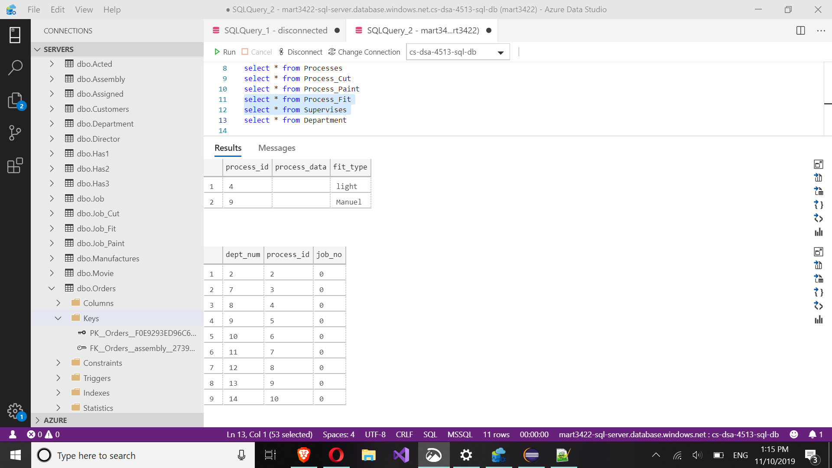

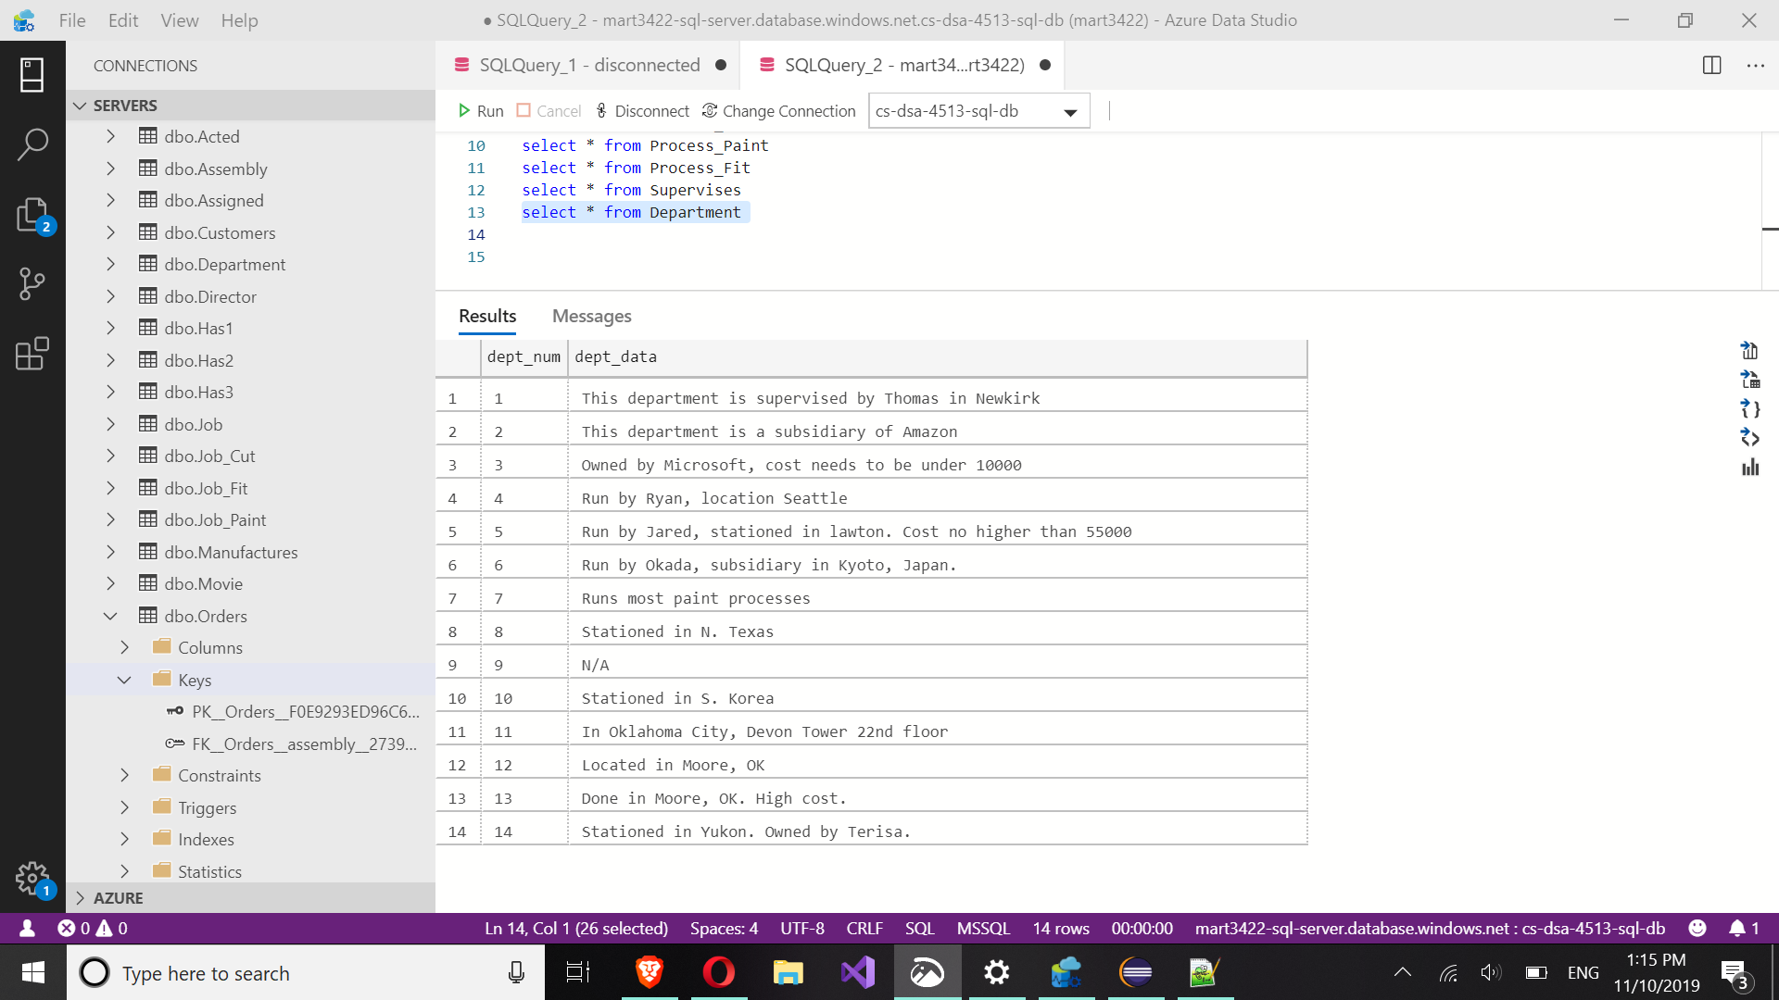

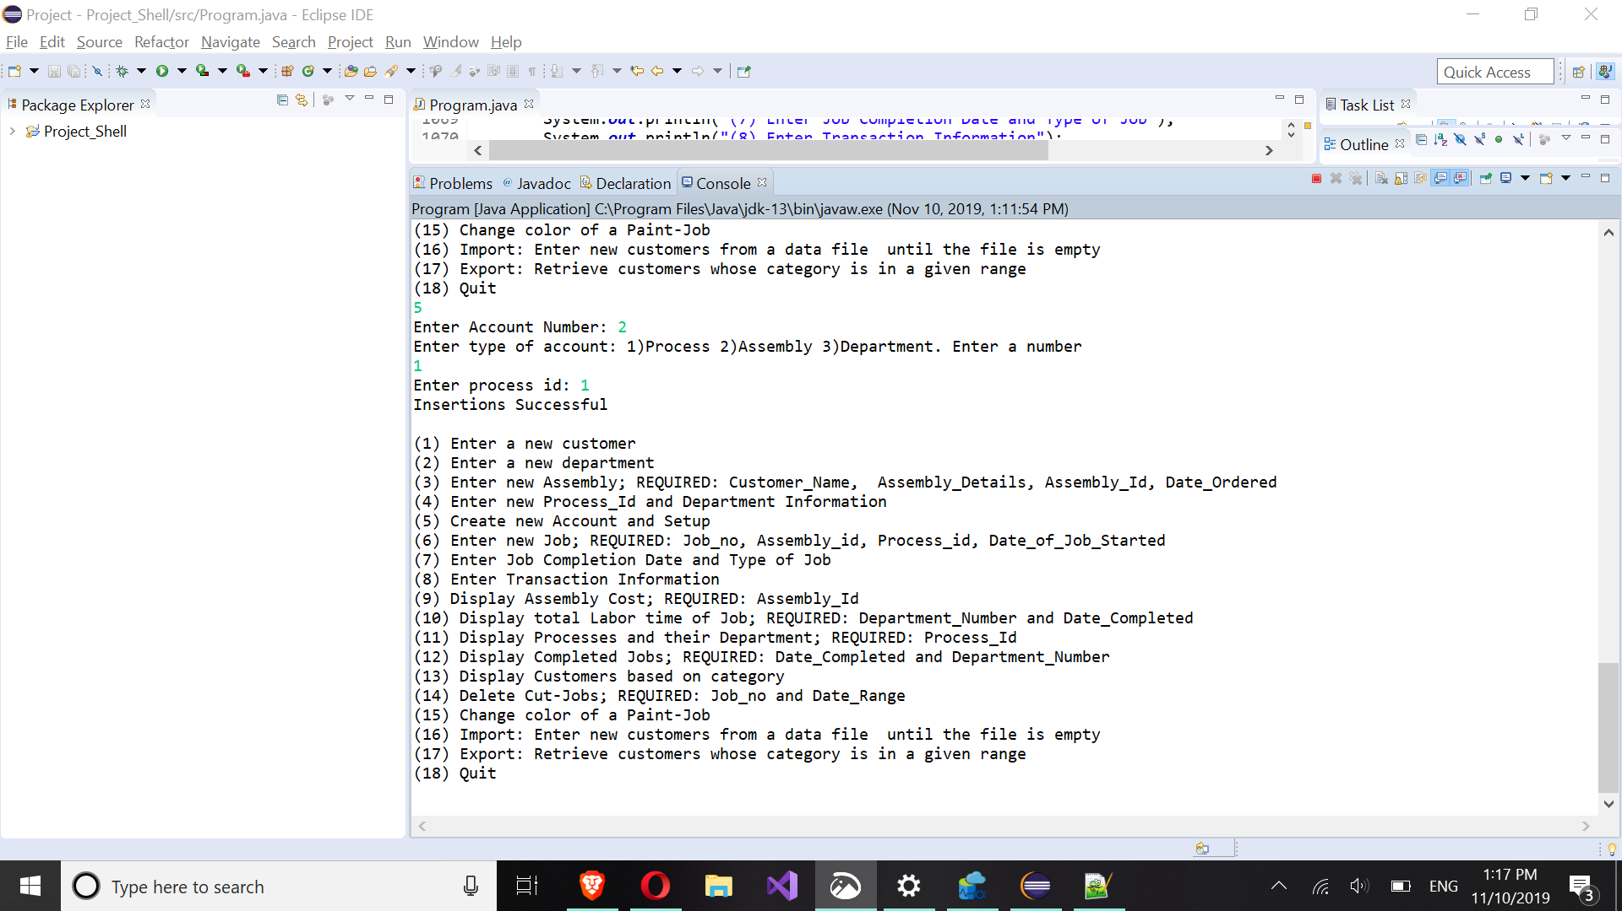

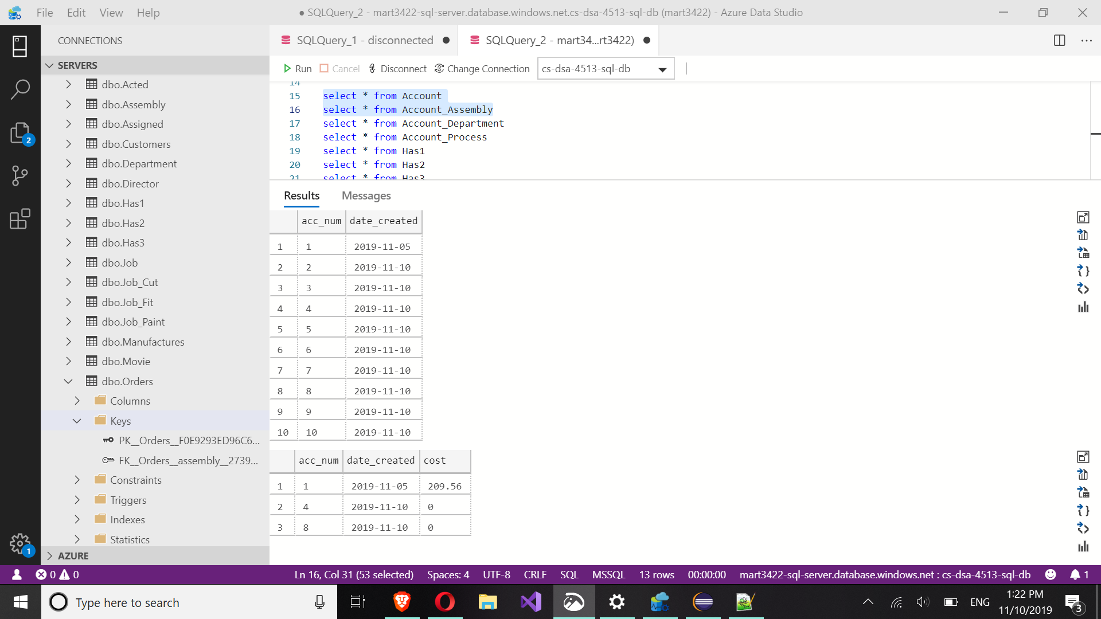

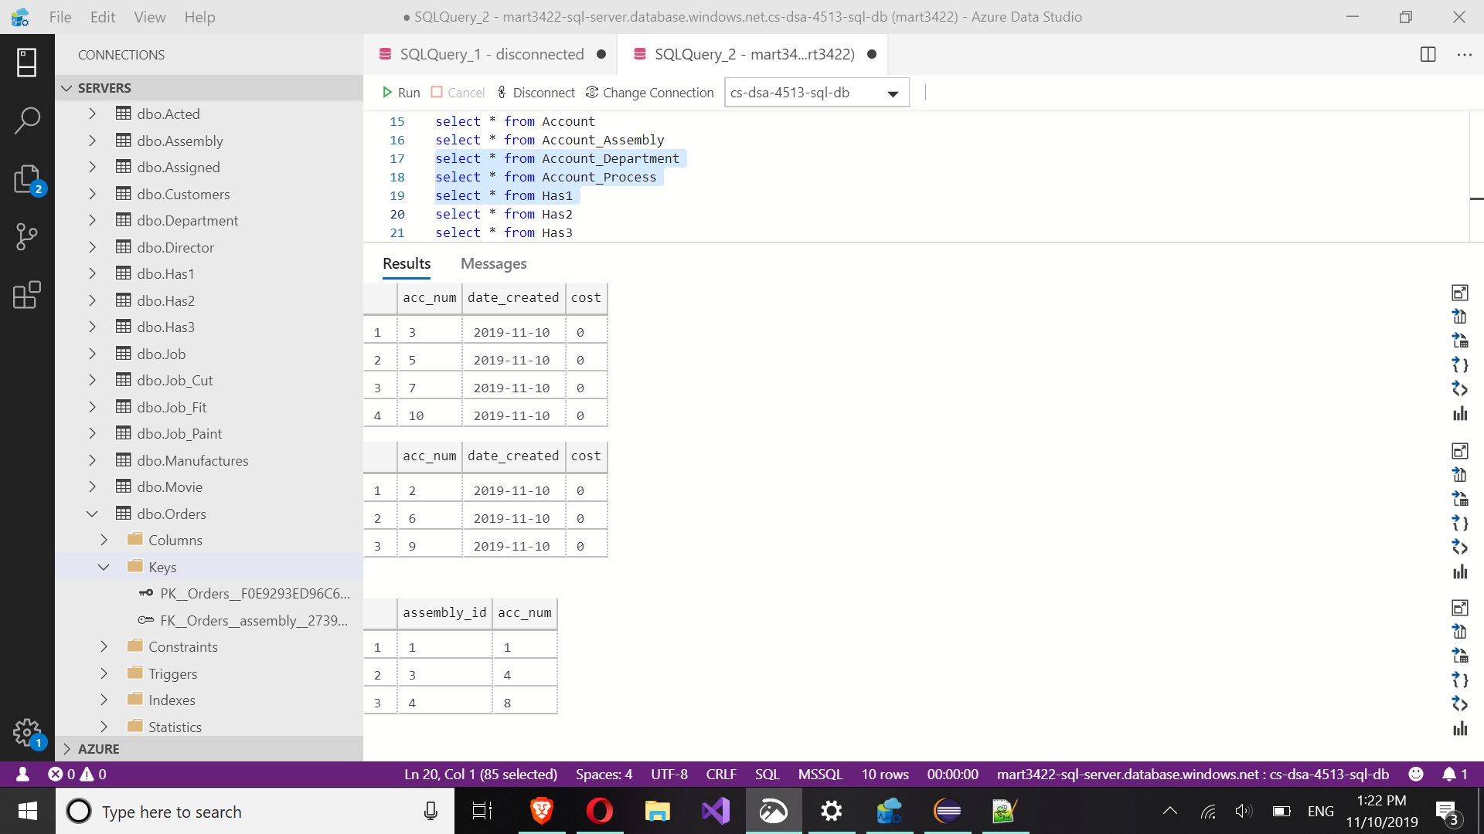

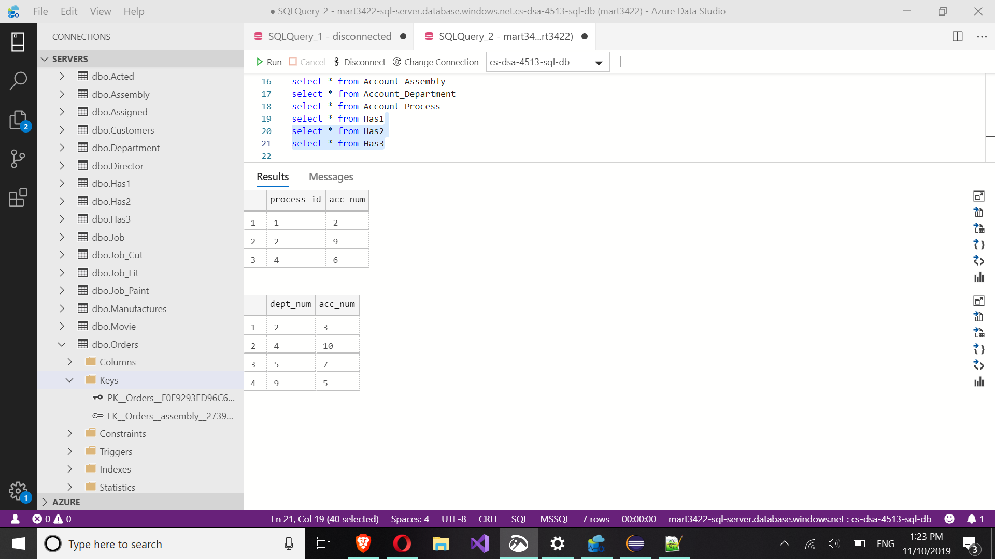

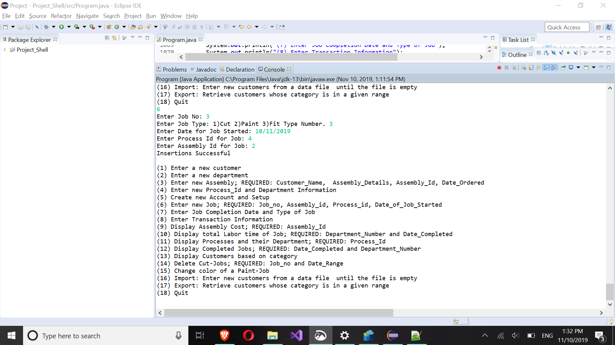

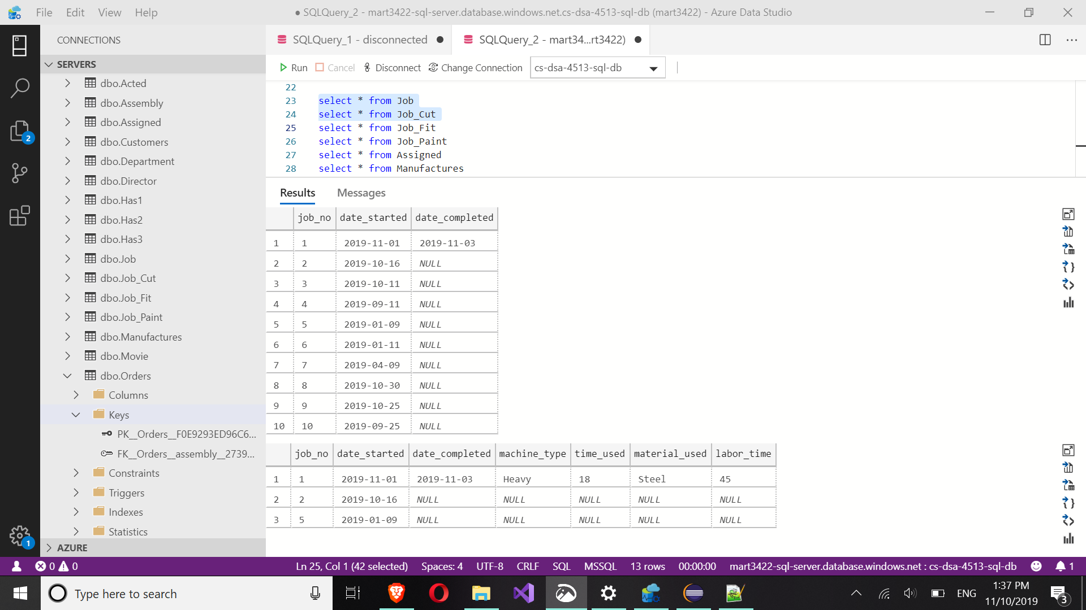

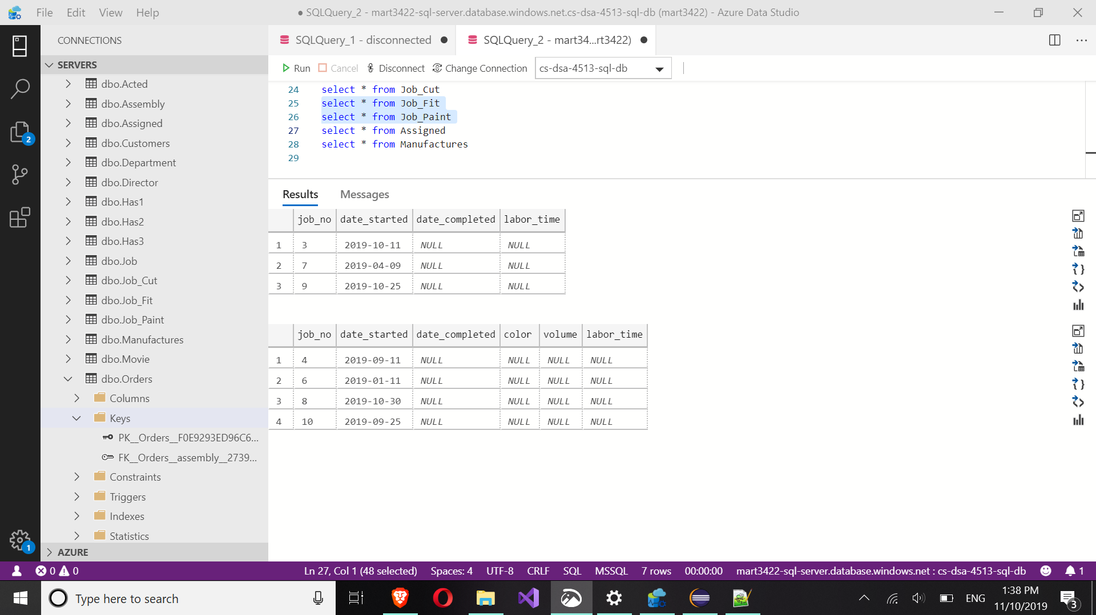

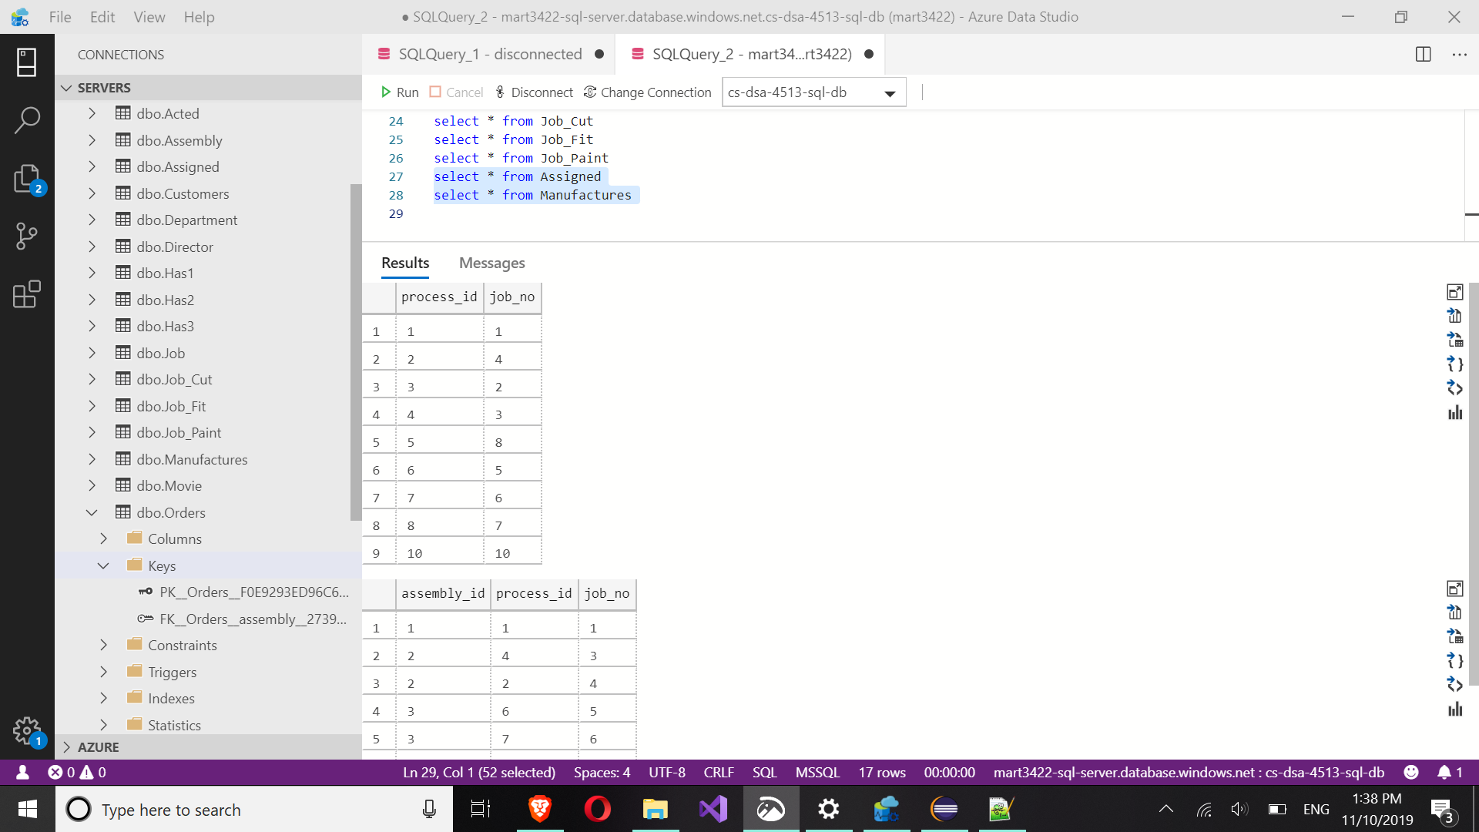

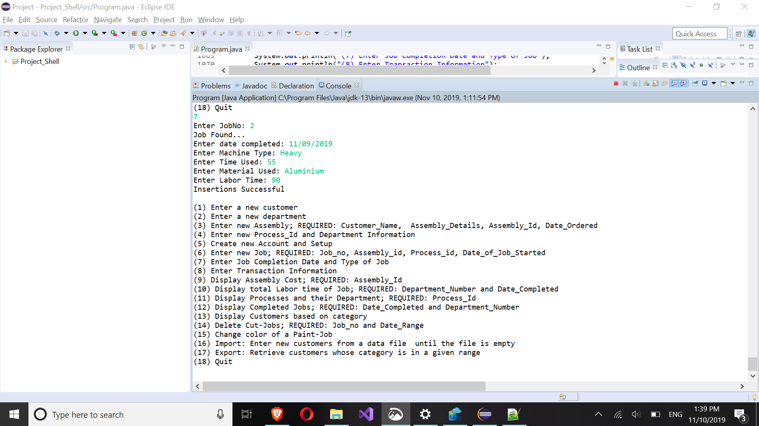

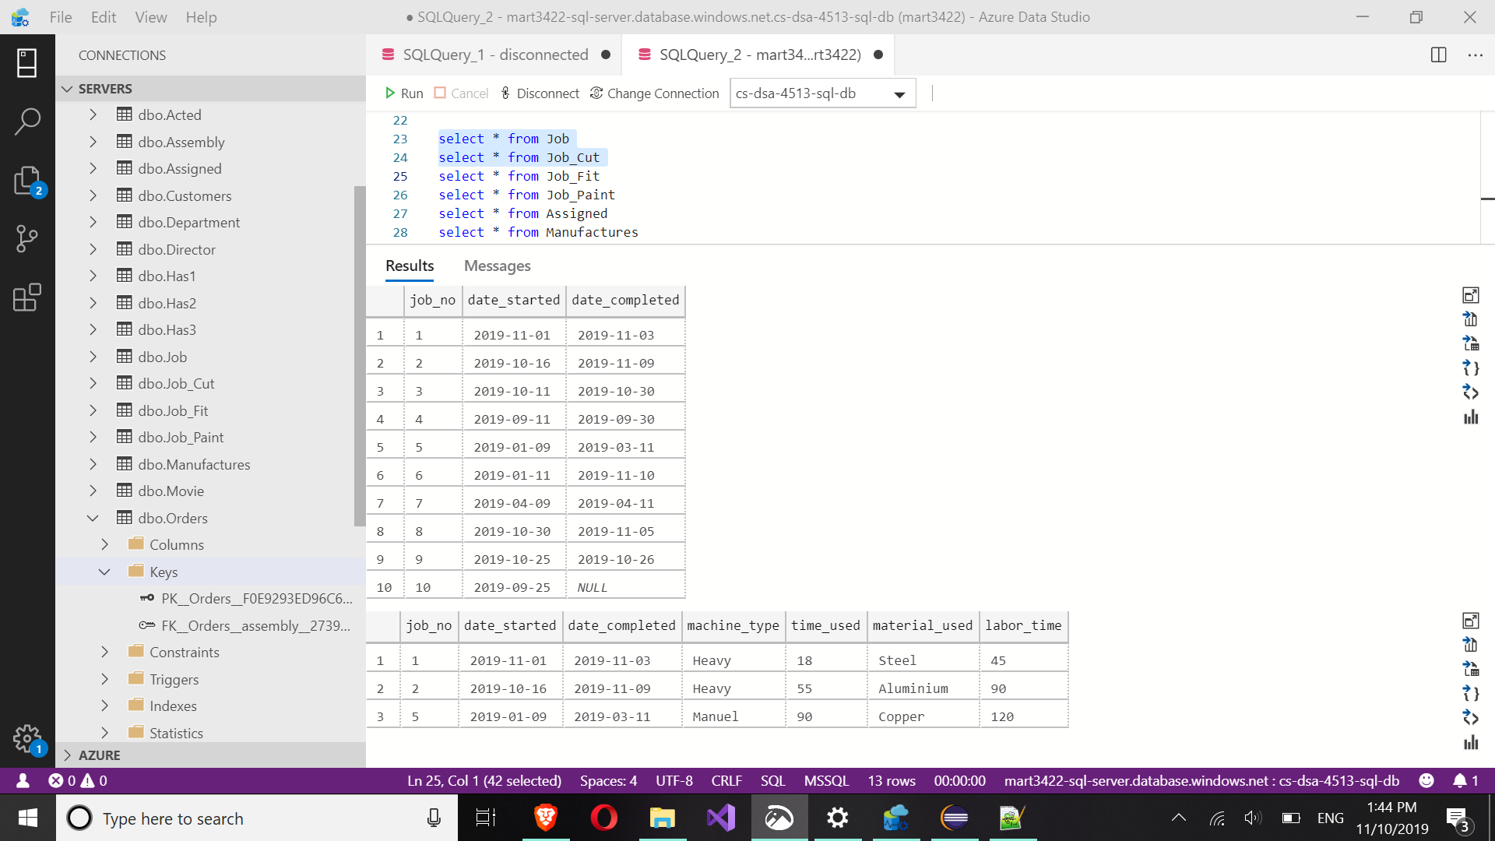

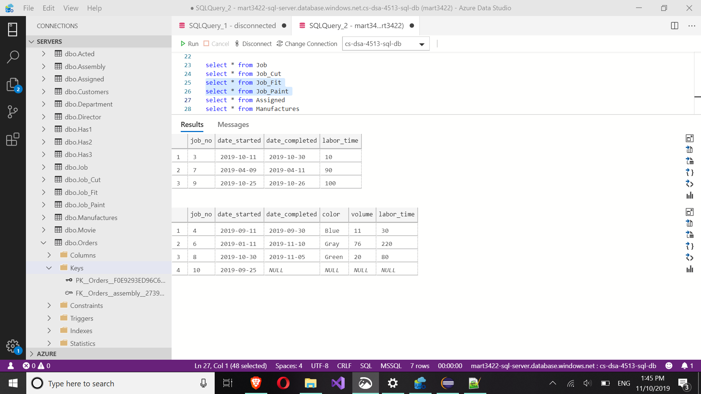

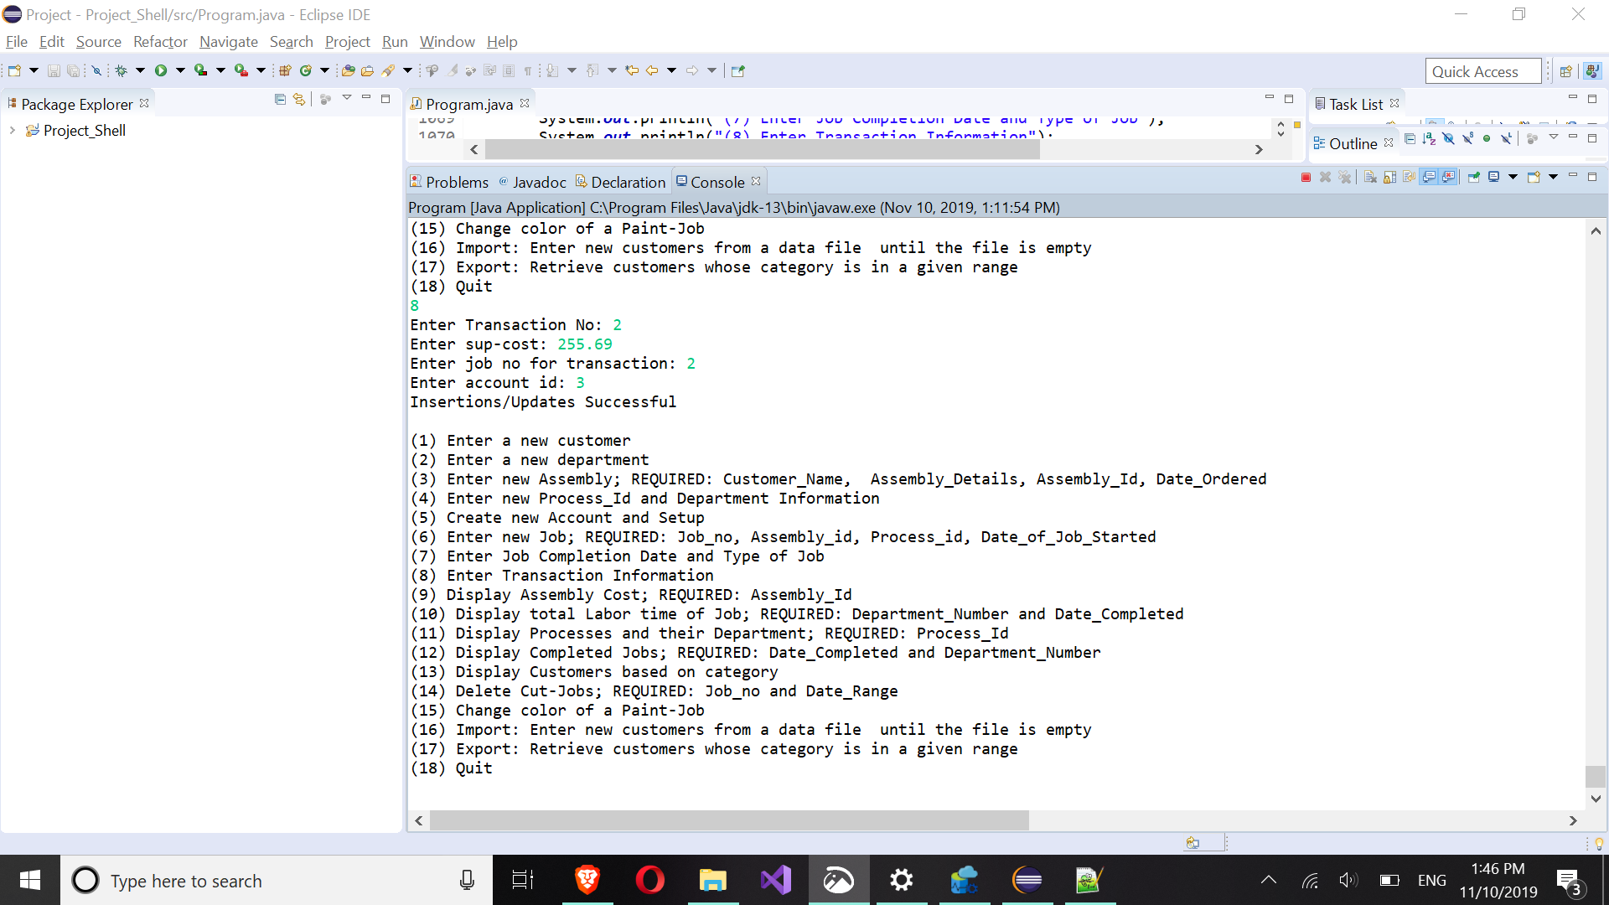

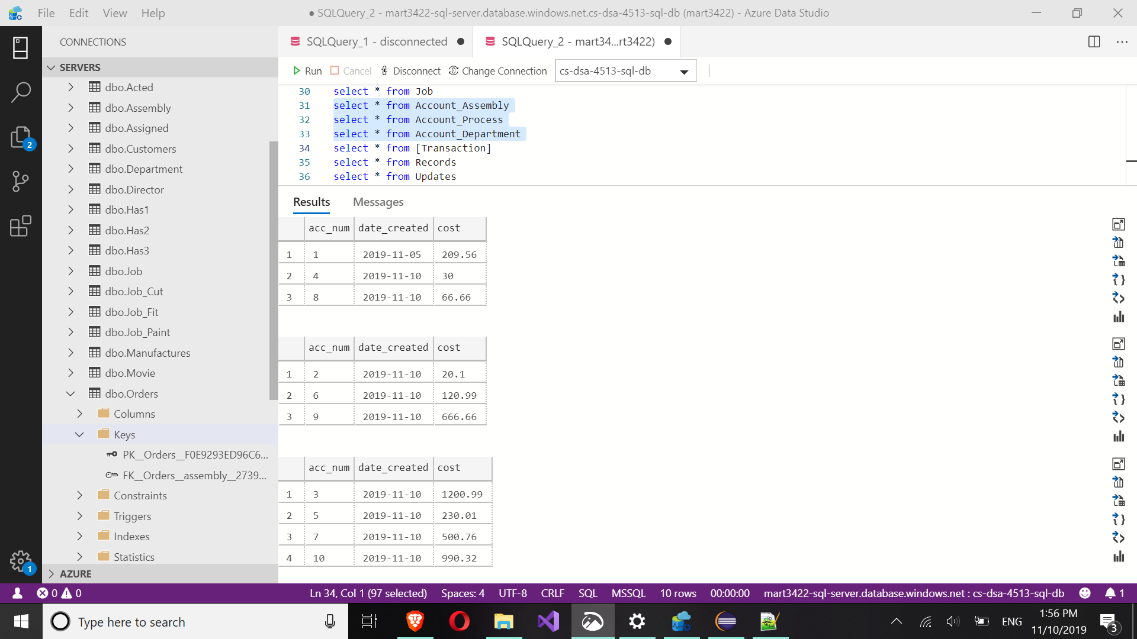

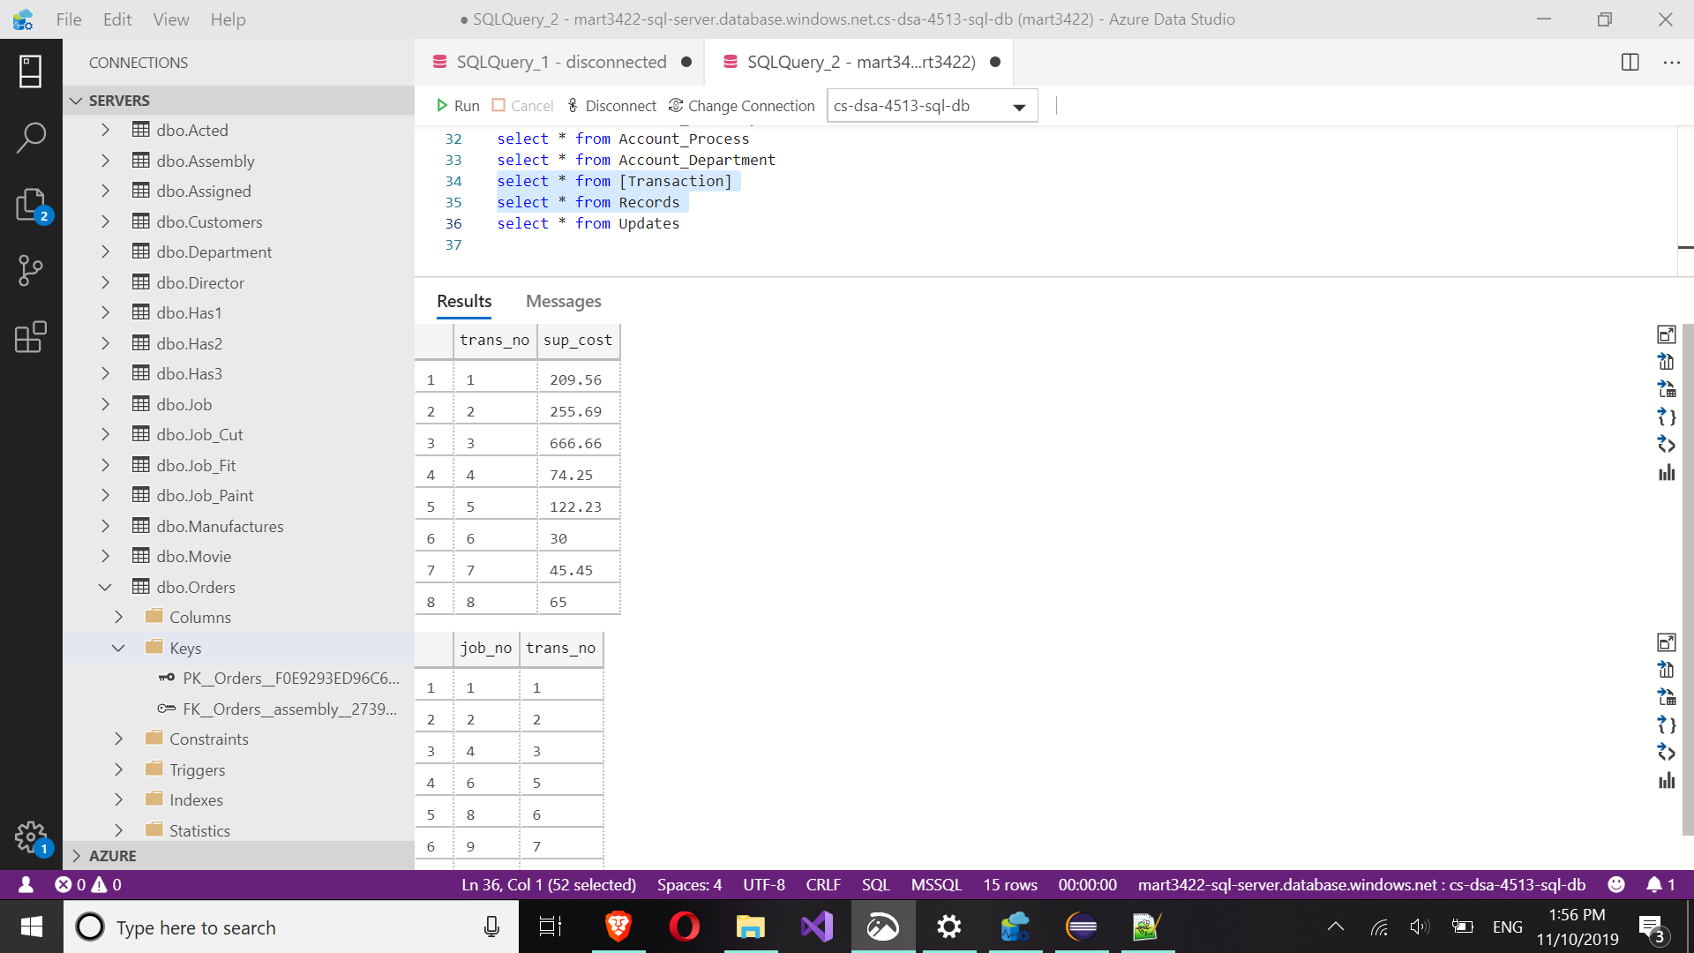

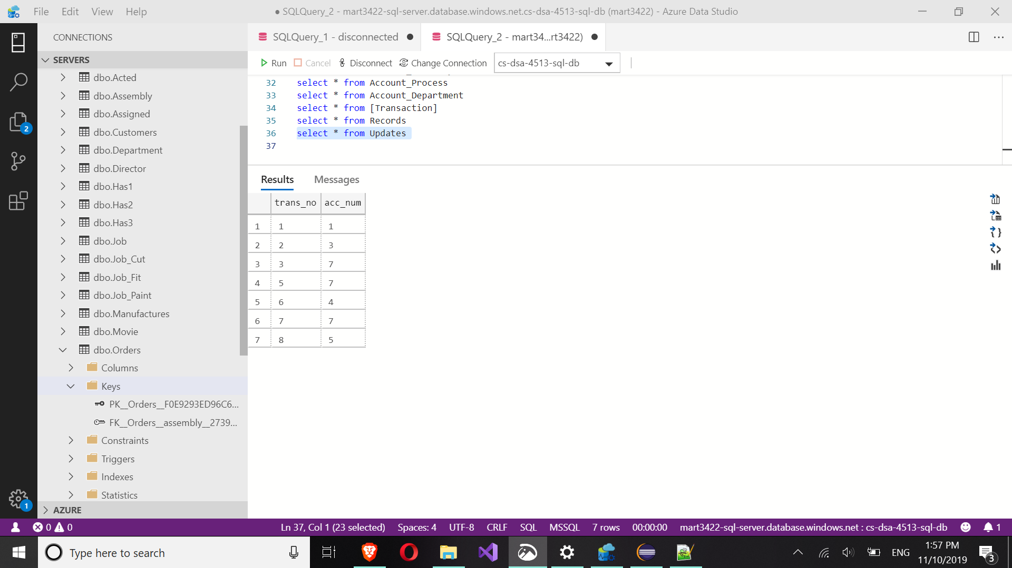

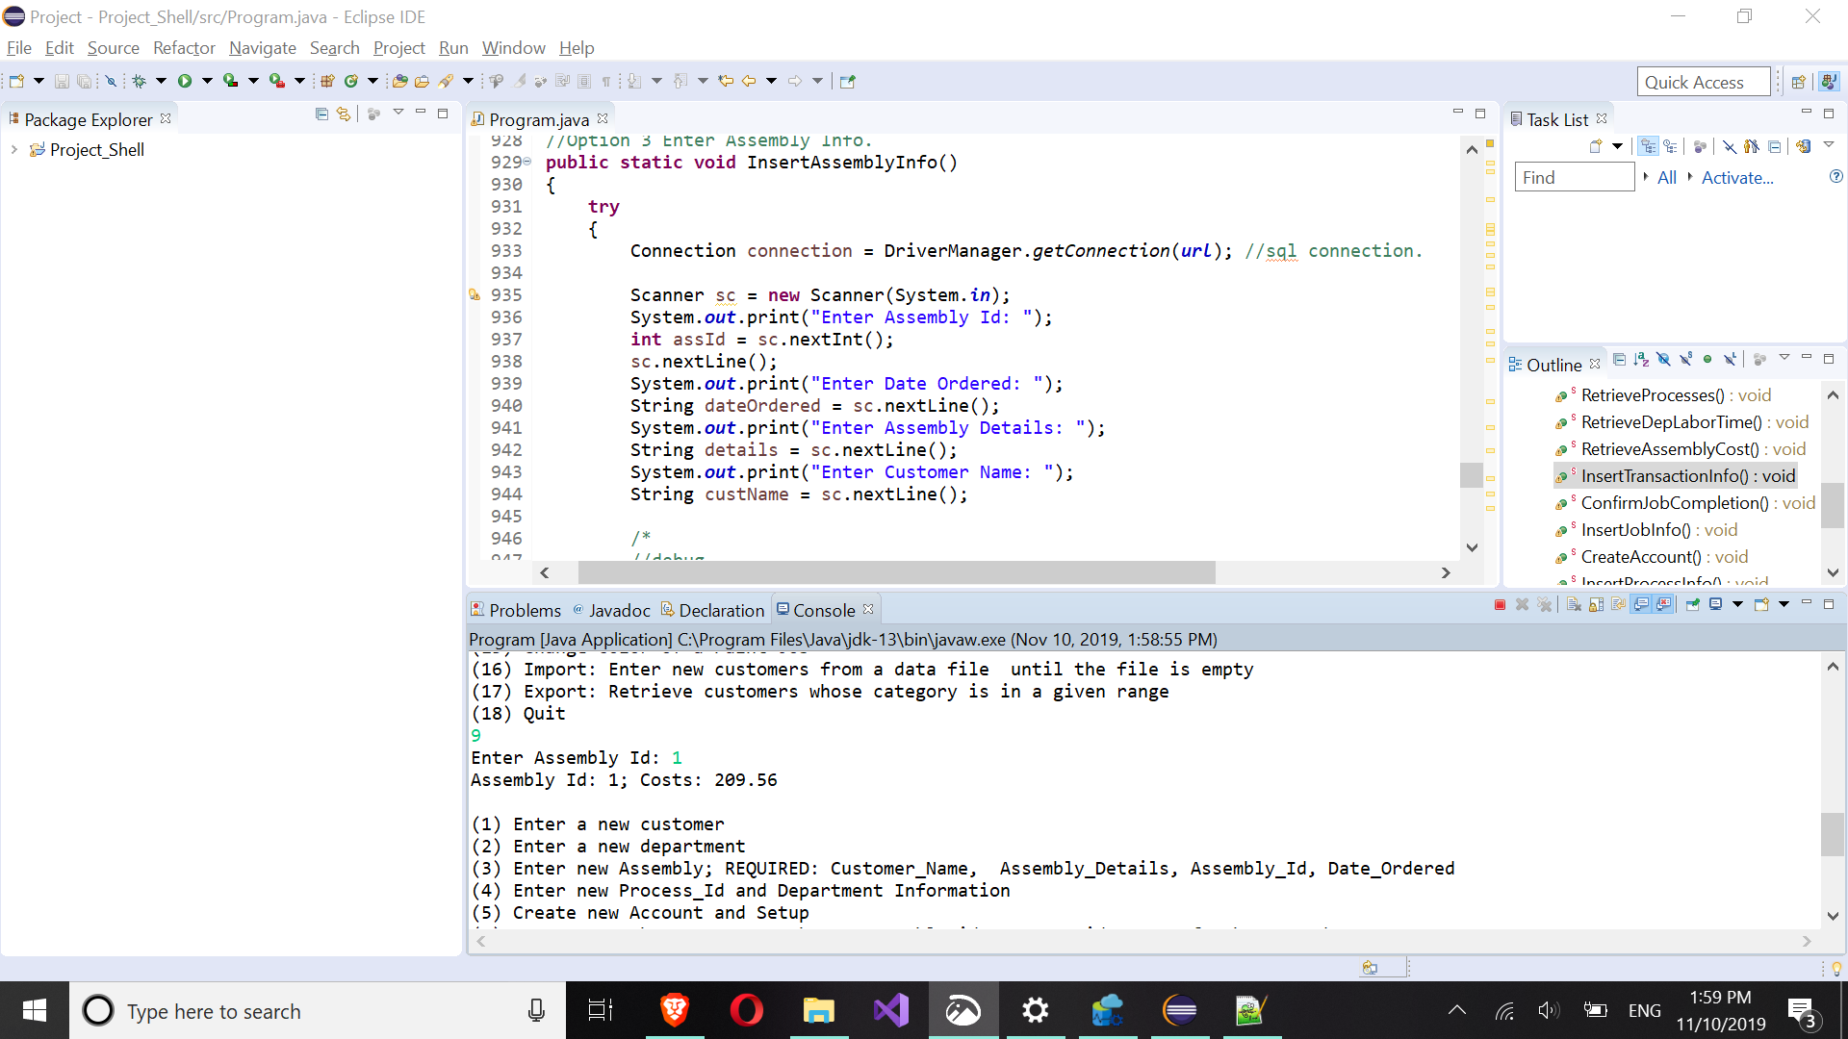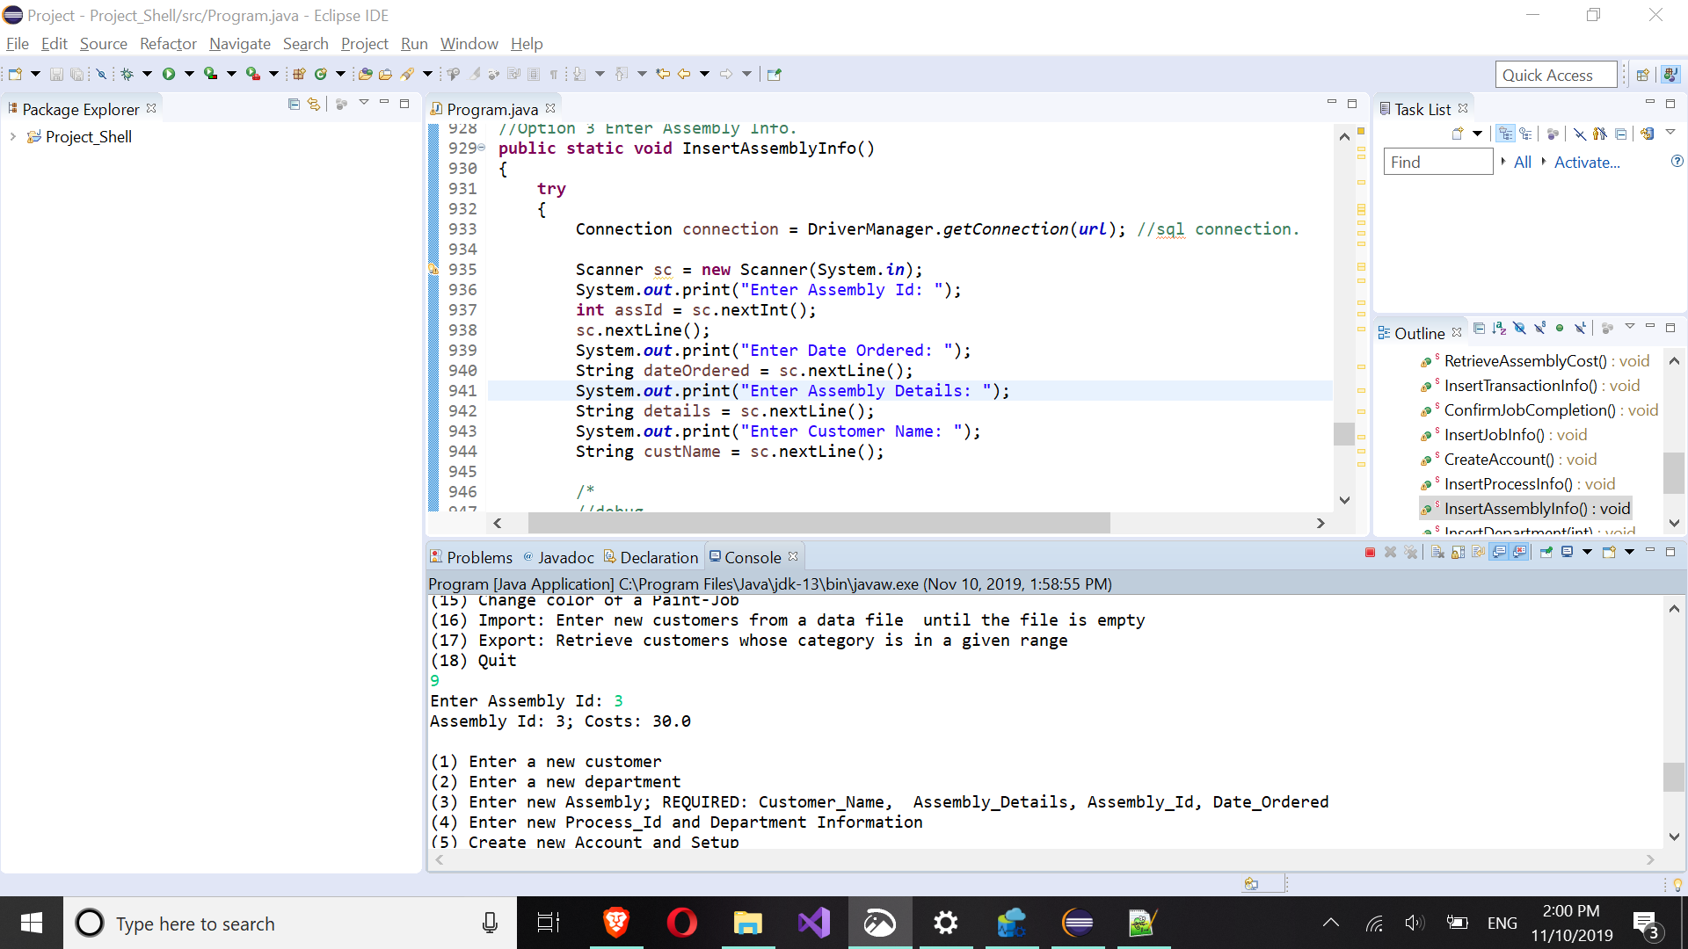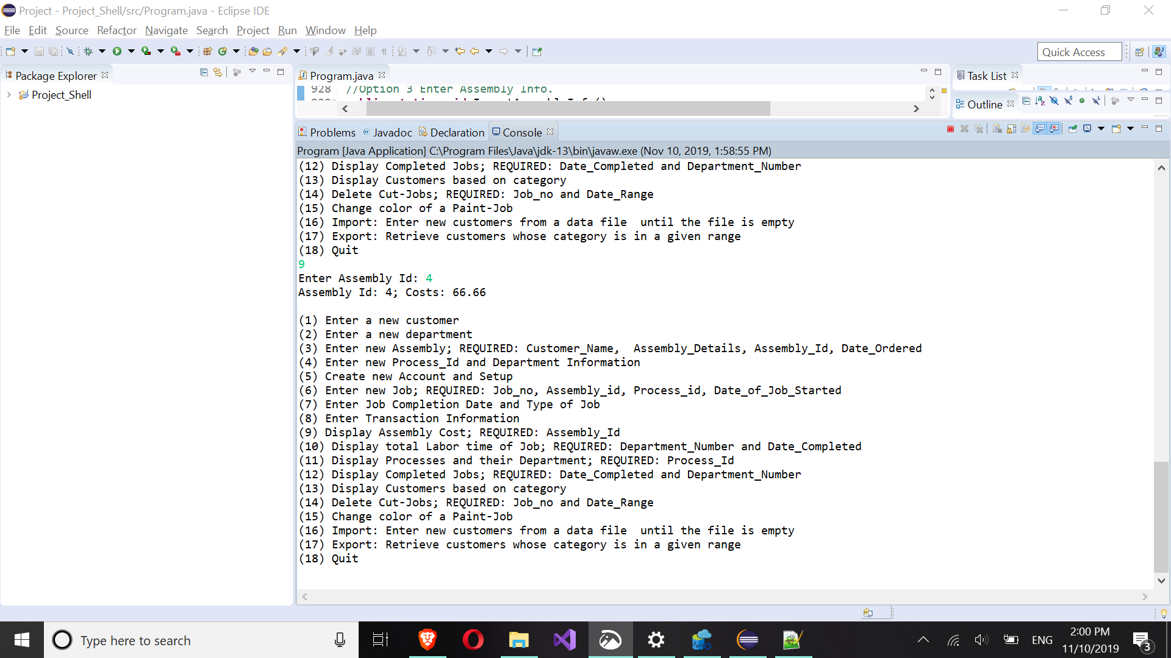

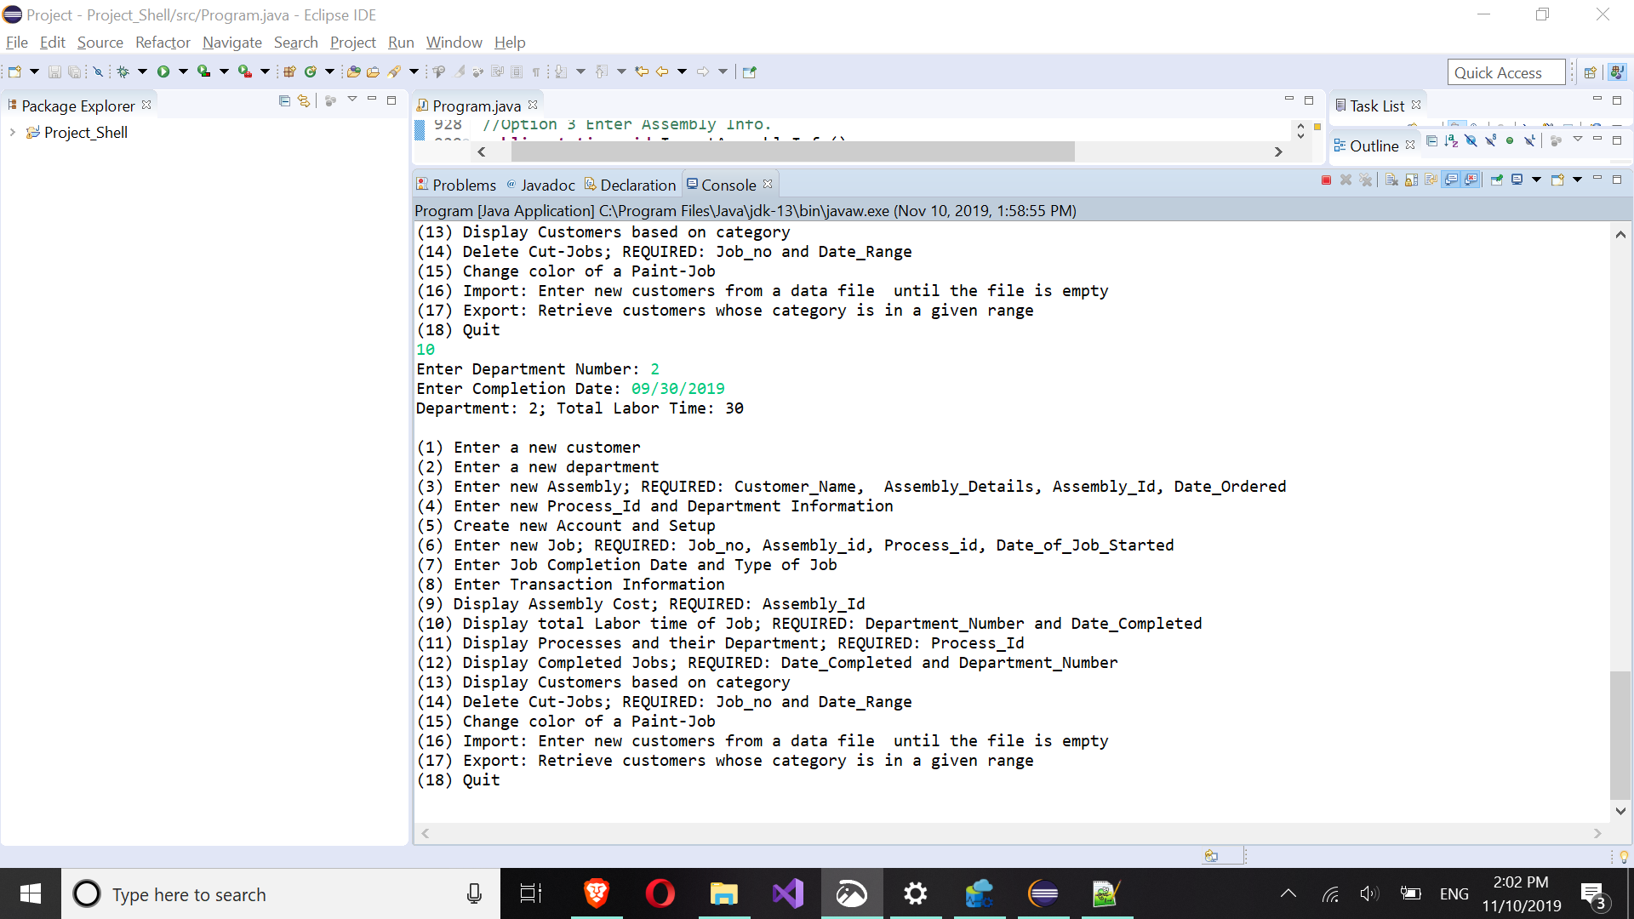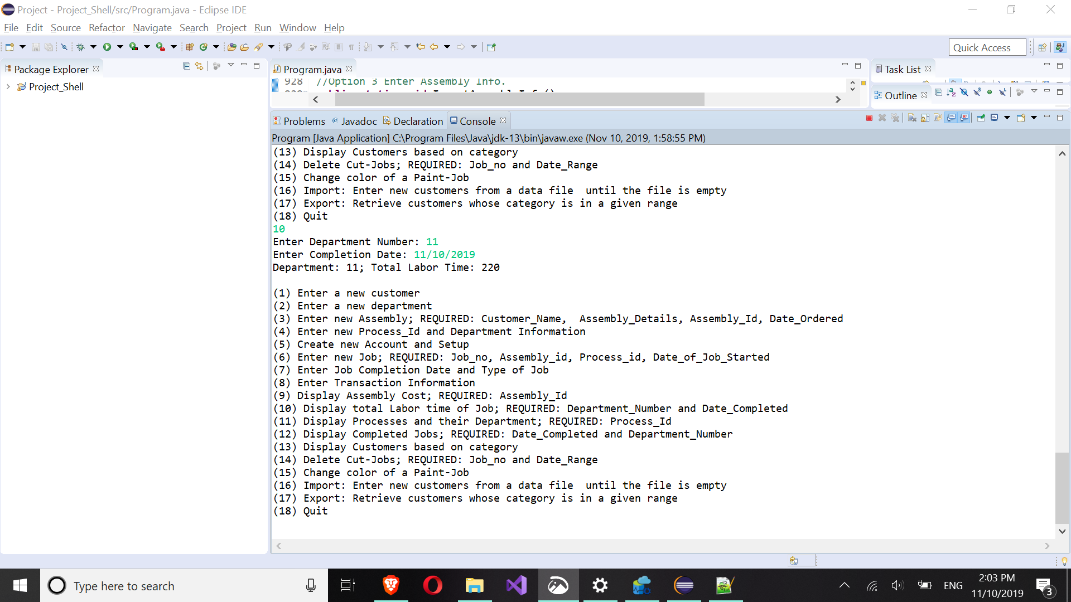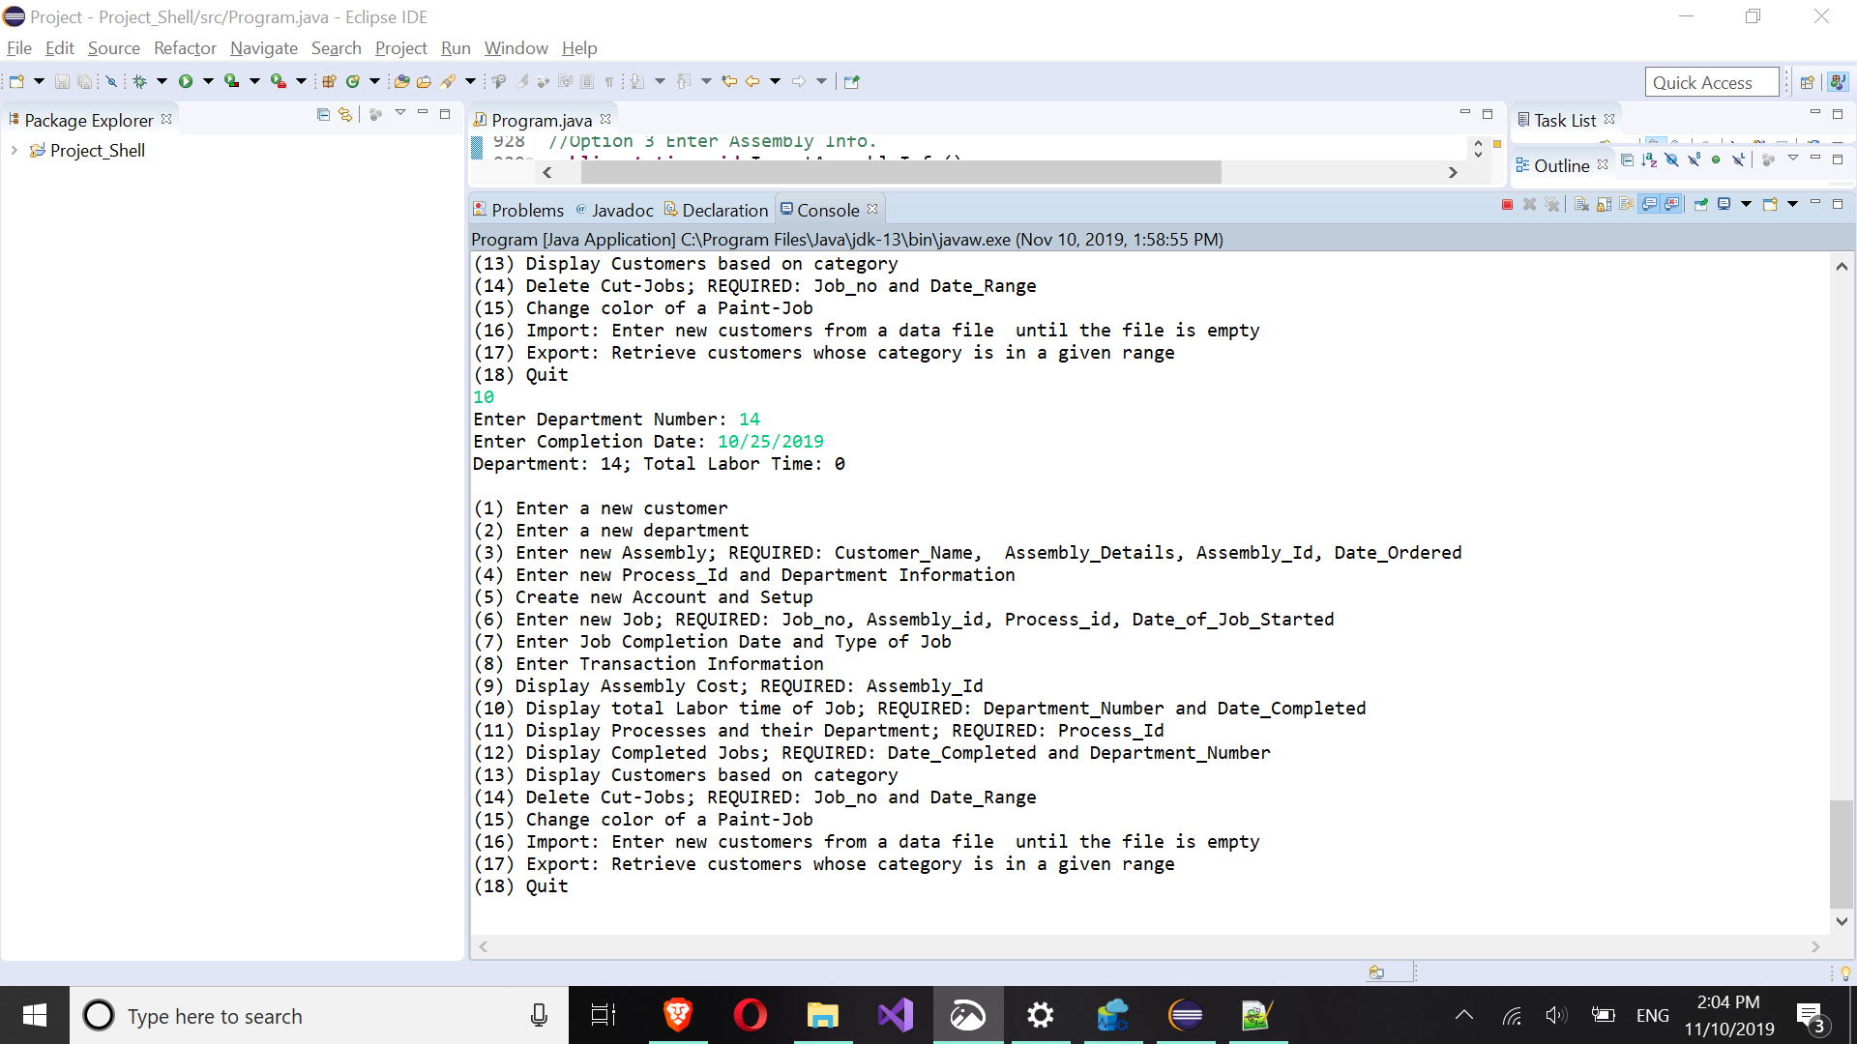

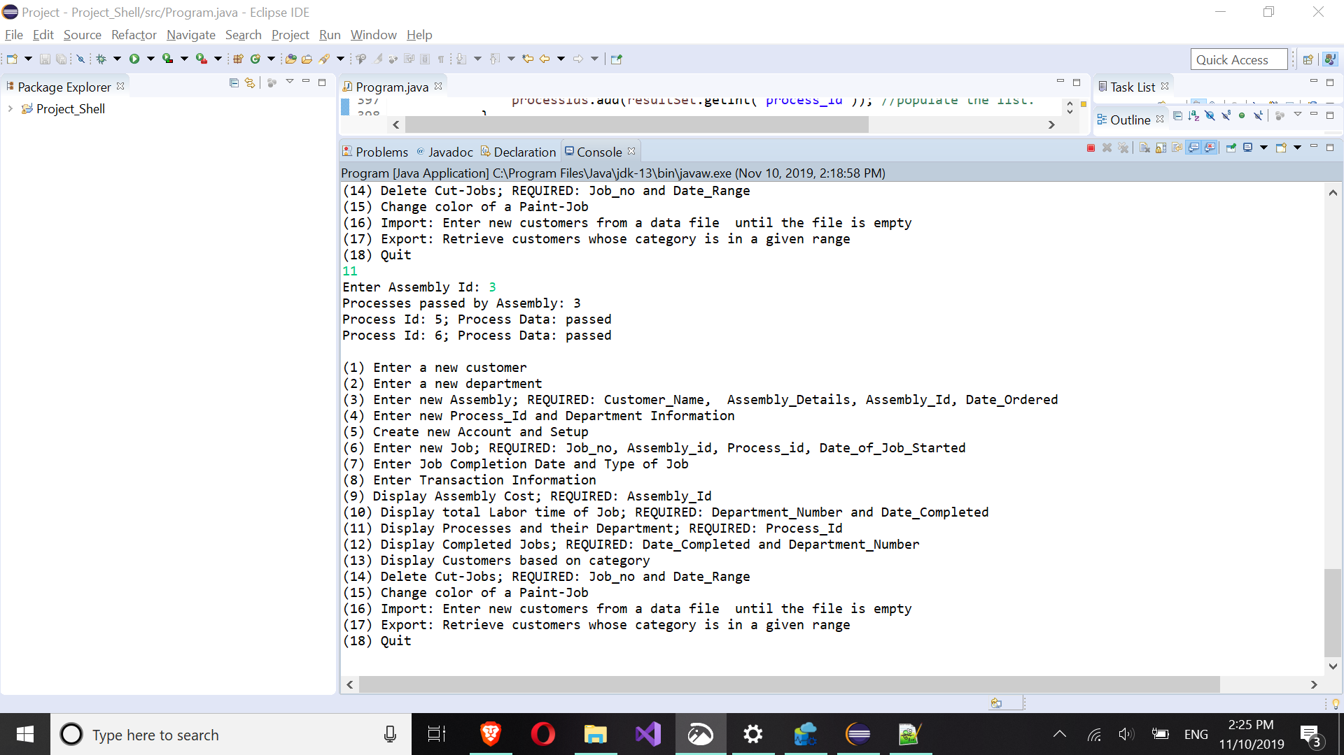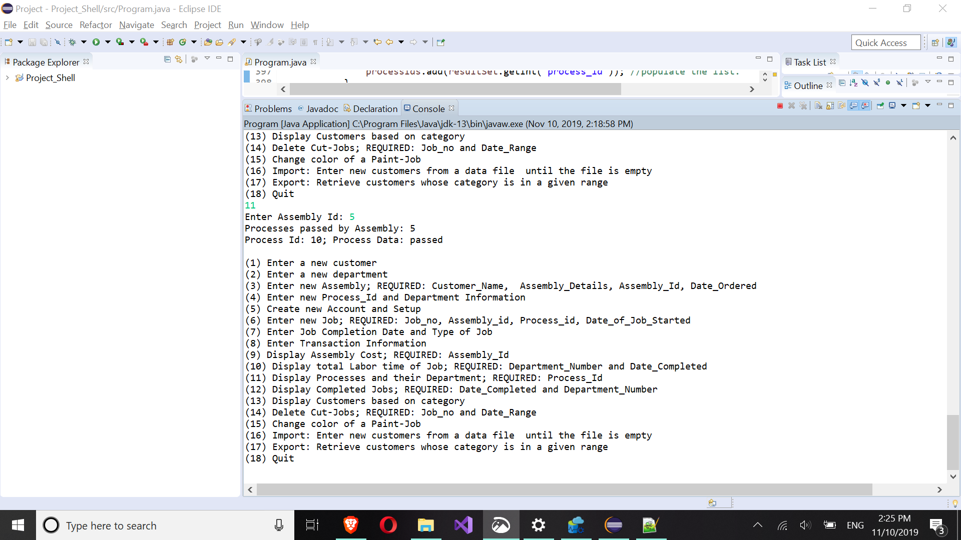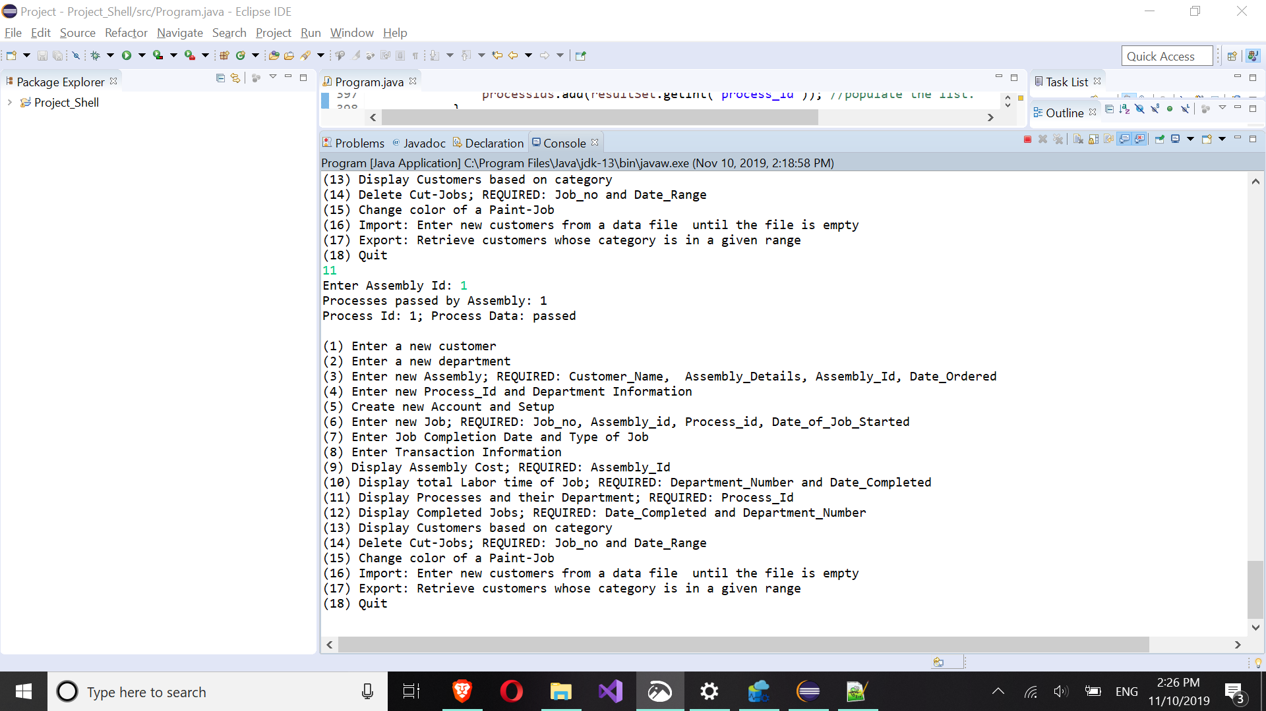

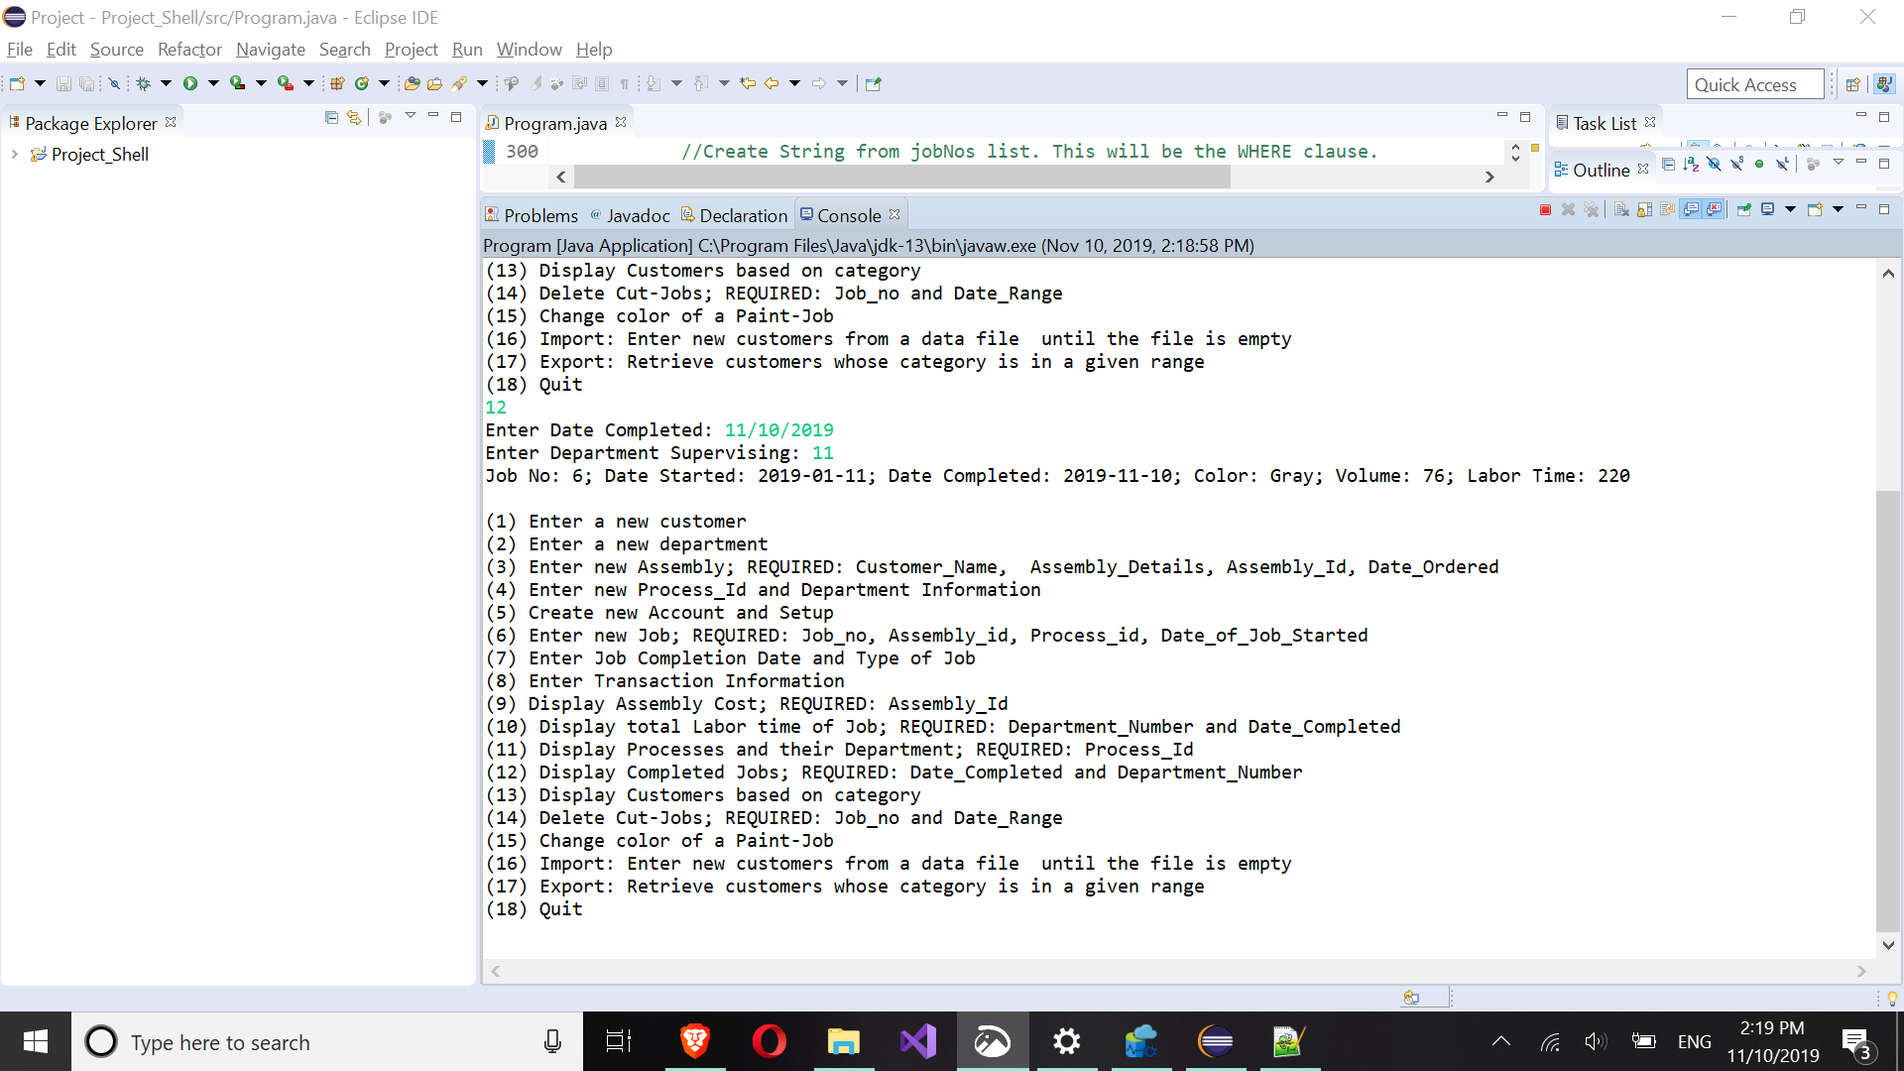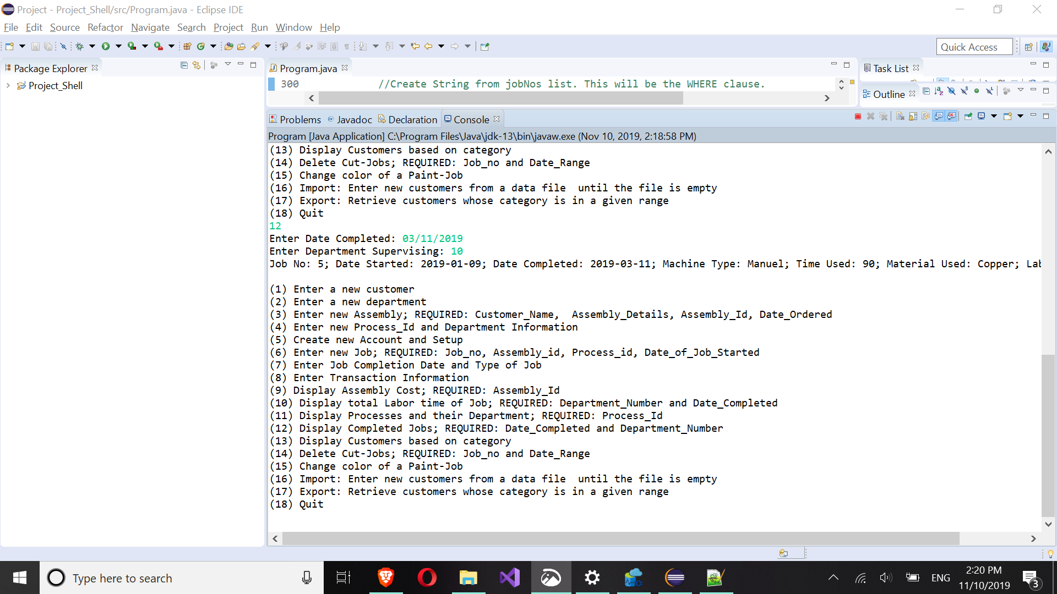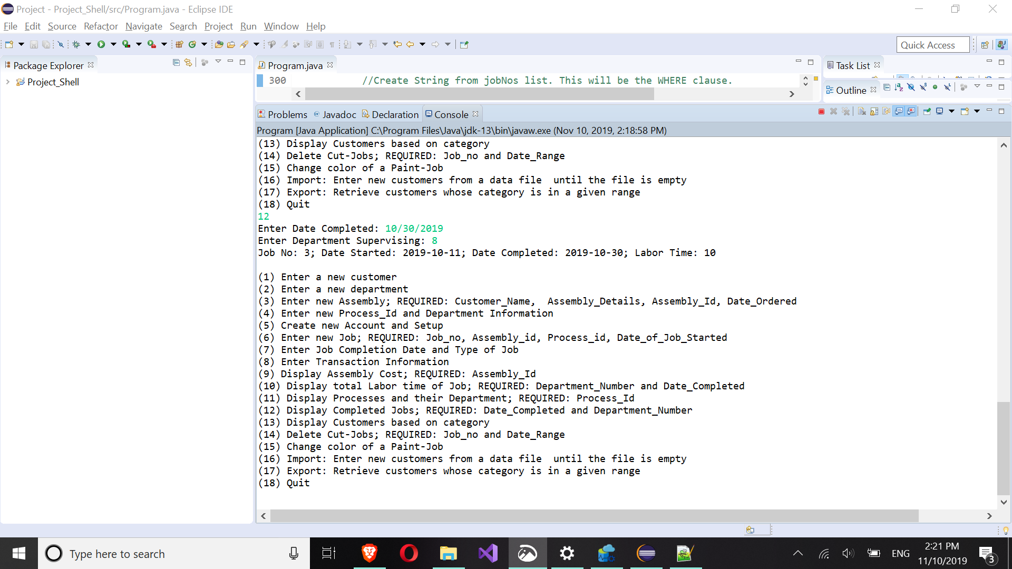

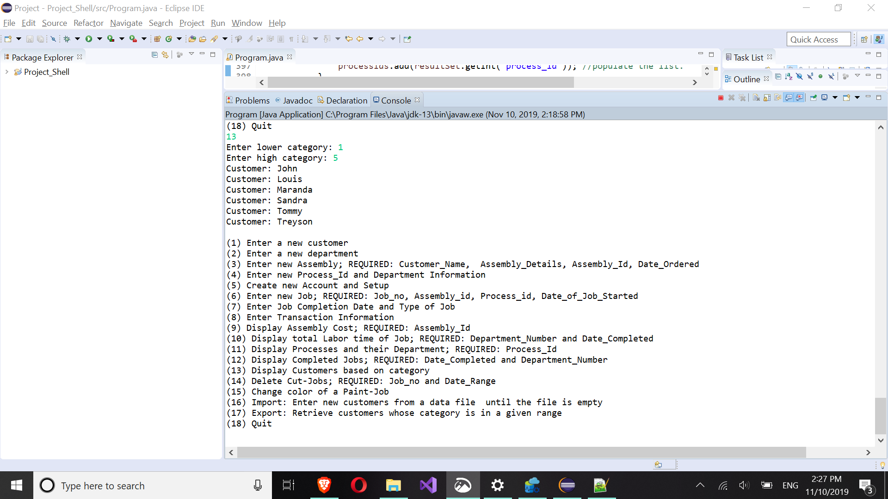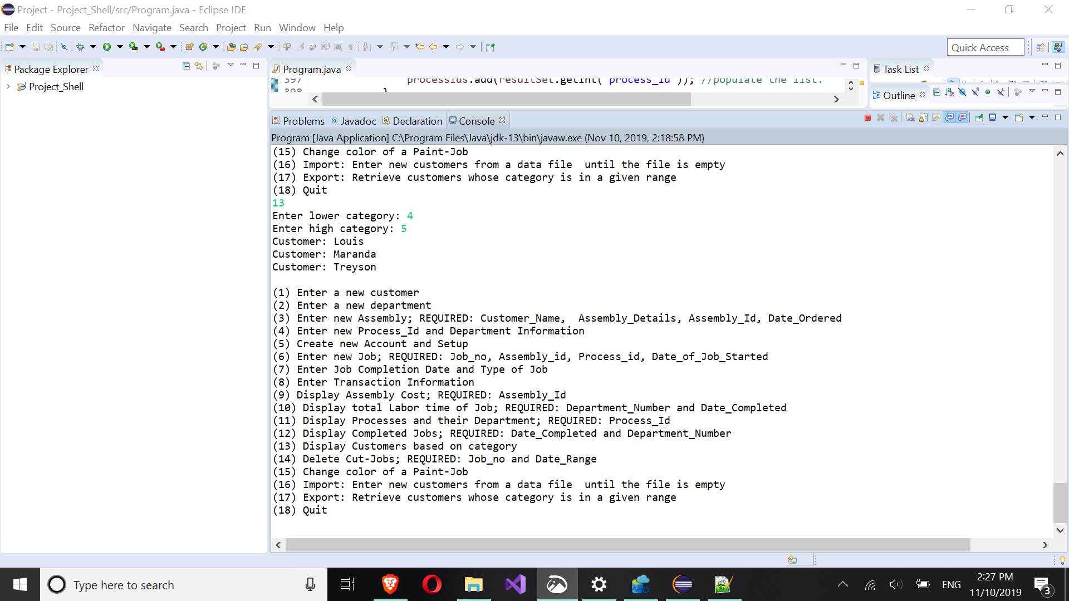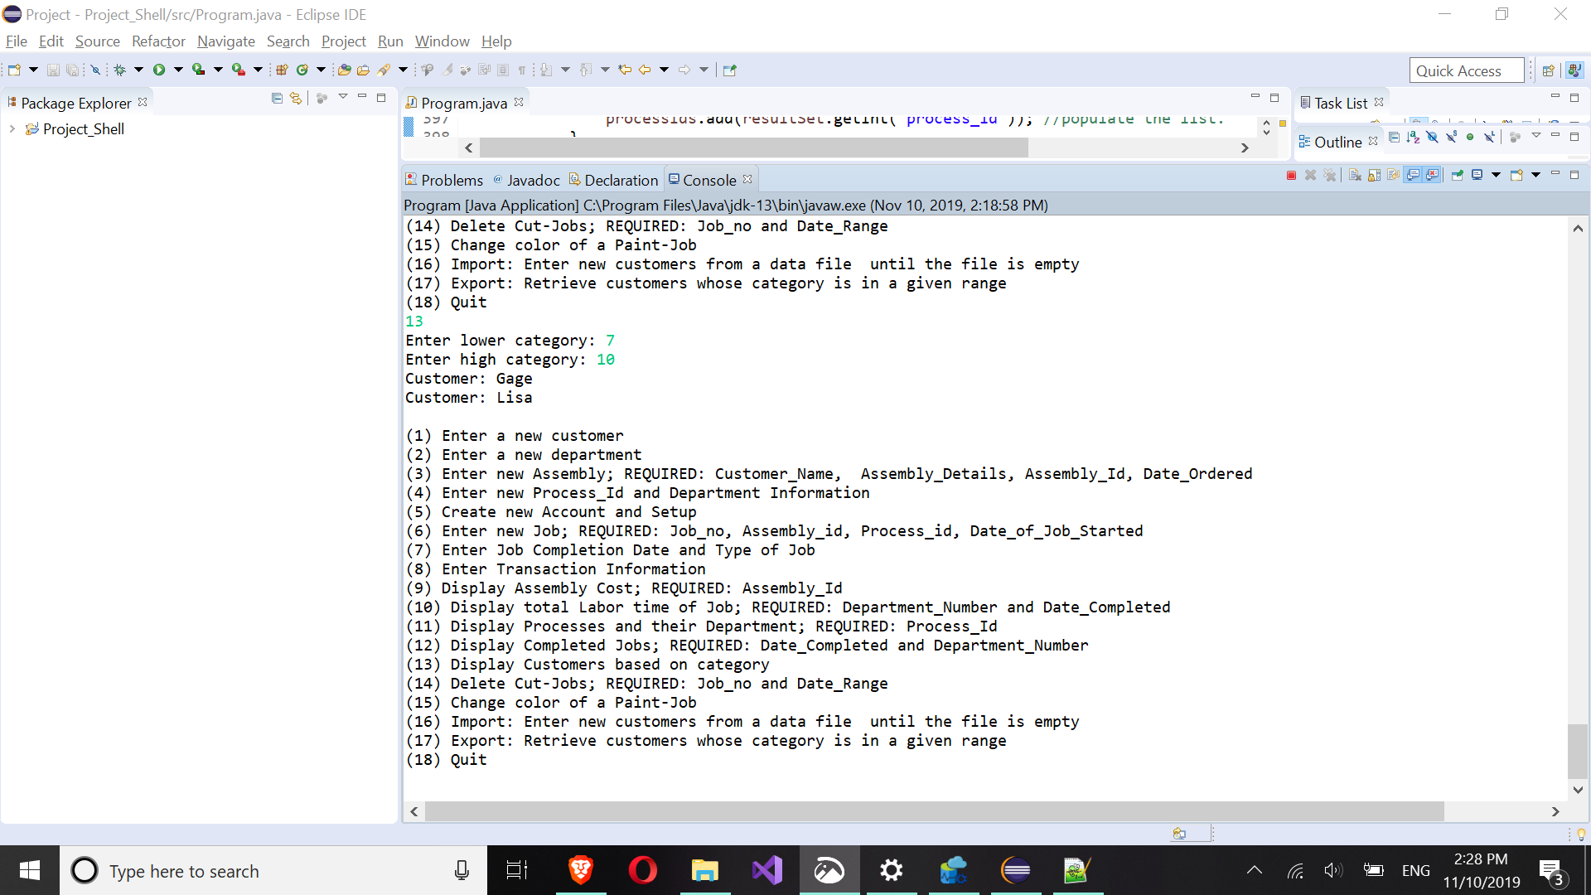

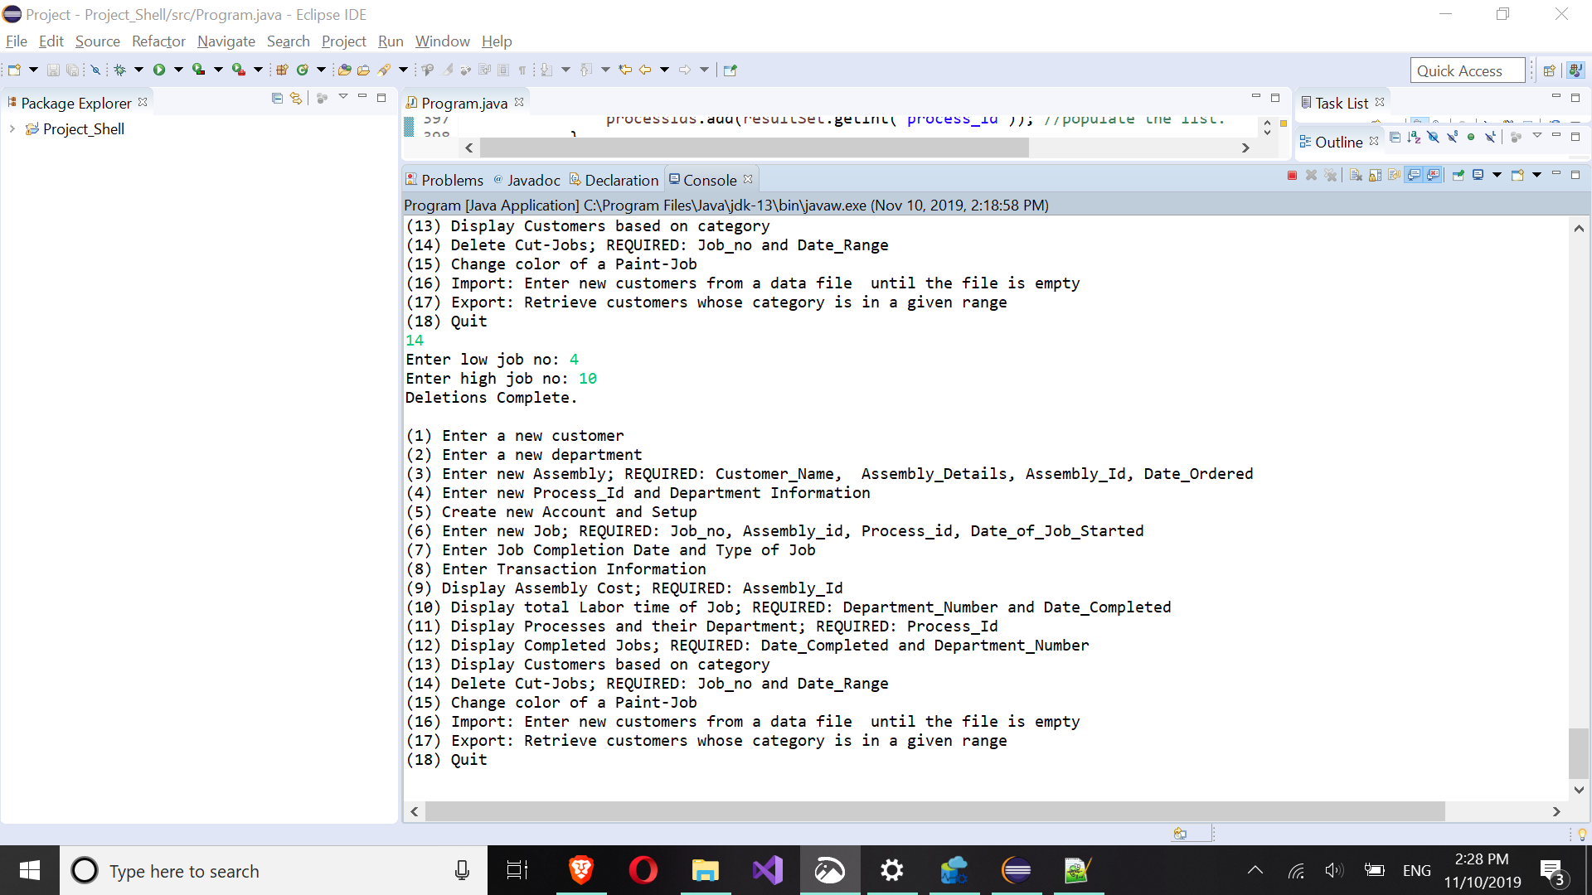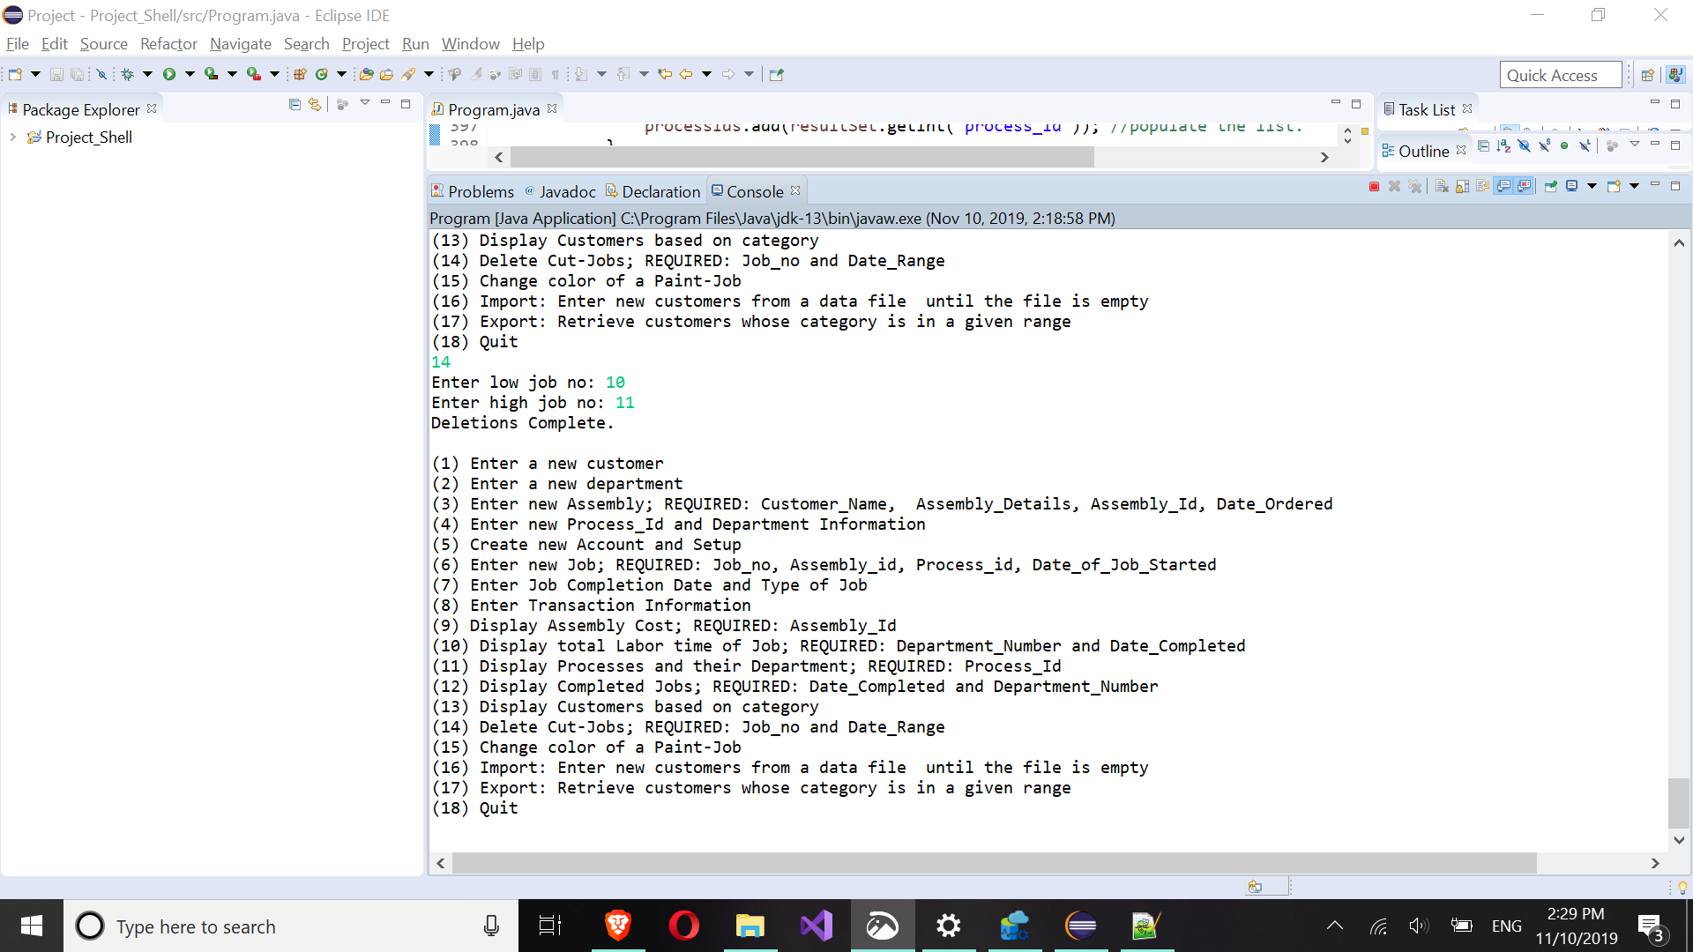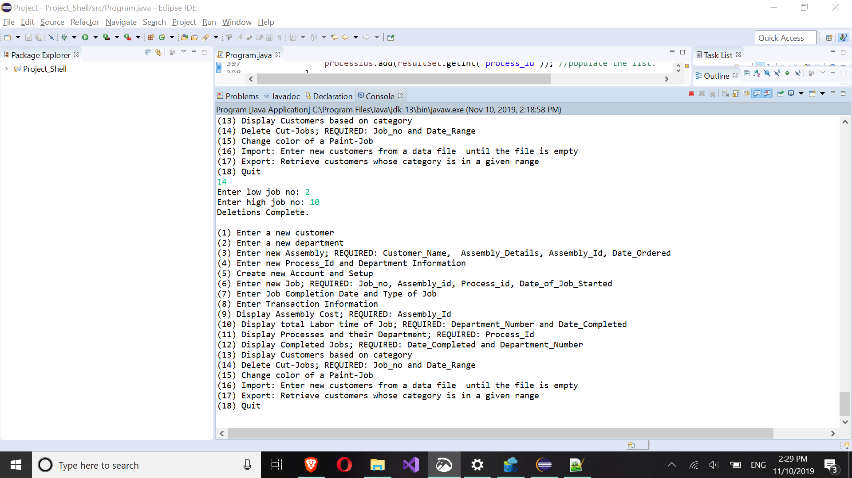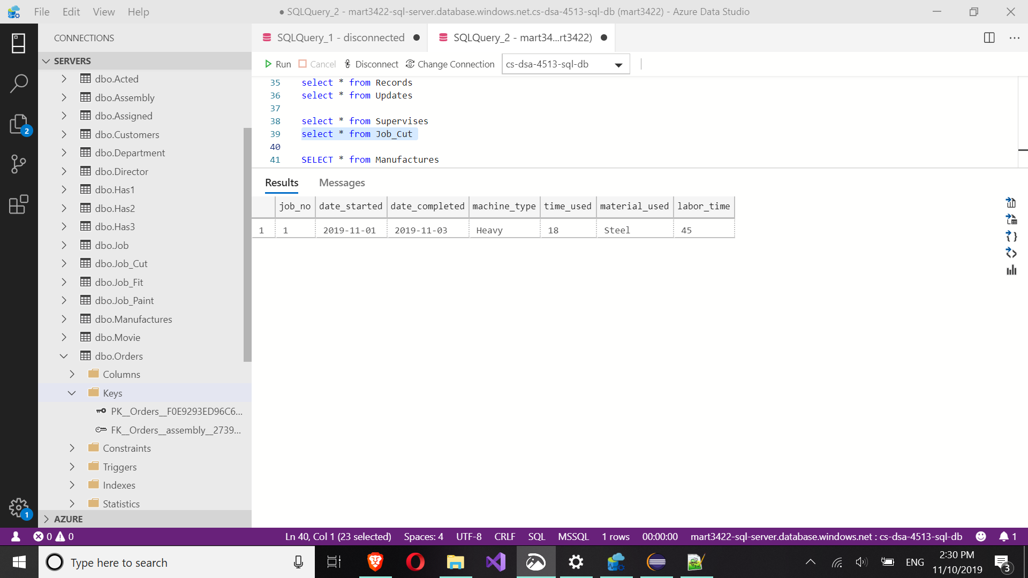

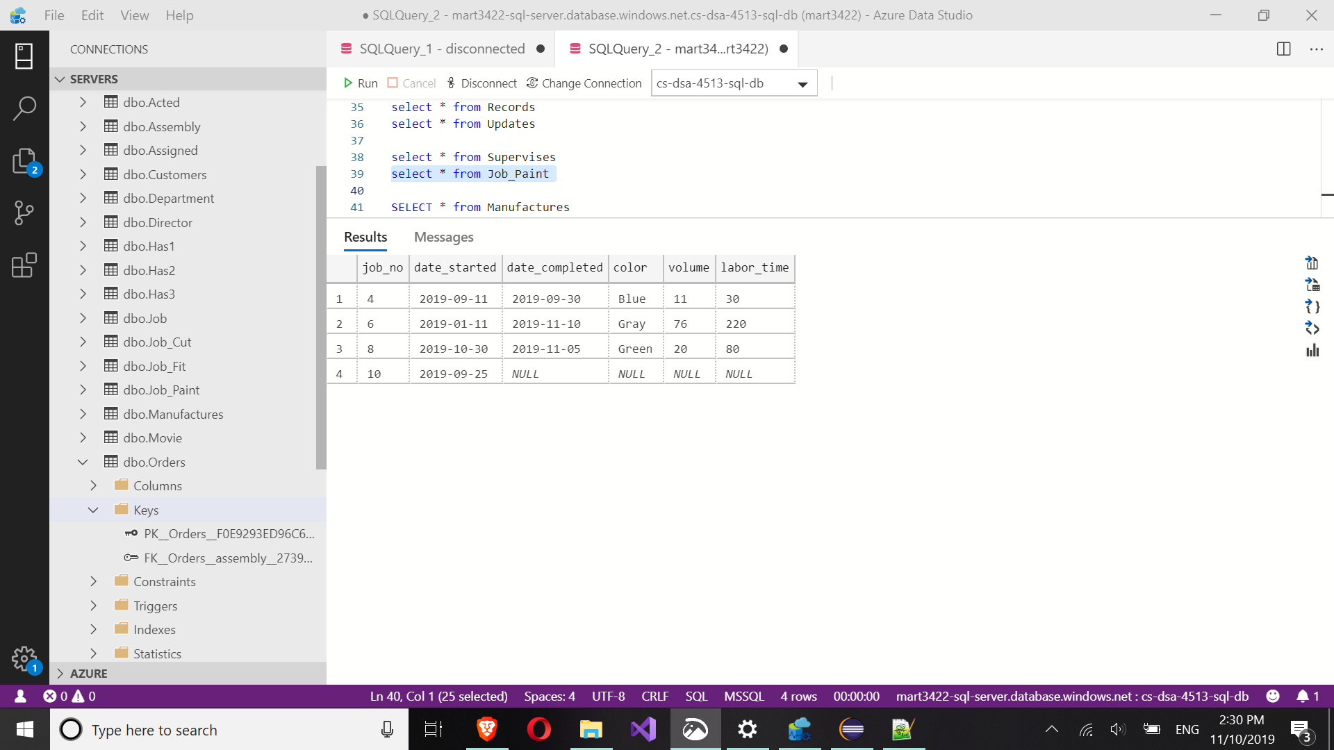

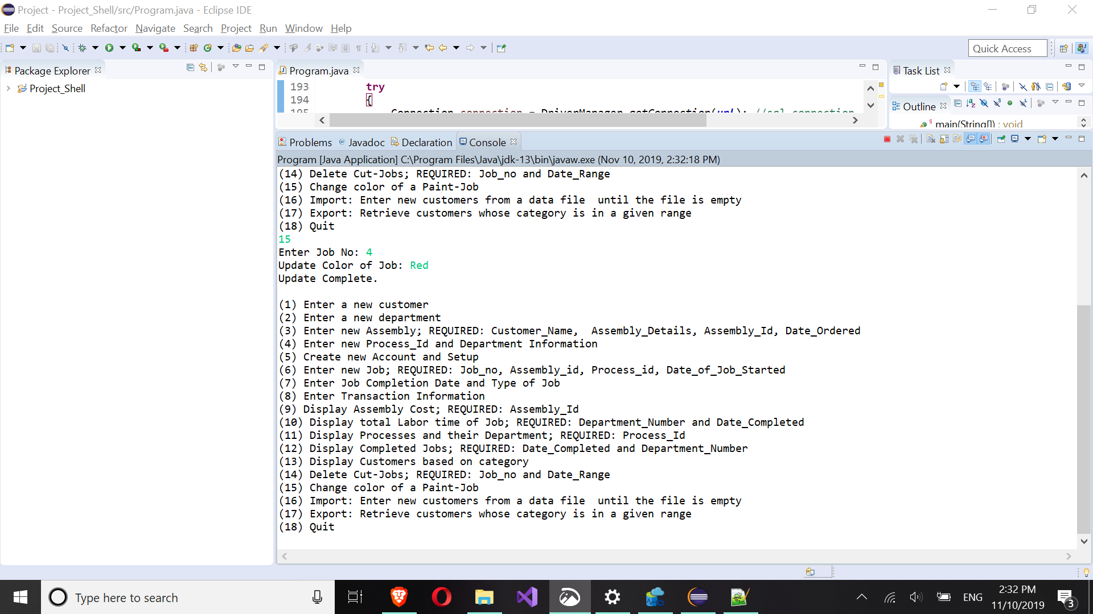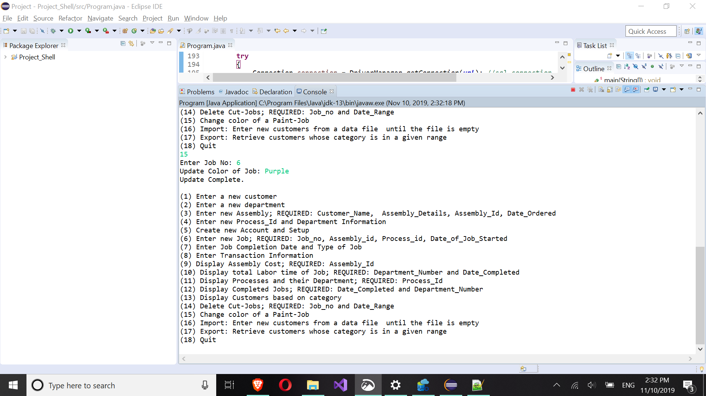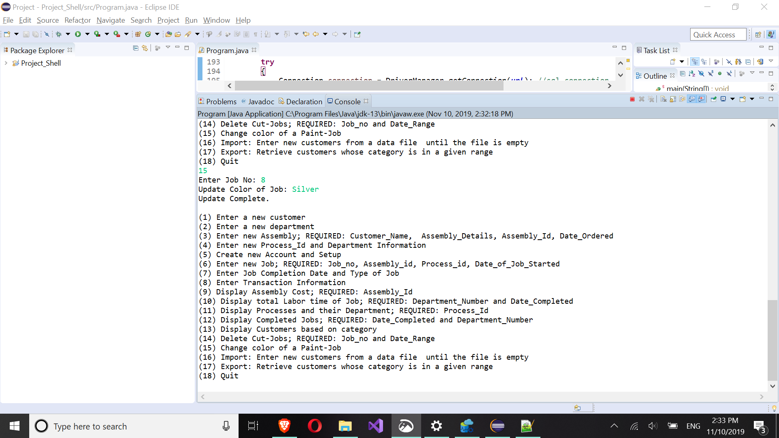

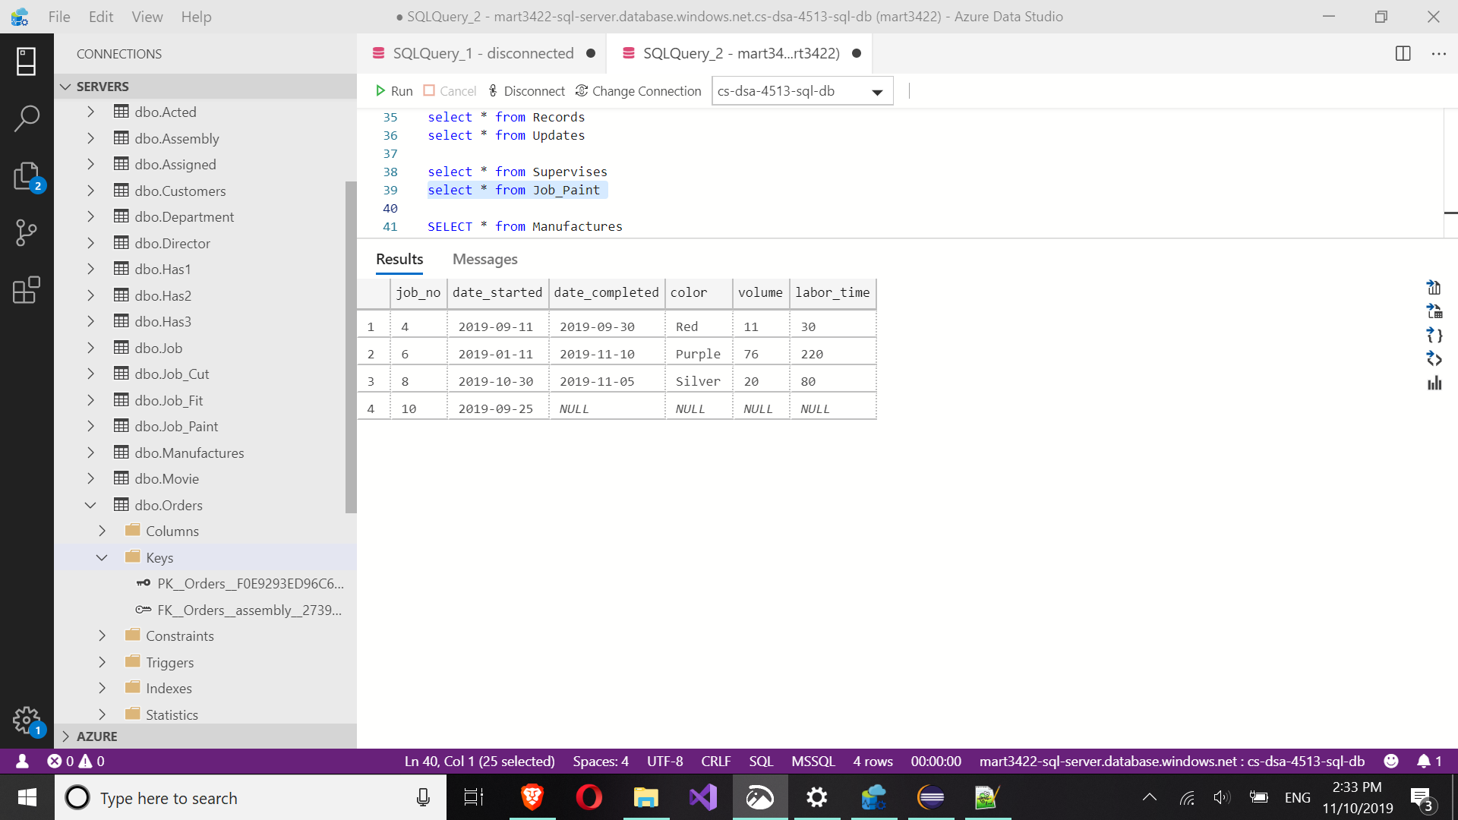

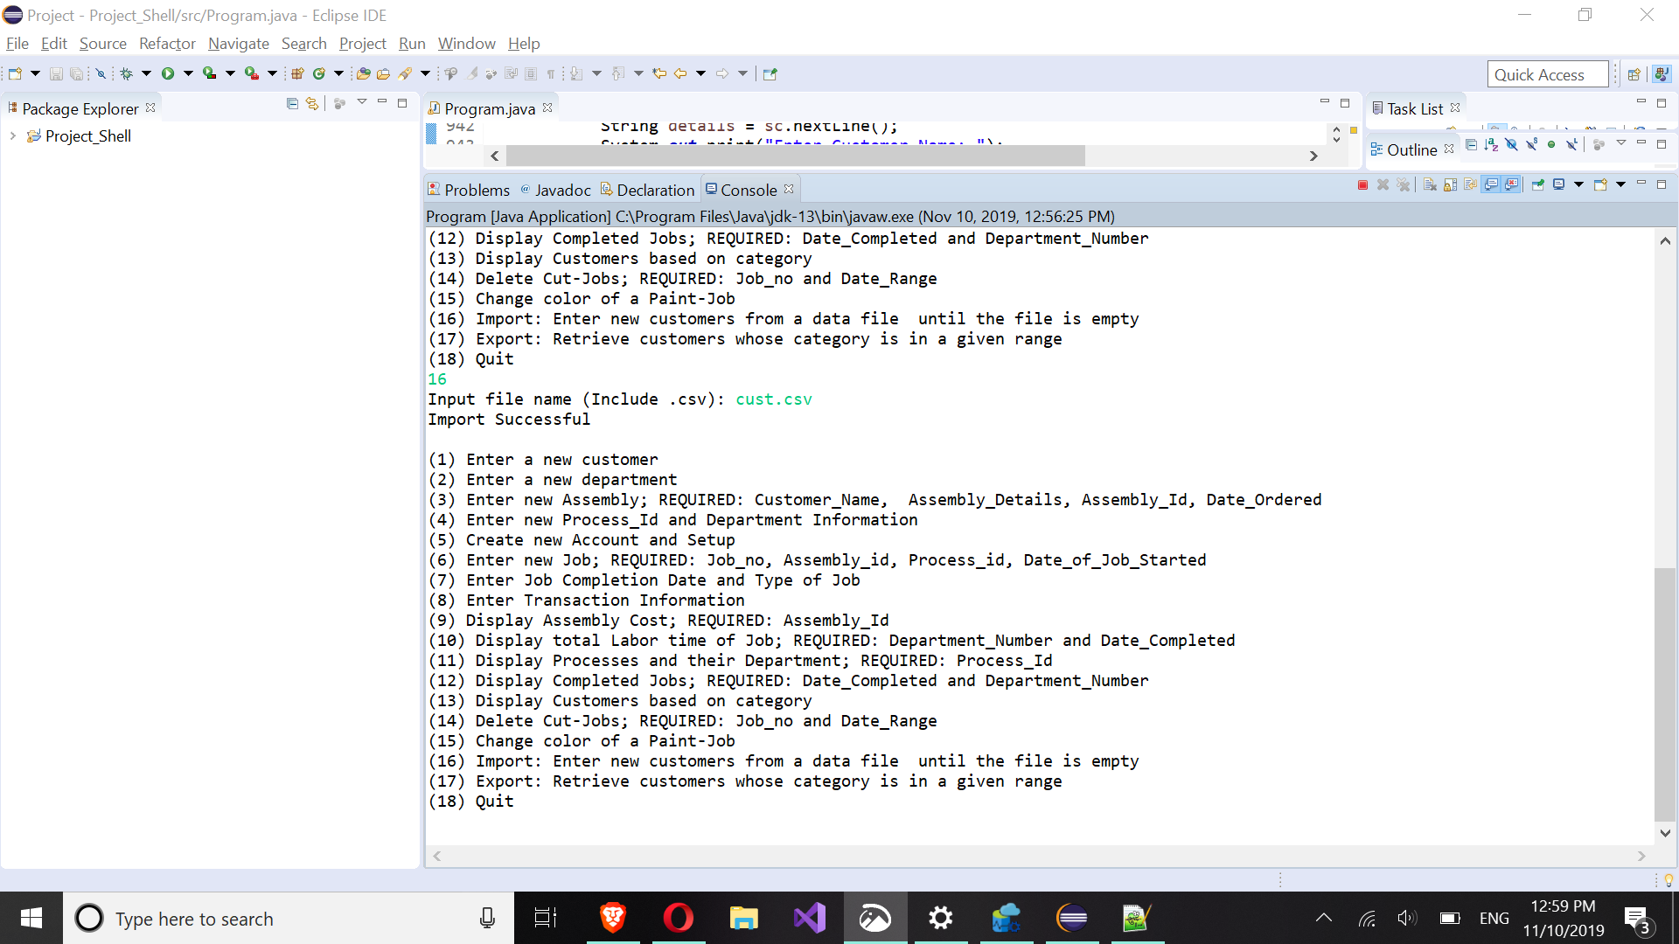

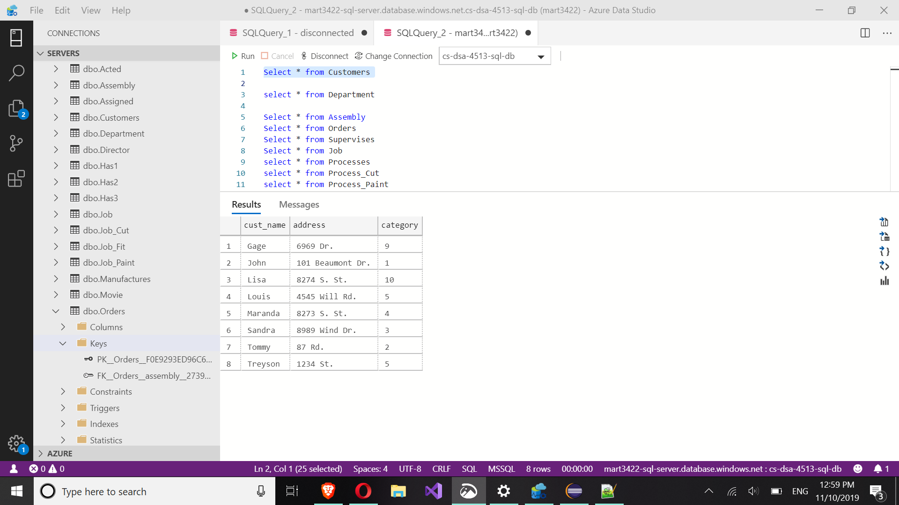

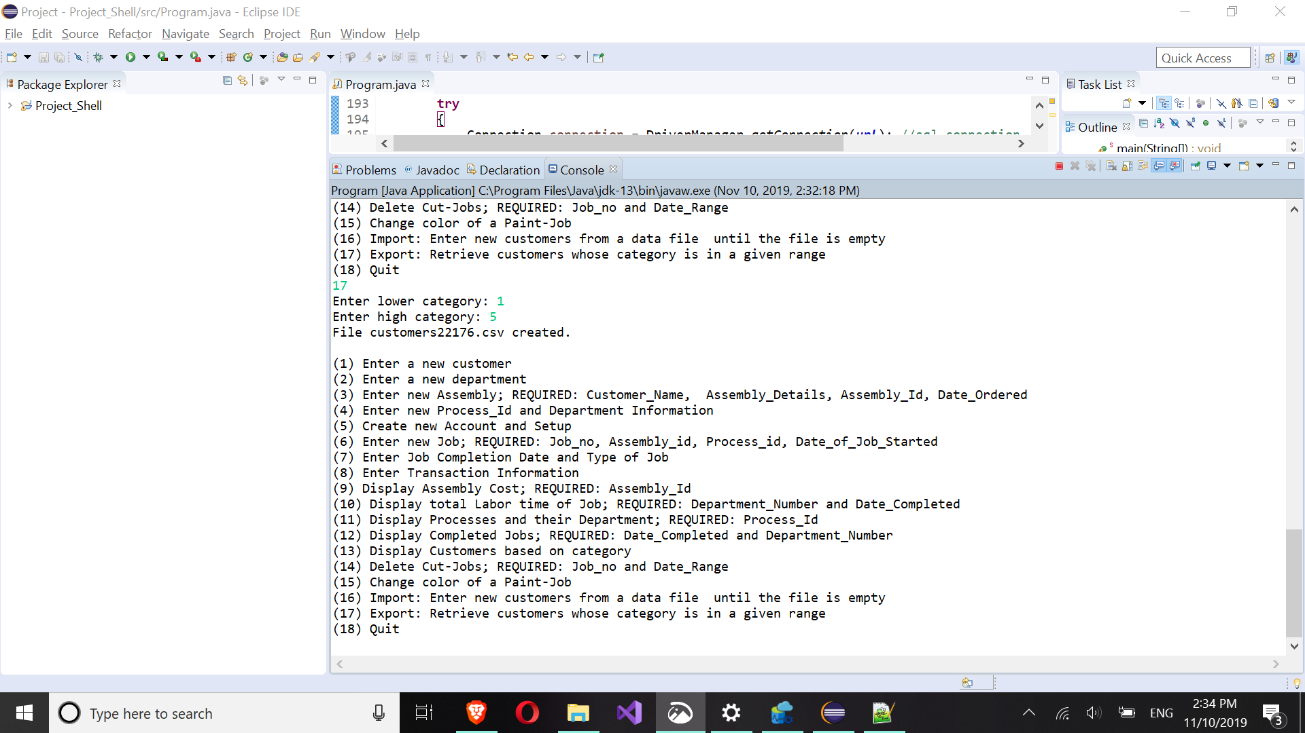

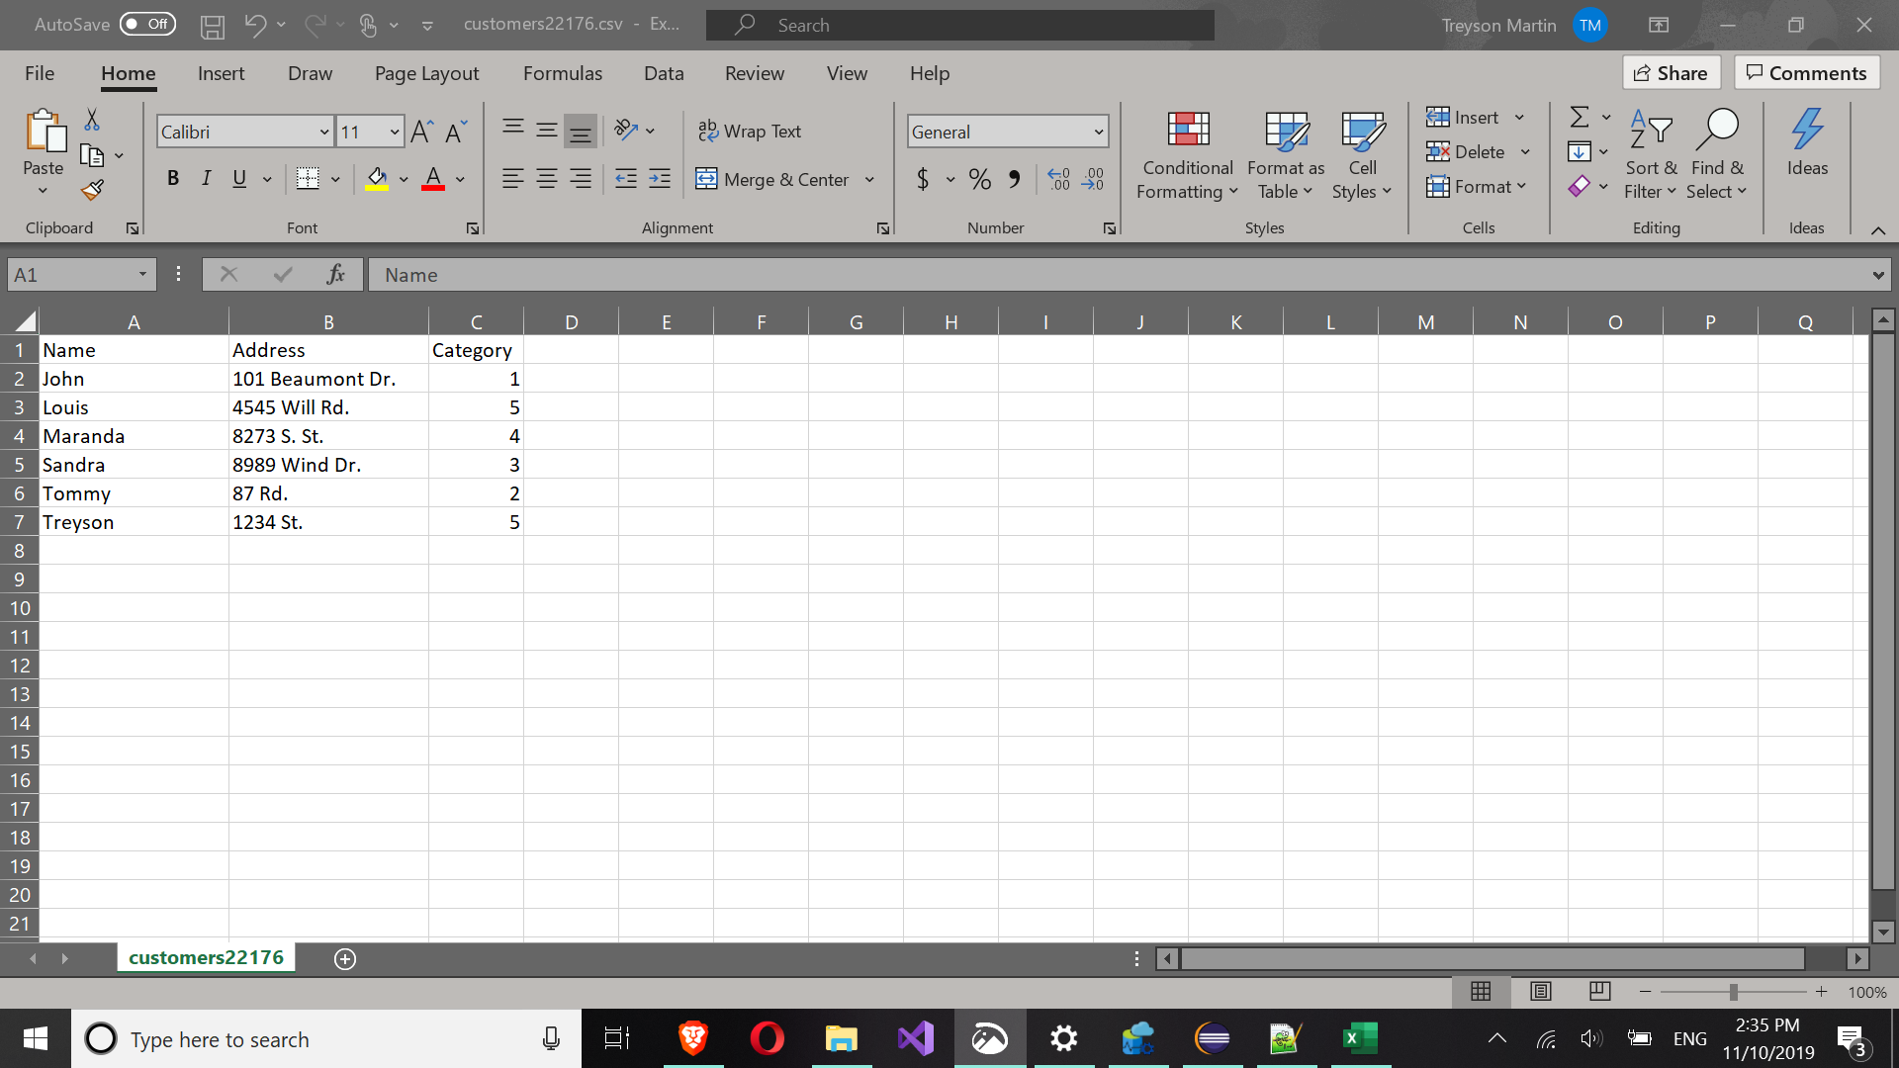

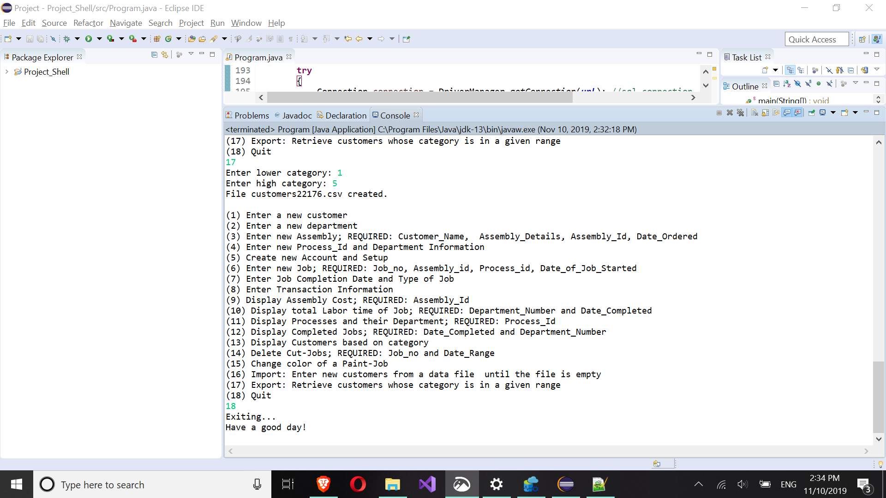

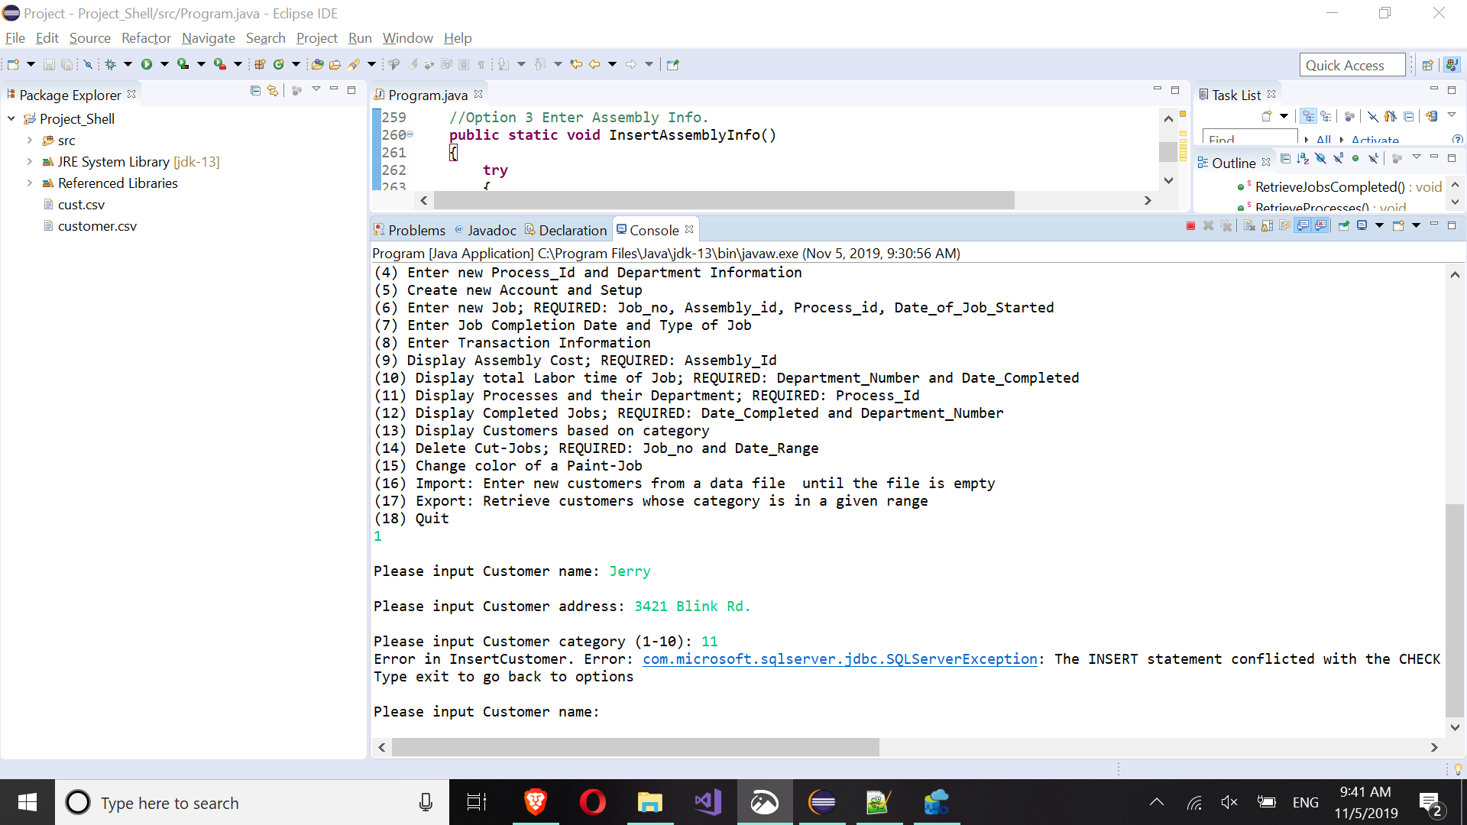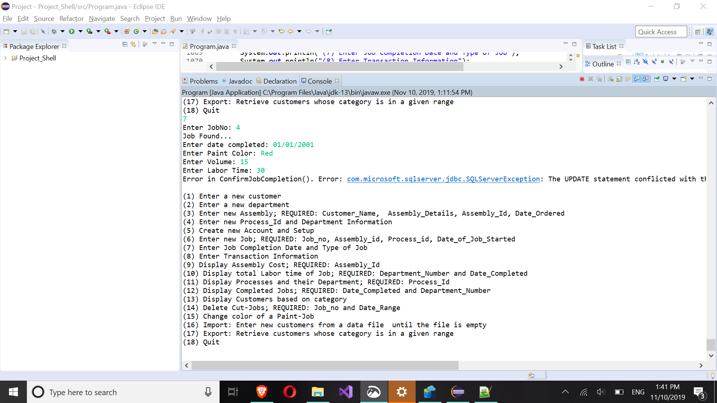

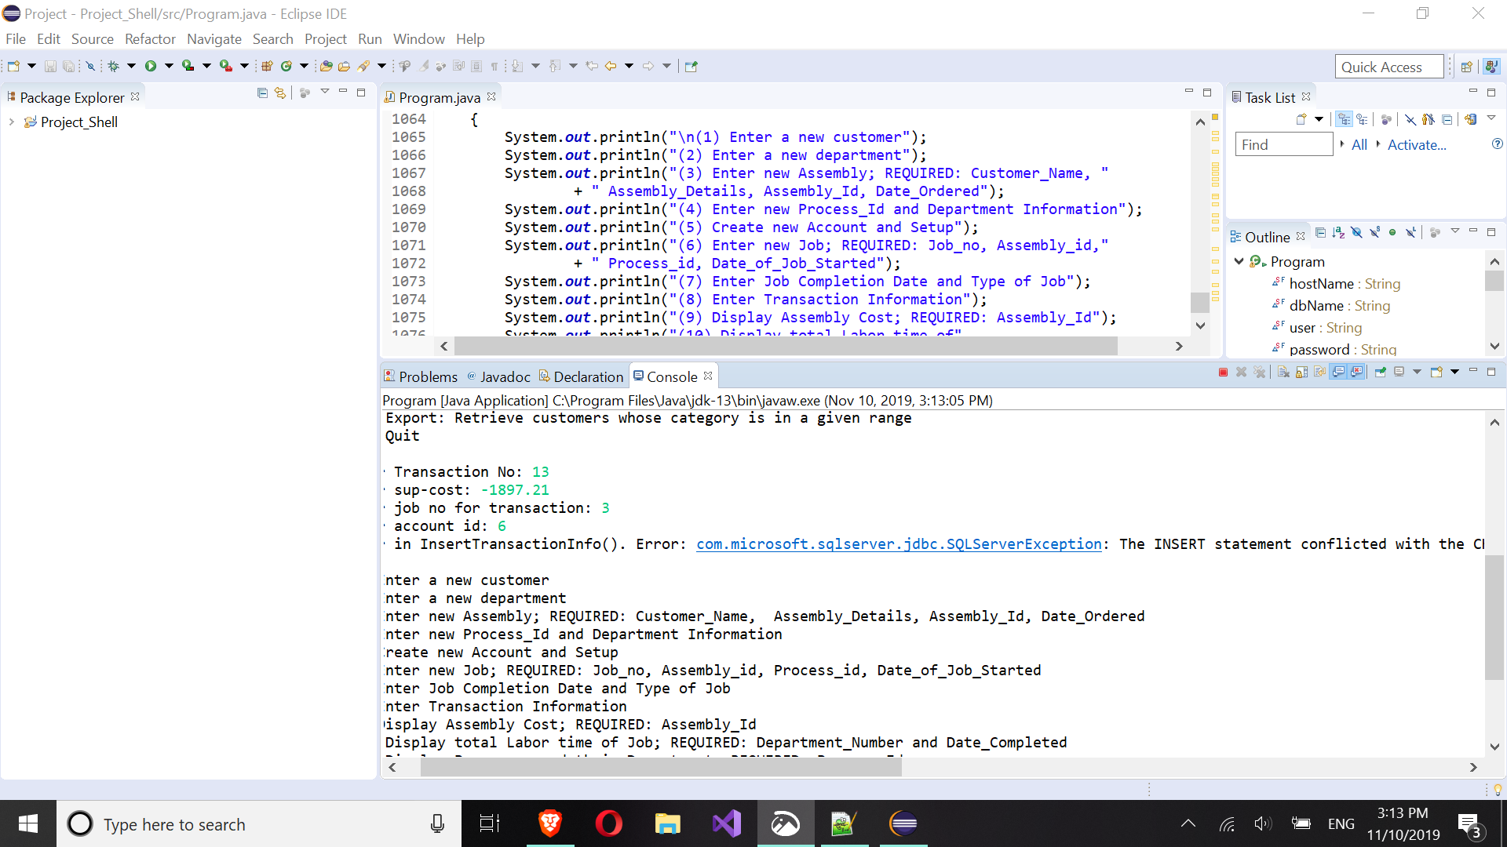

**7) Web Application**